[](https://ok.ru/dk?cmd=PopLayerPhoto&st.layer.cmd=PopLayerPhotoOuter&st.layer.type=GROUP&st.layer.revNav=off&st.layer.limitedUi=false&st.layer.closeLayers=off&st.layer.sphotoIds=866454626115;866454625859;866454625603;866454625347;866454625091;866454624835;866454624579&st.layer.showNav=on&st.layer.photoAlbumId=53073113251907&st.layer.epm=off&st.layer.photoId=866454626115&st.layer.opl=off&st.layer.navStartPhotoId=866454626115&st.layer.sbd=off&st.cmd=userMain&st._aid=GroupTopicLayer_openPhotoLayer)

[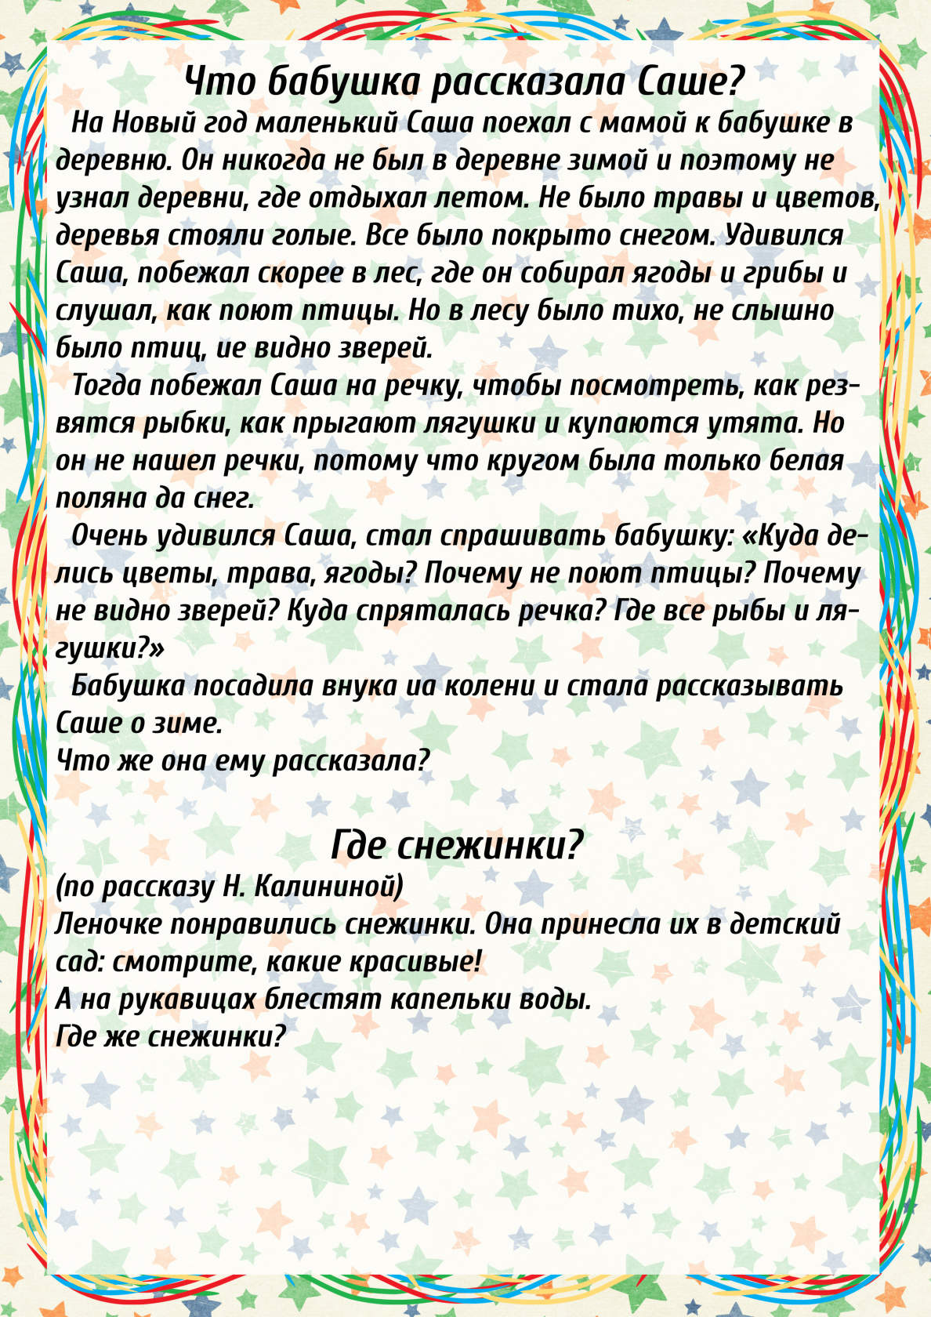](https://ok.ru/dk?cmd=PopLayerPhoto&st.layer.cmd=PopLayerPhotoOuter&st.layer.type=GROUP&st.layer.revNav=off&st.layer.limitedUi=false&st.layer.closeLayers=off&st.layer.sphotoIds=866454626115;866454625859;866454625603;866454625347;866454625091;866454624835;866454624579&st.layer.showNav=on&st.layer.photoAlbumId=53073113251907&st.layer.epm=off&st.layer.photoId=866454625859&st.layer.opl=off&st.layer.navStartPhotoId=866454625859&st.layer.sbd=off&st.cmd=userMain&st._aid=GroupTopicLayer_openPhotoLayer)

[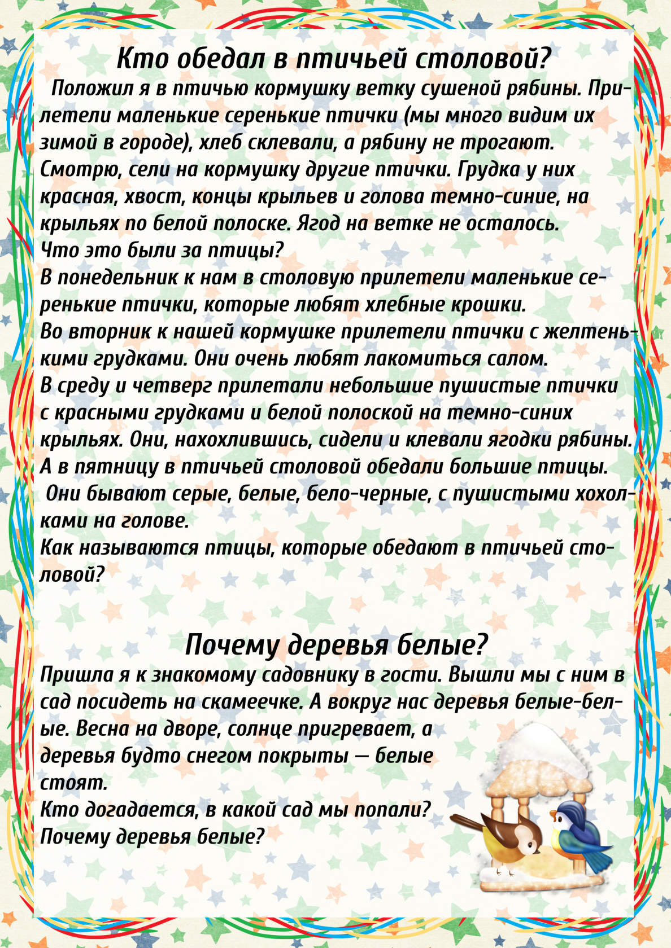](https://ok.ru/dk?cmd=PopLayerPhoto&st.layer.cmd=PopLayerPhotoOuter&st.layer.type=GROUP&st.layer.revNav=off&st.layer.limitedUi=false&st.layer.closeLayers=off&st.layer.sphotoIds=866454626115;866454625859;866454625603;866454625347;866454625091;866454624835;866454624579&st.layer.showNav=on&st.layer.photoAlbumId=53073113251907&st.layer.epm=off&st.layer.photoId=866454625603&st.layer.opl=off&st.layer.navStartPhotoId=866454625603&st.layer.sbd=off&st.cmd=userMain&st._aid=GroupTopicLayer_openPhotoLayer)

[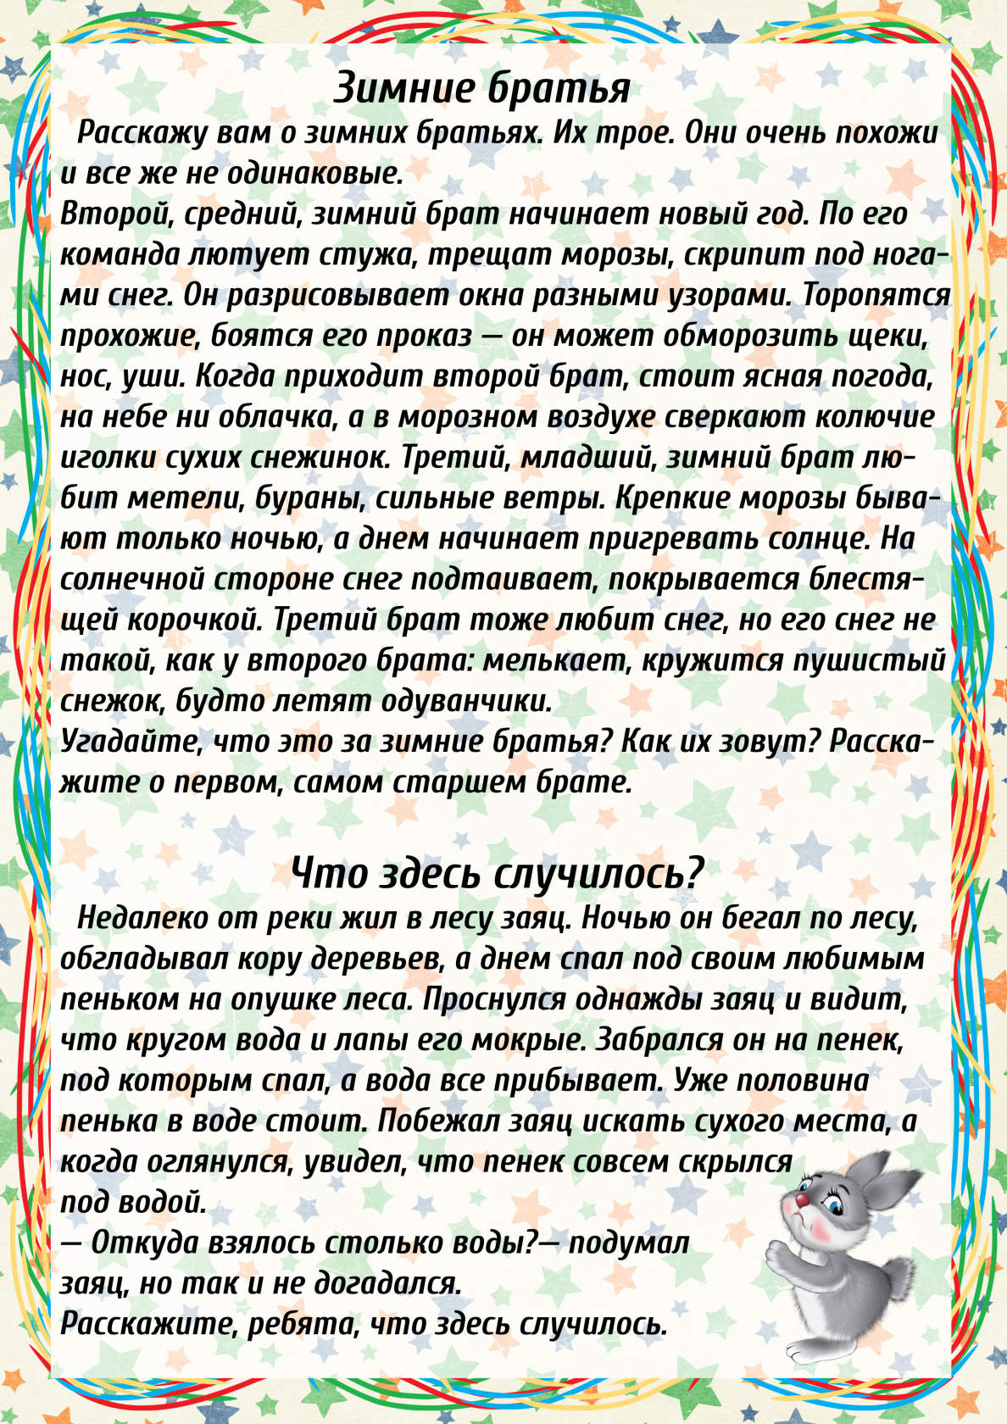](https://ok.ru/dk?cmd=PopLayerPhoto&st.layer.cmd=PopLayerPhotoOuter&st.layer.type=GROUP&st.layer.revNav=off&st.layer.limitedUi=false&st.layer.closeLayers=off&st.layer.sphotoIds=866454626115;866454625859;866454625603;866454625347;866454625091;866454624835;866454624579&st.layer.showNav=on&st.layer.photoAlbumId=53073113251907&st.layer.epm=off&st.layer.photoId=866454625347&st.layer.opl=off&st.layer.navStartPhotoId=866454625347&st.layer.sbd=off&st.cmd=userMain&st._aid=GroupTopicLayer_openPhotoLayer)

[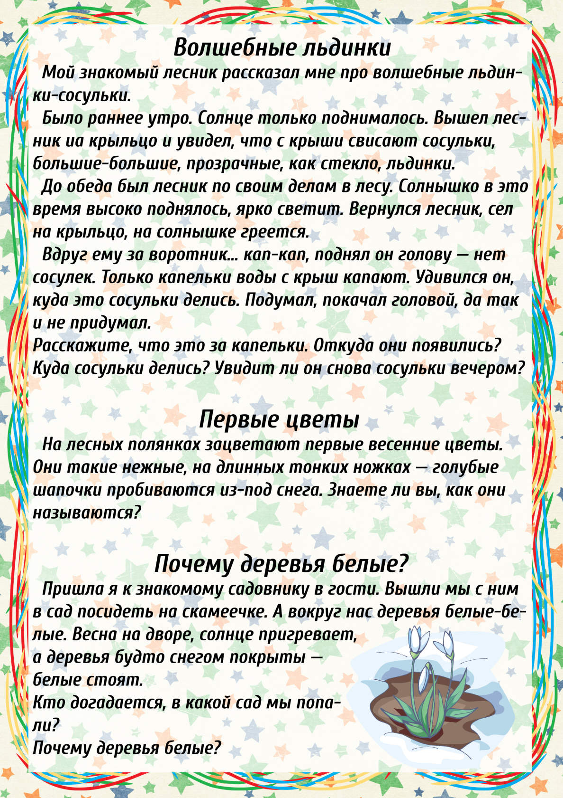](https://ok.ru/dk?cmd=PopLayerPhoto&st.layer.cmd=PopLayerPhotoOuter&st.layer.type=GROUP&st.layer.revNav=off&st.layer.limitedUi=false&st.layer.closeLayers=off&st.layer.sphotoIds=866454626115;866454625859;866454625603;866454625347;866454625091;866454624835;866454624579&st.layer.showNav=on&st.layer.photoAlbumId=53073113251907&st.layer.epm=off&st.layer.photoId=866454625091&st.layer.opl=off&st.layer.navStartPhotoId=866454625091&st.layer.sbd=off&st.cmd=userMain&st._aid=GroupTopicLayer_openPhotoLayer)

[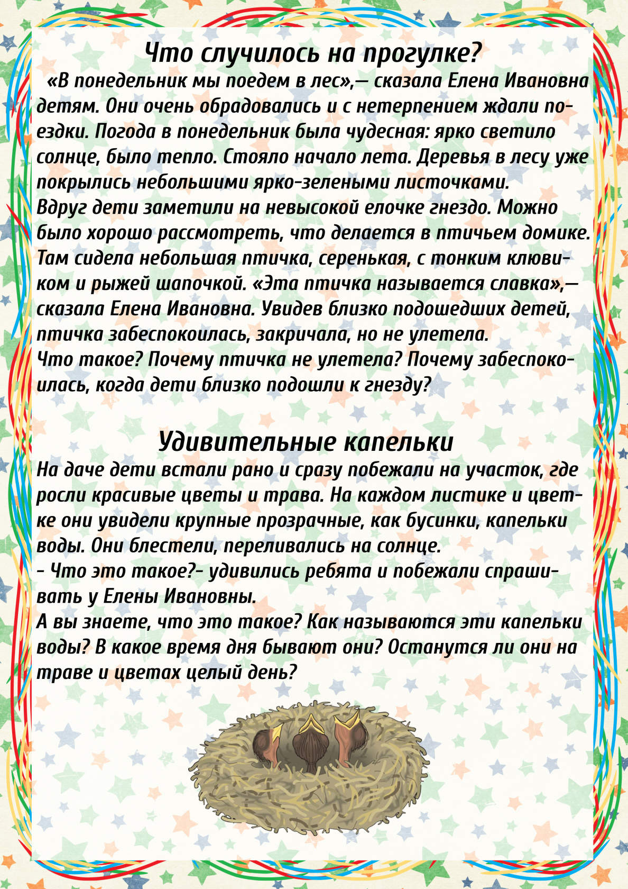](https://ok.ru/dk?cmd=PopLayerPhoto&st.layer.cmd=PopLayerPhotoOuter&st.layer.type=GROUP&st.layer.revNav=off&st.layer.limitedUi=false&st.layer.closeLayers=off&st.layer.sphotoIds=866454626115;866454625859;866454625603;866454625347;866454625091;866454624835;866454624579&st.layer.showNav=on&st.layer.photoAlbumId=53073113251907&st.layer.epm=off&st.layer.photoId=866454624835&st.layer.opl=off&st.layer.navStartPhotoId=866454624835&st.layer.sbd=off&st.cmd=userMain&st._aid=GroupTopicLayer_openPhotoLayer)

[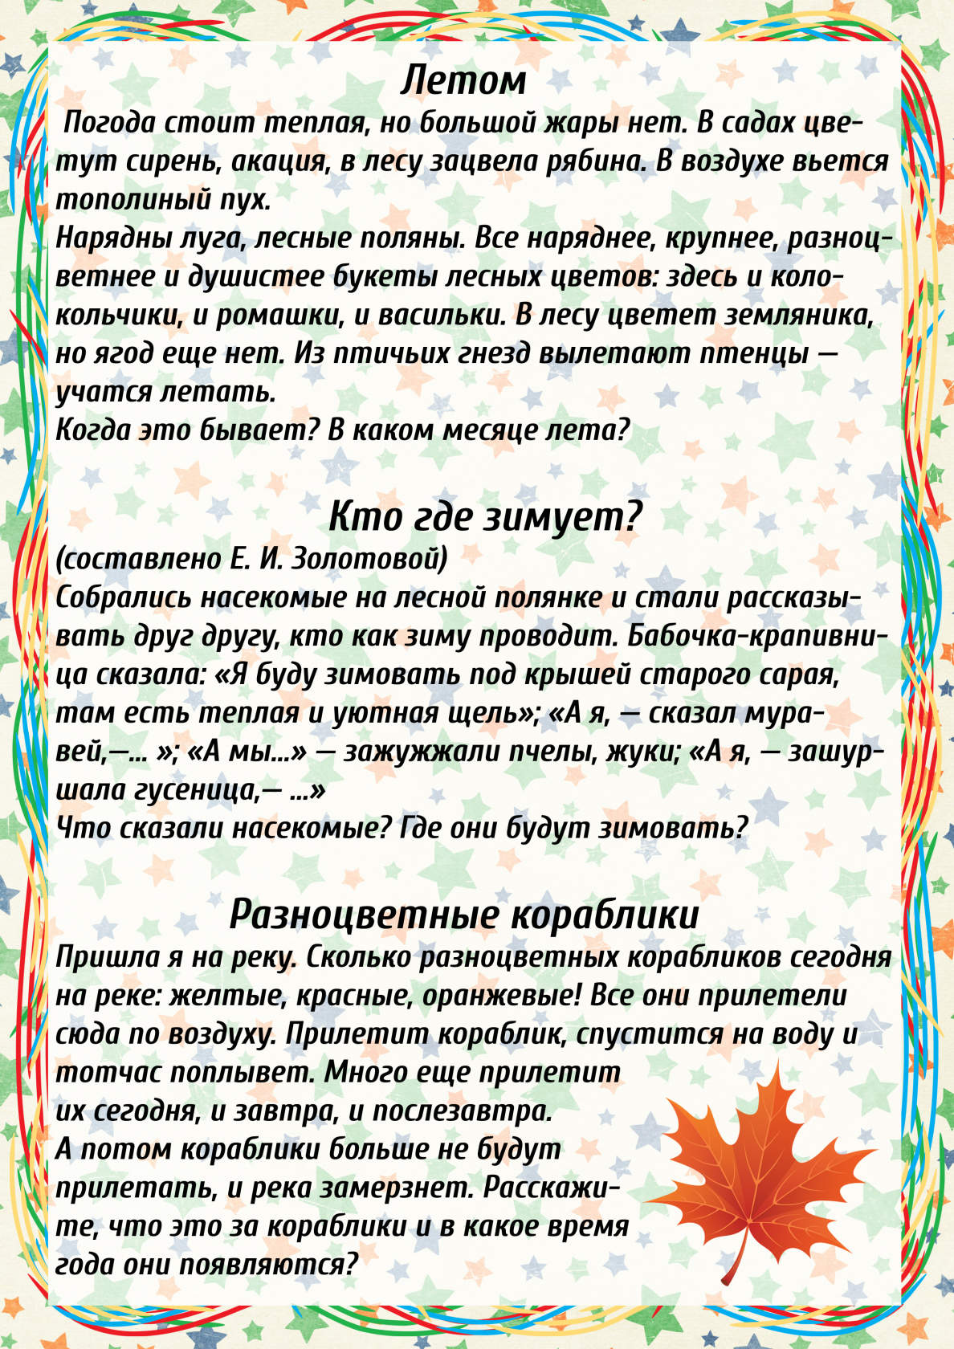](https://ok.ru/dk?cmd=PopLayerPhoto&st.layer.cmd=PopLayerPhotoOuter&st.layer.type=GROUP&st.layer.revNav=off&st.layer.limitedUi=false&st.layer.closeLayers=off&st.layer.sphotoIds=866454626115;866454625859;866454625603;866454625347;866454625091;866454624835;866454624579&st.layer.showNav=on&st.layer.photoAlbumId=53073113251907&st.layer.epm=off&st.layer.photoId=866454624579&st.layer.opl=off&st.layer.navStartPhotoId=866454624579&st.layer.sbd=off&st.cmd=userMain&st._aid=GroupTopicLayer_openPhotoLayer)