**Учимся писать печатные буквы**

[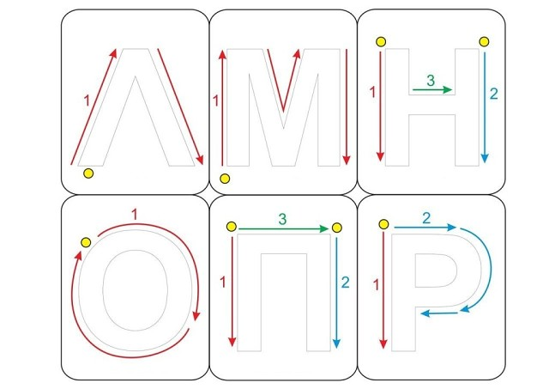](https://ok.ru/dk?cmd=PopLayerPhoto&st.layer.cmd=PopLayerPhotoOuter&st.layer.type=GROUP&st.layer.revNav=off&st.layer.limitedUi=false&st.layer.closeLayers=off&st.layer.sphotoIds=877223956276%3B877223956532%3B877223956788%3B877223957044%3B877223957300%3B877223957556&st.layer.showNav=on&st.layer.photoAlbumId=57249062780980&st.layer.epm=off&st.layer.photoId=877223956276&st.layer.opl=off&st.layer.navStartPhotoId=877223956276&st.layer.sbd=off&st.cmd=userMain&st._aid=GroupTopicLayer_openPhotoLayer)

[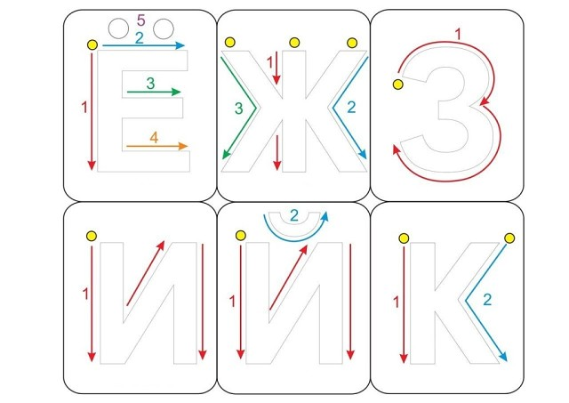](https://ok.ru/dk?cmd=PopLayerPhoto&st.layer.cmd=PopLayerPhotoOuter&st.layer.type=GROUP&st.layer.revNav=off&st.layer.limitedUi=false&st.layer.closeLayers=off&st.layer.sphotoIds=877223956276%3B877223956532%3B877223956788%3B877223957044%3B877223957300%3B877223957556&st.layer.showNav=on&st.layer.photoAlbumId=57249062780980&st.layer.epm=off&st.layer.photoId=877223956532&st.layer.opl=off&st.layer.navStartPhotoId=877223956532&st.layer.sbd=off&st.cmd=userMain&st._aid=GroupTopicLayer_openPhotoLayer)

[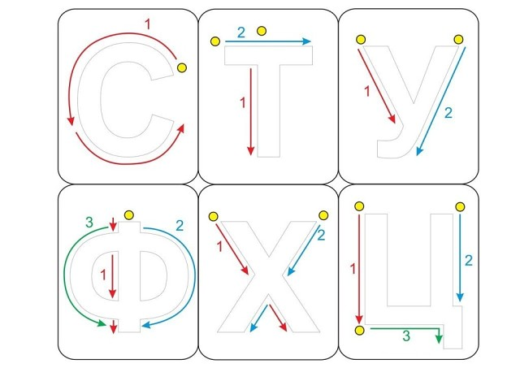](https://ok.ru/dk?cmd=PopLayerPhoto&st.layer.cmd=PopLayerPhotoOuter&st.layer.type=GROUP&st.layer.revNav=off&st.layer.limitedUi=false&st.layer.closeLayers=off&st.layer.sphotoIds=877223956276%3B877223956532%3B877223956788%3B877223957044%3B877223957300%3B877223957556&st.layer.showNav=on&st.layer.photoAlbumId=57249062780980&st.layer.epm=off&st.layer.photoId=877223956788&st.layer.opl=off&st.layer.navStartPhotoId=877223956788&st.layer.sbd=off&st.cmd=userMain&st._aid=GroupTopicLayer_openPhotoLayer)

[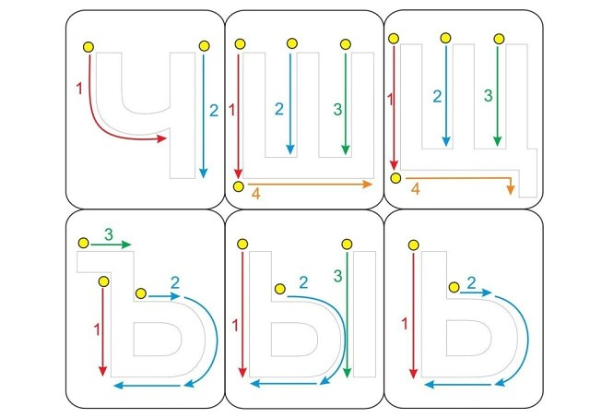](https://ok.ru/dk?cmd=PopLayerPhoto&st.layer.cmd=PopLayerPhotoOuter&st.layer.type=GROUP&st.layer.revNav=off&st.layer.limitedUi=false&st.layer.closeLayers=off&st.layer.sphotoIds=877223956276%3B877223956532%3B877223956788%3B877223957044%3B877223957300%3B877223957556&st.layer.showNav=on&st.layer.photoAlbumId=57249062780980&st.layer.epm=off&st.layer.photoId=877223957044&st.layer.opl=off&st.layer.navStartPhotoId=877223957044&st.layer.sbd=off&st.cmd=userMain&st._aid=GroupTopicLayer_openPhotoLayer)

[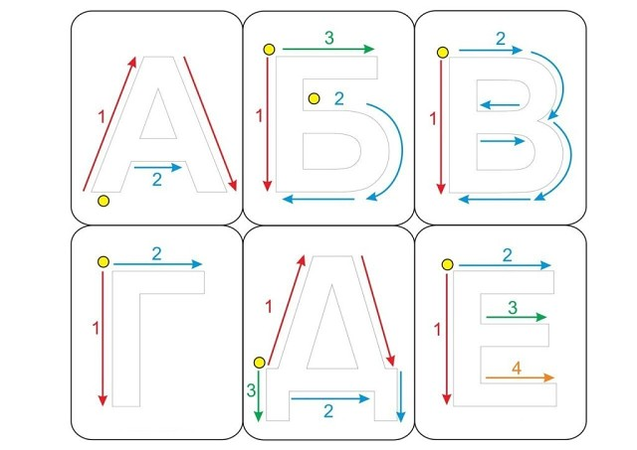](https://ok.ru/dk?cmd=PopLayerPhoto&st.layer.cmd=PopLayerPhotoOuter&st.layer.type=GROUP&st.layer.revNav=off&st.layer.limitedUi=false&st.layer.closeLayers=off&st.layer.sphotoIds=877223956276%3B877223956532%3B877223956788%3B877223957044%3B877223957300%3B877223957556&st.layer.showNav=on&st.layer.photoAlbumId=57249062780980&st.layer.epm=off&st.layer.photoId=877223957300&st.layer.opl=off&st.layer.navStartPhotoId=877223957300&st.layer.sbd=off&st.cmd=userMain&st._aid=GroupTopicLayer_openPhotoLayer)

[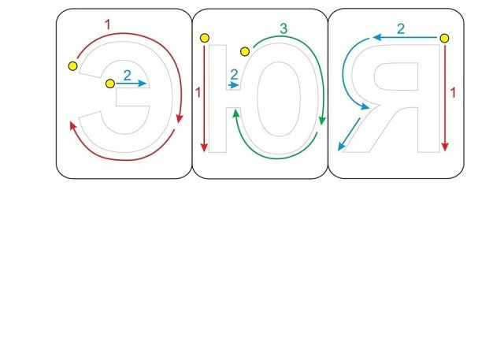](https://ok.ru/dk?cmd=PopLayerPhoto&st.layer.cmd=PopLayerPhotoOuter&st.layer.type=GROUP&st.layer.revNav=off&st.layer.limitedUi=false&st.layer.closeLayers=off&st.layer.sphotoIds=877223956276%3B877223956532%3B877223956788%3B877223957044%3B877223957300%3B877223957556&st.layer.showNav=on&st.layer.photoAlbumId=57249062780980&st.layer.epm=off&st.layer.photoId=877223957556&st.layer.opl=off&st.layer.navStartPhotoId=877223957556&st.layer.sbd=off&st.cmd=userMain&st._aid=GroupTopicLayer_openPhotoLayer)