[](https://ok.ru/dk?cmd=PopLayerPhoto&st.layer.cmd=PopLayerPhotoOuter&st.layer.type=GROUP&st.layer.revNav=off&st.layer.limitedUi=false&st.layer.closeLayers=off&st.layer.sphotoIds=866277707587;866277707331;866277707075;866277706819;866277706563;866277706307&st.layer.showNav=on&st.layer.photoAlbumId=53073113251907&st.layer.epm=off&st.layer.photoId=866277707587&st.layer.opl=off&st.layer.navStartPhotoId=866277707587&st.layer.sbd=off&st.cmd=userMain&st._aid=GroupTopicLayer_openPhotoLayer)

[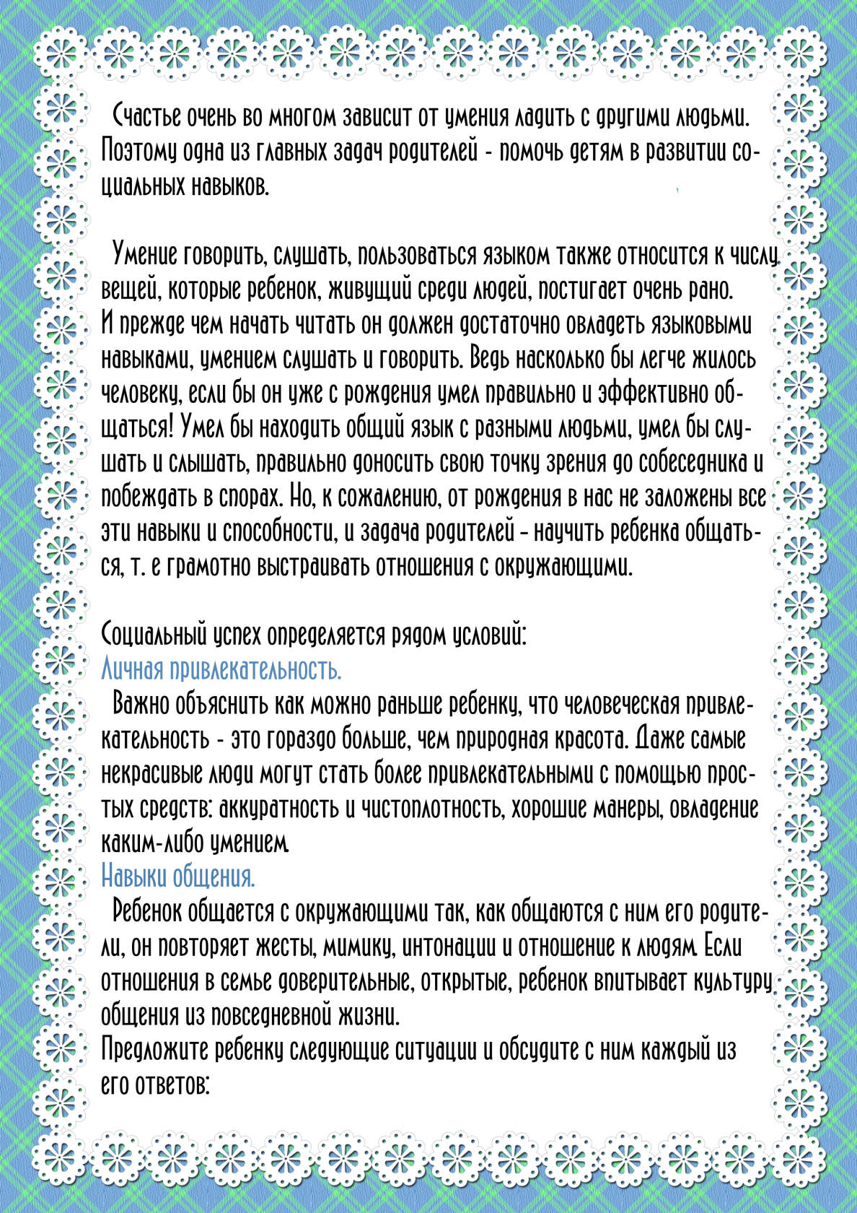](https://ok.ru/dk?cmd=PopLayerPhoto&st.layer.cmd=PopLayerPhotoOuter&st.layer.type=GROUP&st.layer.revNav=off&st.layer.limitedUi=false&st.layer.closeLayers=off&st.layer.sphotoIds=866277707587;866277707331;866277707075;866277706819;866277706563;866277706307&st.layer.showNav=on&st.layer.photoAlbumId=53073113251907&st.layer.epm=off&st.layer.photoId=866277707331&st.layer.opl=off&st.layer.navStartPhotoId=866277707331&st.layer.sbd=off&st.cmd=userMain&st._aid=GroupTopicLayer_openPhotoLayer)

[](https://ok.ru/dk?cmd=PopLayerPhoto&st.layer.cmd=PopLayerPhotoOuter&st.layer.type=GROUP&st.layer.revNav=off&st.layer.limitedUi=false&st.layer.closeLayers=off&st.layer.sphotoIds=866277707587;866277707331;866277707075;866277706819;866277706563;866277706307&st.layer.showNav=on&st.layer.photoAlbumId=53073113251907&st.layer.epm=off&st.layer.photoId=866277707075&st.layer.opl=off&st.layer.navStartPhotoId=866277707075&st.layer.sbd=off&st.cmd=userMain&st._aid=GroupTopicLayer_openPhotoLayer)

[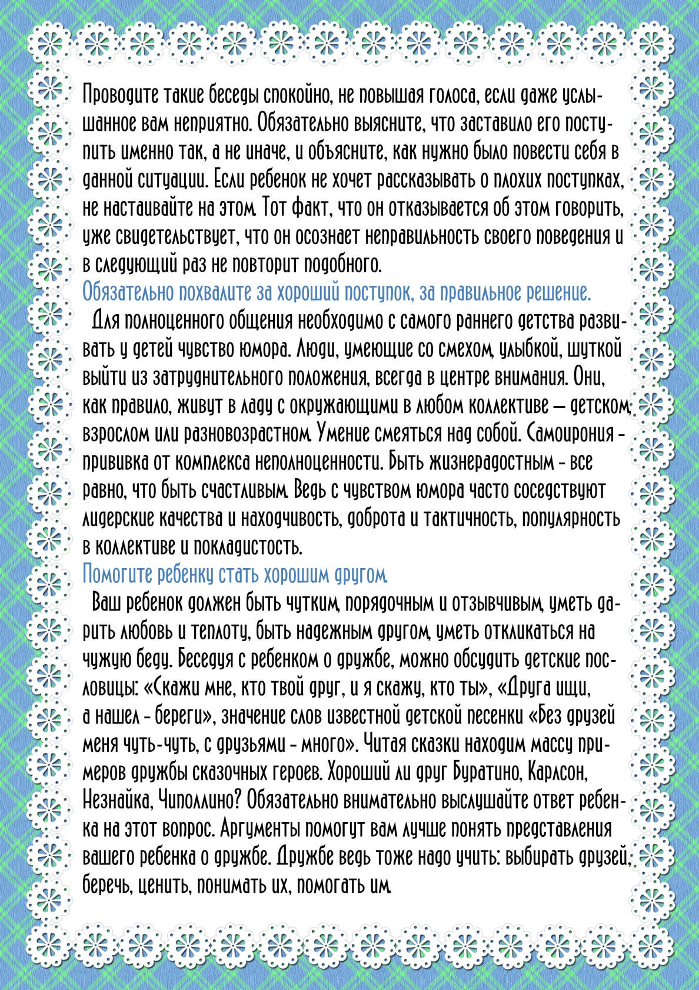](https://ok.ru/dk?cmd=PopLayerPhoto&st.layer.cmd=PopLayerPhotoOuter&st.layer.type=GROUP&st.layer.revNav=off&st.layer.limitedUi=false&st.layer.closeLayers=off&st.layer.sphotoIds=866277707587;866277707331;866277707075;866277706819;866277706563;866277706307&st.layer.showNav=on&st.layer.photoAlbumId=53073113251907&st.layer.epm=off&st.layer.photoId=866277706819&st.layer.opl=off&st.layer.navStartPhotoId=866277706819&st.layer.sbd=off&st.cmd=userMain&st._aid=GroupTopicLayer_openPhotoLayer)

[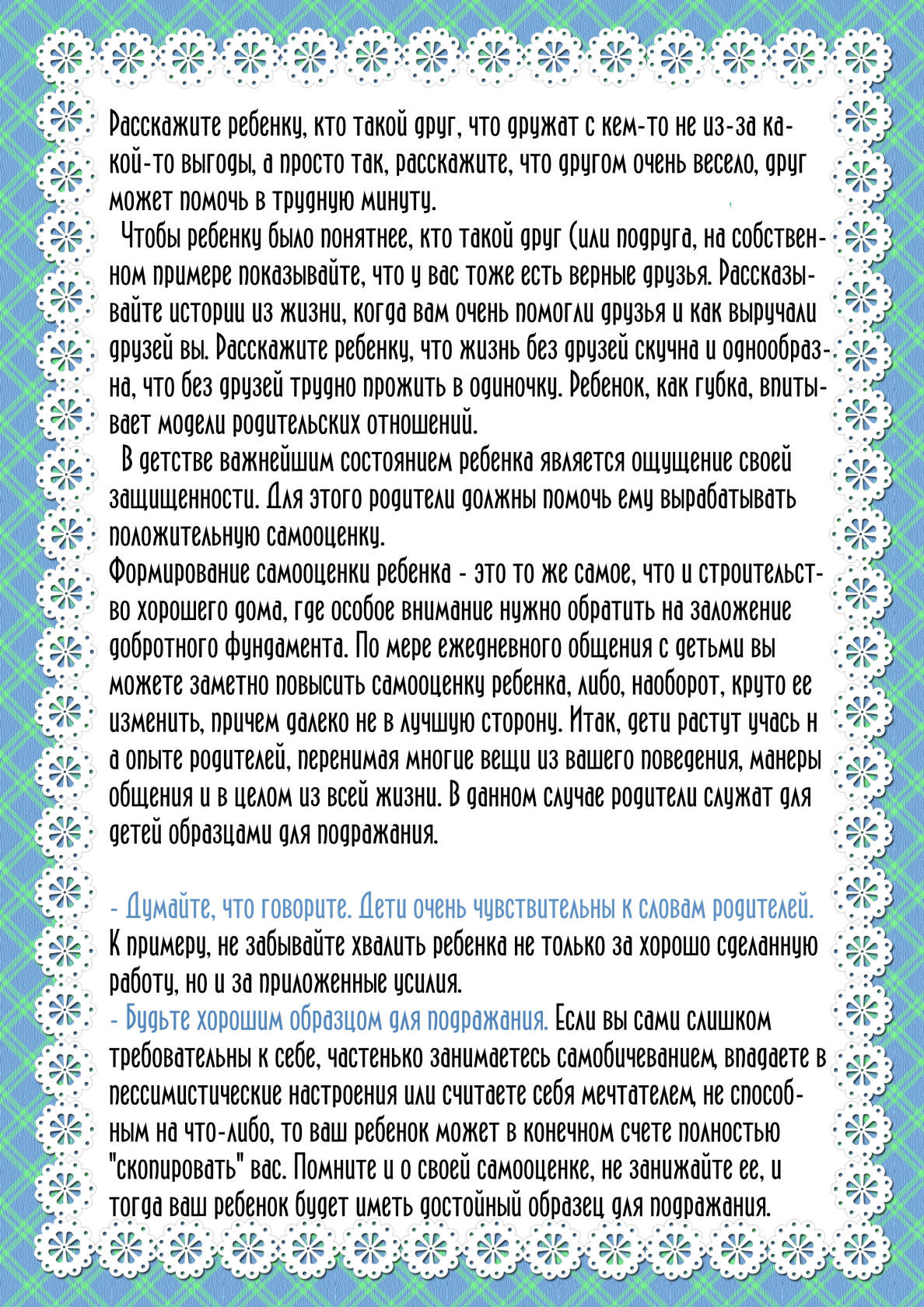](https://ok.ru/dk?cmd=PopLayerPhoto&st.layer.cmd=PopLayerPhotoOuter&st.layer.type=GROUP&st.layer.revNav=off&st.layer.limitedUi=false&st.layer.closeLayers=off&st.layer.sphotoIds=866277707587;866277707331;866277707075;866277706819;866277706563;866277706307&st.layer.showNav=on&st.layer.photoAlbumId=53073113251907&st.layer.epm=off&st.layer.photoId=866277706563&st.layer.opl=off&st.layer.navStartPhotoId=866277706563&st.layer.sbd=off&st.cmd=userMain&st._aid=GroupTopicLayer_openPhotoLayer)

[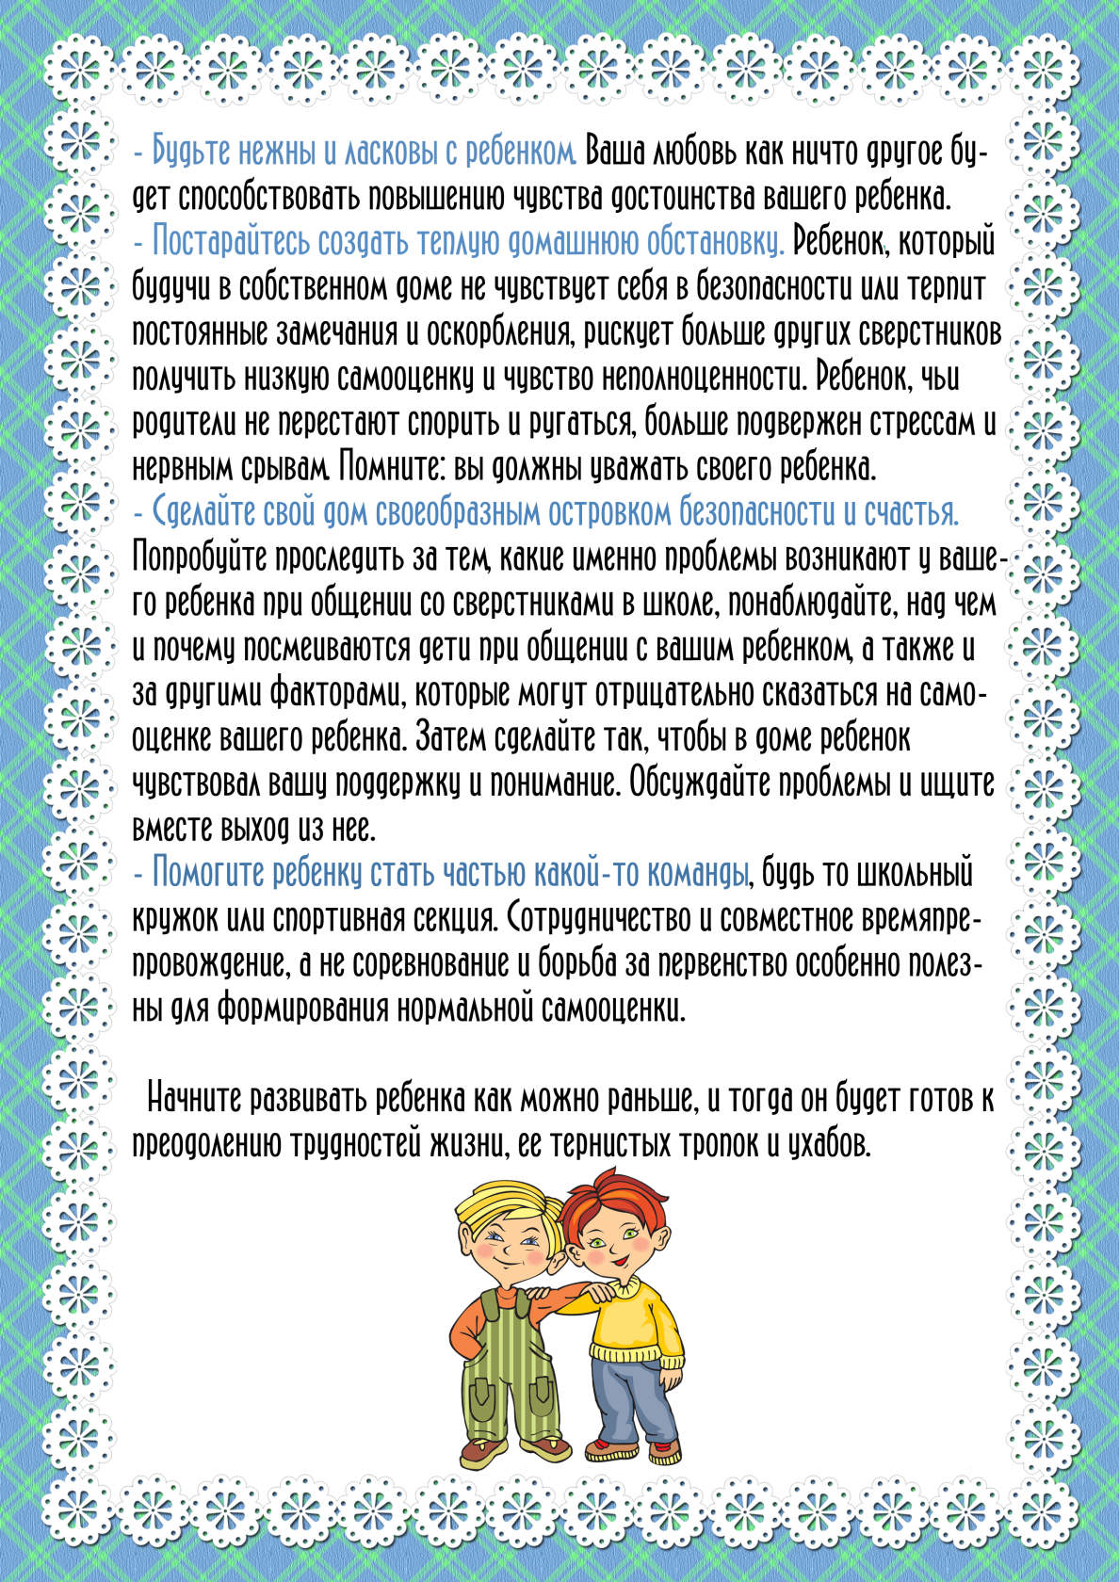](https://ok.ru/dk?cmd=PopLayerPhoto&st.layer.cmd=PopLayerPhotoOuter&st.layer.type=GROUP&st.layer.revNav=off&st.layer.limitedUi=false&st.layer.closeLayers=off&st.layer.sphotoIds=866277707587;866277707331;866277707075;866277706819;866277706563;866277706307&st.layer.showNav=on&st.layer.photoAlbumId=53073113251907&st.layer.epm=off&st.layer.photoId=866277706307&st.layer.opl=off&st.layer.navStartPhotoId=866277706307&st.layer.sbd=off&st.cmd=userMain&st._aid=GroupTopicLayer_openPhotoLayer)