**Стихи о безопасном поведении в быту**

[](https://ok.ru/dk?cmd=PopLayerPhoto&st.layer.cmd=PopLayerPhotoOuter&st.layer.type=GROUP&st.layer.revNav=off&st.layer.limitedUi=false&st.layer.closeLayers=off&st.layer.sphotoIds=877166410548;877166410804;877166411060;877166411316;877166411572;877166411828;877166412084;877166412340;877166412596&st.layer.showNav=on&st.layer.photoAlbumId=57249062780980&st.layer.epm=off&st.layer.photoId=877166410548&st.layer.opl=off&st.layer.navStartPhotoId=877166410548&st.layer.sbd=off&st.cmd=userMain&st._aid=GroupTopicLayer_openPhotoLayer)

[](https://ok.ru/dk?cmd=PopLayerPhoto&st.layer.cmd=PopLayerPhotoOuter&st.layer.type=GROUP&st.layer.revNav=off&st.layer.limitedUi=false&st.layer.closeLayers=off&st.layer.sphotoIds=877166410548;877166410804;877166411060;877166411316;877166411572;877166411828;877166412084;877166412340;877166412596&st.layer.showNav=on&st.layer.photoAlbumId=57249062780980&st.layer.epm=off&st.layer.photoId=877166410804&st.layer.opl=off&st.layer.navStartPhotoId=877166410804&st.layer.sbd=off&st.cmd=userMain&st._aid=GroupTopicLayer_openPhotoLayer)

[](https://ok.ru/dk?cmd=PopLayerPhoto&st.layer.cmd=PopLayerPhotoOuter&st.layer.type=GROUP&st.layer.revNav=off&st.layer.limitedUi=false&st.layer.closeLayers=off&st.layer.sphotoIds=877166410548;877166410804;877166411060;877166411316;877166411572;877166411828;877166412084;877166412340;877166412596&st.layer.showNav=on&st.layer.photoAlbumId=57249062780980&st.layer.epm=off&st.layer.photoId=877166411060&st.layer.opl=off&st.layer.navStartPhotoId=877166411060&st.layer.sbd=off&st.cmd=userMain&st._aid=GroupTopicLayer_openPhotoLayer)

[](https://ok.ru/dk?cmd=PopLayerPhoto&st.layer.cmd=PopLayerPhotoOuter&st.layer.type=GROUP&st.layer.revNav=off&st.layer.limitedUi=false&st.layer.closeLayers=off&st.layer.sphotoIds=877166410548;877166410804;877166411060;877166411316;877166411572;877166411828;877166412084;877166412340;877166412596&st.layer.showNav=on&st.layer.photoAlbumId=57249062780980&st.layer.epm=off&st.layer.photoId=877166411316&st.layer.opl=off&st.layer.navStartPhotoId=877166411316&st.layer.sbd=off&st.cmd=userMain&st._aid=GroupTopicLayer_openPhotoLayer)

[](https://ok.ru/dk?cmd=PopLayerPhoto&st.layer.cmd=PopLayerPhotoOuter&st.layer.type=GROUP&st.layer.revNav=off&st.layer.limitedUi=false&st.layer.closeLayers=off&st.layer.sphotoIds=877166410548;877166410804;877166411060;877166411316;877166411572;877166411828;877166412084;877166412340;877166412596&st.layer.showNav=on&st.layer.photoAlbumId=57249062780980&st.layer.epm=off&st.layer.photoId=877166411572&st.layer.opl=off&st.layer.navStartPhotoId=877166411572&st.layer.sbd=off&st.cmd=userMain&st._aid=GroupTopicLayer_openPhotoLayer)

[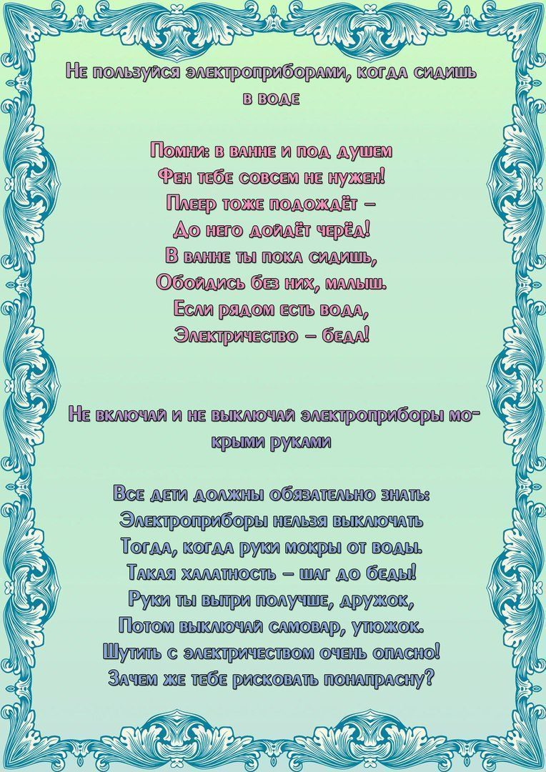](https://ok.ru/dk?cmd=PopLayerPhoto&st.layer.cmd=PopLayerPhotoOuter&st.layer.type=GROUP&st.layer.revNav=off&st.layer.limitedUi=false&st.layer.closeLayers=off&st.layer.sphotoIds=877166410548;877166410804;877166411060;877166411316;877166411572;877166411828;877166412084;877166412340;877166412596&st.layer.showNav=on&st.layer.photoAlbumId=57249062780980&st.layer.epm=off&st.layer.photoId=877166411828&st.layer.opl=off&st.layer.navStartPhotoId=877166411828&st.layer.sbd=off&st.cmd=userMain&st._aid=GroupTopicLayer_openPhotoLayer)

[](https://ok.ru/dk?cmd=PopLayerPhoto&st.layer.cmd=PopLayerPhotoOuter&st.layer.type=GROUP&st.layer.revNav=off&st.layer.limitedUi=false&st.layer.closeLayers=off&st.layer.sphotoIds=877166410548;877166410804;877166411060;877166411316;877166411572;877166411828;877166412084;877166412340;877166412596&st.layer.showNav=on&st.layer.photoAlbumId=57249062780980&st.layer.epm=off&st.layer.photoId=877166412084&st.layer.opl=off&st.layer.navStartPhotoId=877166412084&st.layer.sbd=off&st.cmd=userMain&st._aid=GroupTopicLayer_openPhotoLayer)

[](https://ok.ru/dk?cmd=PopLayerPhoto&st.layer.cmd=PopLayerPhotoOuter&st.layer.type=GROUP&st.layer.revNav=off&st.layer.limitedUi=false&st.layer.closeLayers=off&st.layer.sphotoIds=877166410548;877166410804;877166411060;877166411316;877166411572;877166411828;877166412084;877166412340;877166412596&st.layer.showNav=on&st.layer.photoAlbumId=57249062780980&st.layer.epm=off&st.layer.photoId=877166412340&st.layer.opl=off&st.layer.navStartPhotoId=877166412340&st.layer.sbd=off&st.cmd=userMain&st._aid=GroupTopicLayer_openPhotoLayer)

[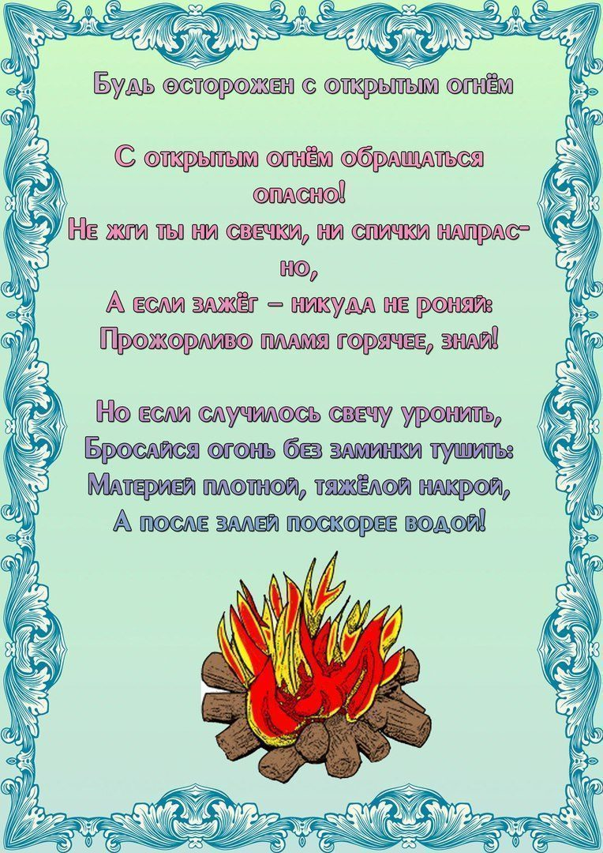](https://ok.ru/dk?cmd=PopLayerPhoto&st.layer.cmd=PopLayerPhotoOuter&st.layer.type=GROUP&st.layer.revNav=off&st.layer.limitedUi=false&st.layer.closeLayers=off&st.layer.sphotoIds=877166410548;877166410804;877166411060;877166411316;877166411572;877166411828;877166412084;877166412340;877166412596&st.layer.showNav=on&st.layer.photoAlbumId=57249062780980&st.layer.epm=off&st.layer.photoId=877166412596&st.layer.opl=off&st.layer.navStartPhotoId=877166412596&st.layer.sbd=off&st.cmd=userMain&st._aid=GroupTopicLayer_openPhotoLayer)