[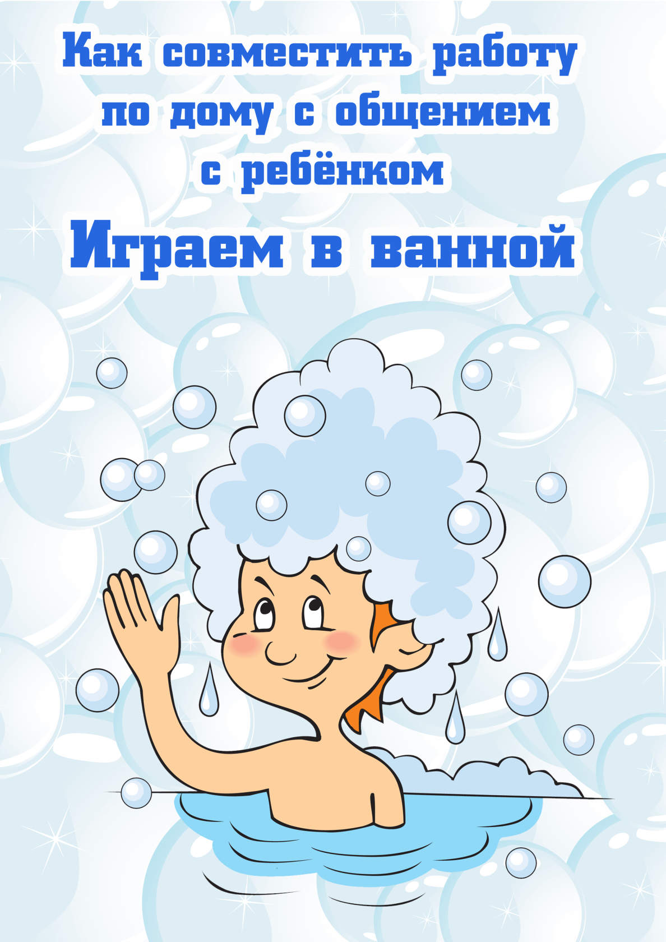](https://ok.ru/dk?cmd=PopLayerPhoto&st.layer.cmd=PopLayerPhotoOuter&st.layer.type=GROUP&st.layer.revNav=off&st.layer.limitedUi=false&st.layer.closeLayers=off&st.layer.sphotoIds=866827876675;866827876419;866827876163;866827875907;866827875651&st.layer.showNav=on&st.layer.photoAlbumId=53073113251907&st.layer.epm=off&st.layer.photoId=866827876675&st.layer.opl=off&st.layer.navStartPhotoId=866827876675&st.layer.sbd=off&st.cmd=userMain&st._aid=GroupTopicLayer_openPhotoLayer)

[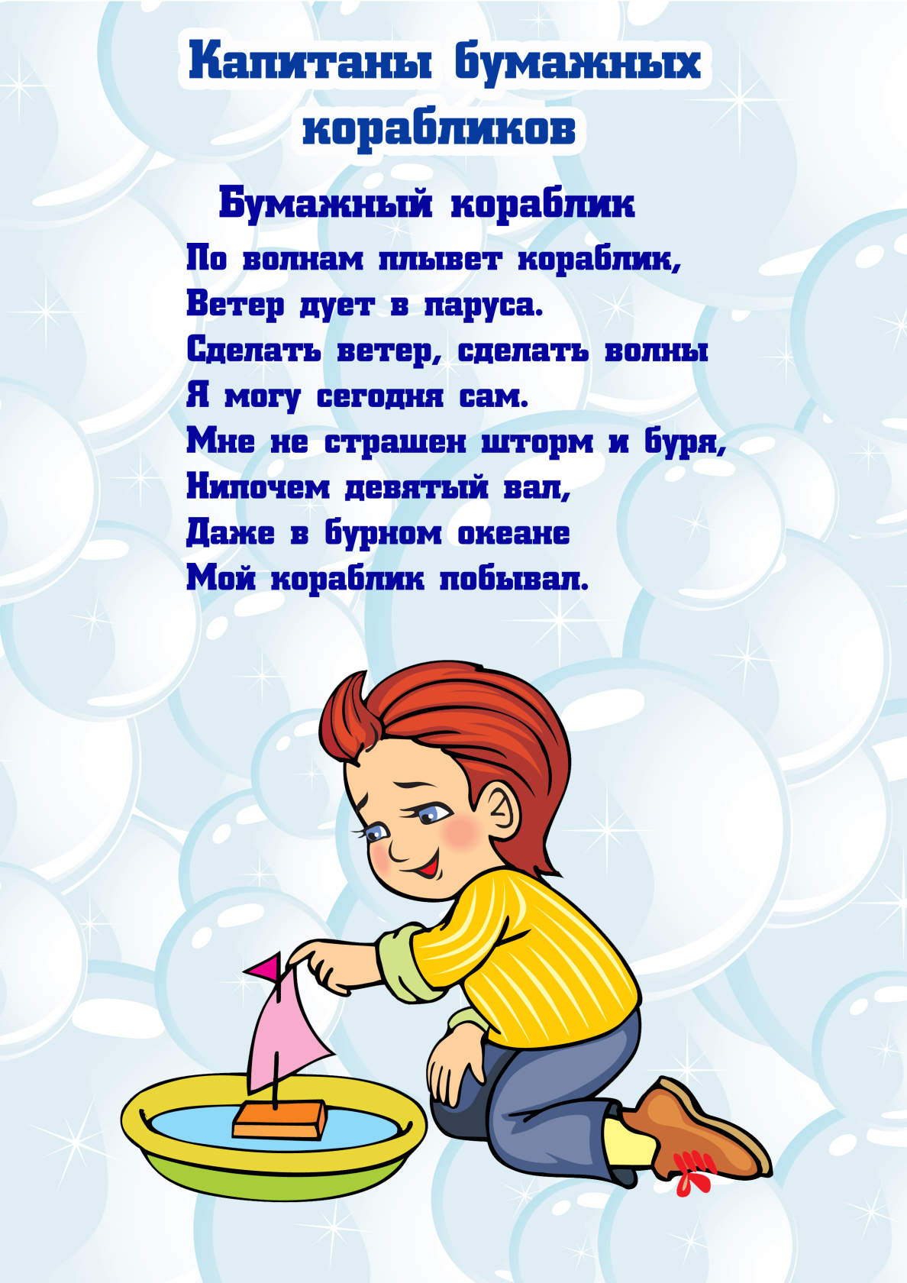](https://ok.ru/dk?cmd=PopLayerPhoto&st.layer.cmd=PopLayerPhotoOuter&st.layer.type=GROUP&st.layer.revNav=off&st.layer.limitedUi=false&st.layer.closeLayers=off&st.layer.sphotoIds=866827876675;866827876419;866827876163;866827875907;866827875651&st.layer.showNav=on&st.layer.photoAlbumId=53073113251907&st.layer.epm=off&st.layer.photoId=866827876419&st.layer.opl=off&st.layer.navStartPhotoId=866827876419&st.layer.sbd=off&st.cmd=userMain&st._aid=GroupTopicLayer_openPhotoLayer)

[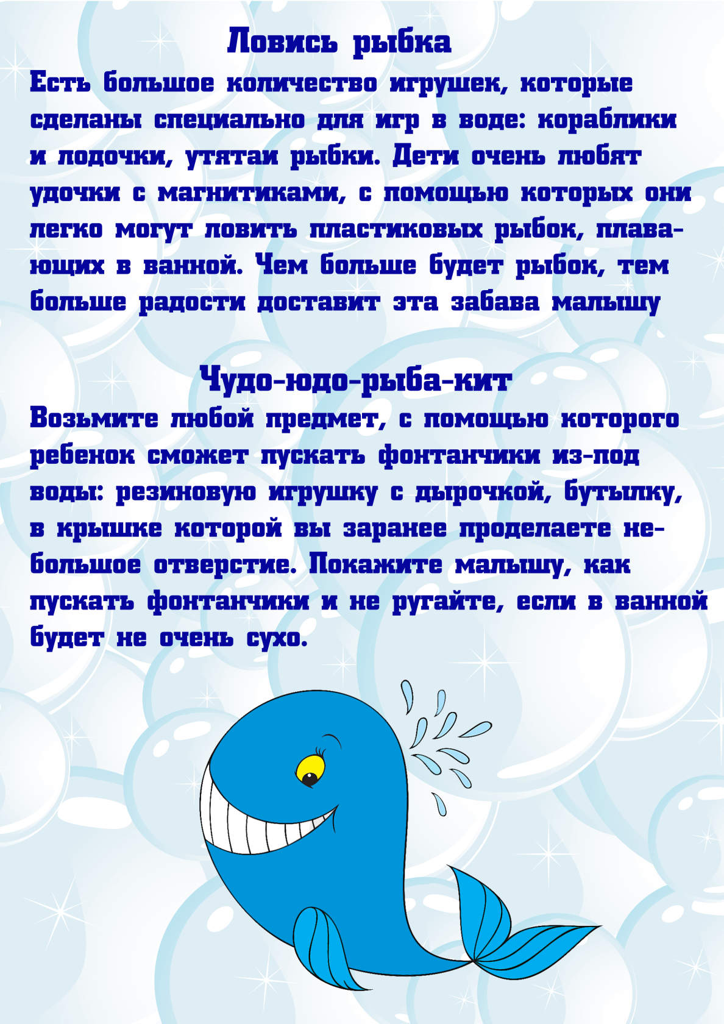](https://ok.ru/dk?cmd=PopLayerPhoto&st.layer.cmd=PopLayerPhotoOuter&st.layer.type=GROUP&st.layer.revNav=off&st.layer.limitedUi=false&st.layer.closeLayers=off&st.layer.sphotoIds=866827876675;866827876419;866827876163;866827875907;866827875651&st.layer.showNav=on&st.layer.photoAlbumId=53073113251907&st.layer.epm=off&st.layer.photoId=866827876163&st.layer.opl=off&st.layer.navStartPhotoId=866827876163&st.layer.sbd=off&st.cmd=userMain&st._aid=GroupTopicLayer_openPhotoLayer)

[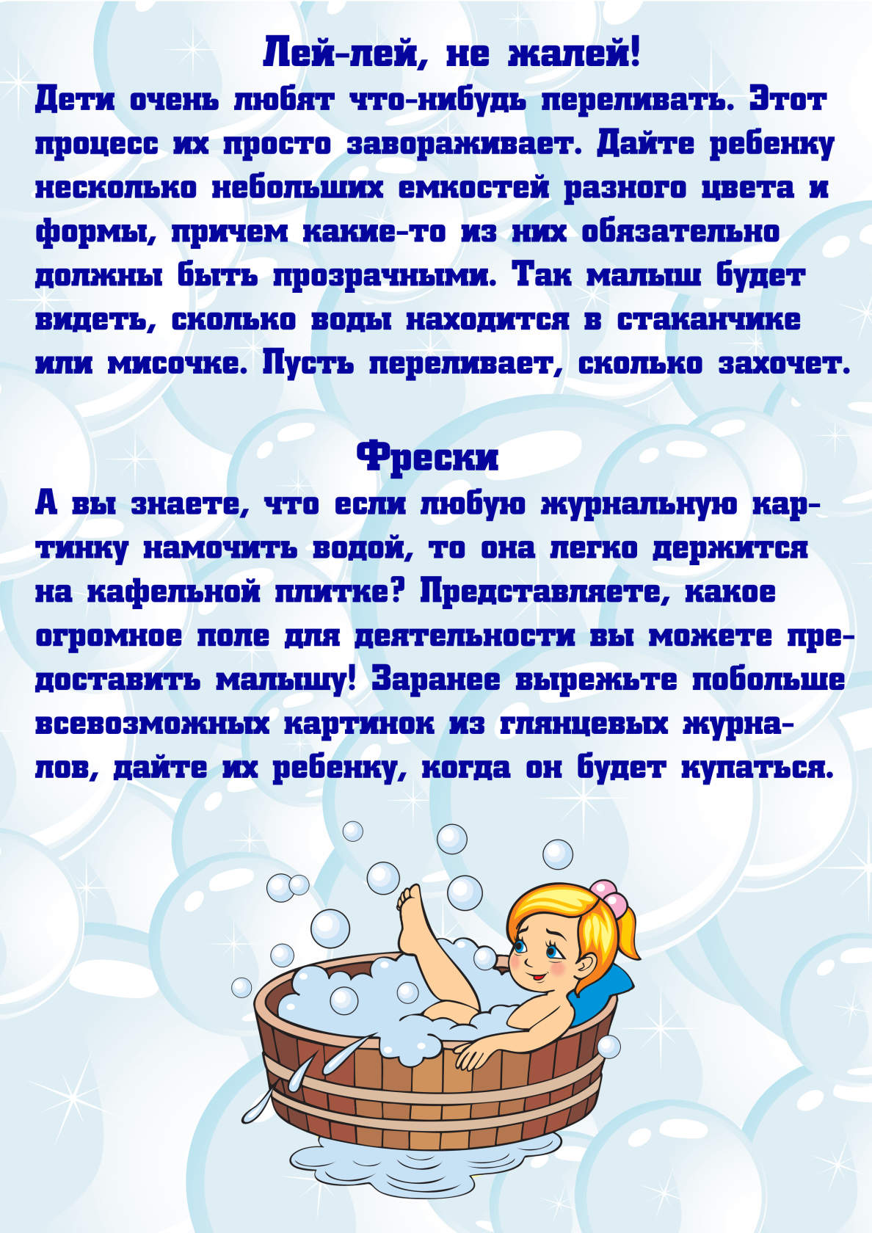](https://ok.ru/dk?cmd=PopLayerPhoto&st.layer.cmd=PopLayerPhotoOuter&st.layer.type=GROUP&st.layer.revNav=off&st.layer.limitedUi=false&st.layer.closeLayers=off&st.layer.sphotoIds=866827876675;866827876419;866827876163;866827875907;866827875651&st.layer.showNav=on&st.layer.photoAlbumId=53073113251907&st.layer.epm=off&st.layer.photoId=866827875907&st.layer.opl=off&st.layer.navStartPhotoId=866827875907&st.layer.sbd=off&st.cmd=userMain&st._aid=GroupTopicLayer_openPhotoLayer)

[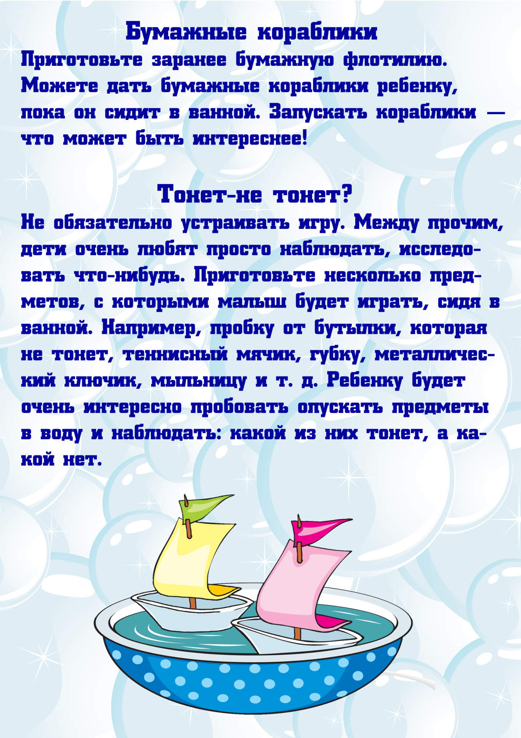](https://ok.ru/dk?cmd=PopLayerPhoto&st.layer.cmd=PopLayerPhotoOuter&st.layer.type=GROUP&st.layer.revNav=off&st.layer.limitedUi=false&st.layer.closeLayers=off&st.layer.sphotoIds=866827876675;866827876419;866827876163;866827875907;866827875651&st.layer.showNav=on&st.layer.photoAlbumId=53073113251907&st.layer.epm=off&st.layer.photoId=866827875651&st.layer.opl=off&st.layer.navStartPhotoId=866827875651&st.layer.sbd=off&st.cmd=userMain&st._aid=GroupTopicLayer_openPhotoLayer)