[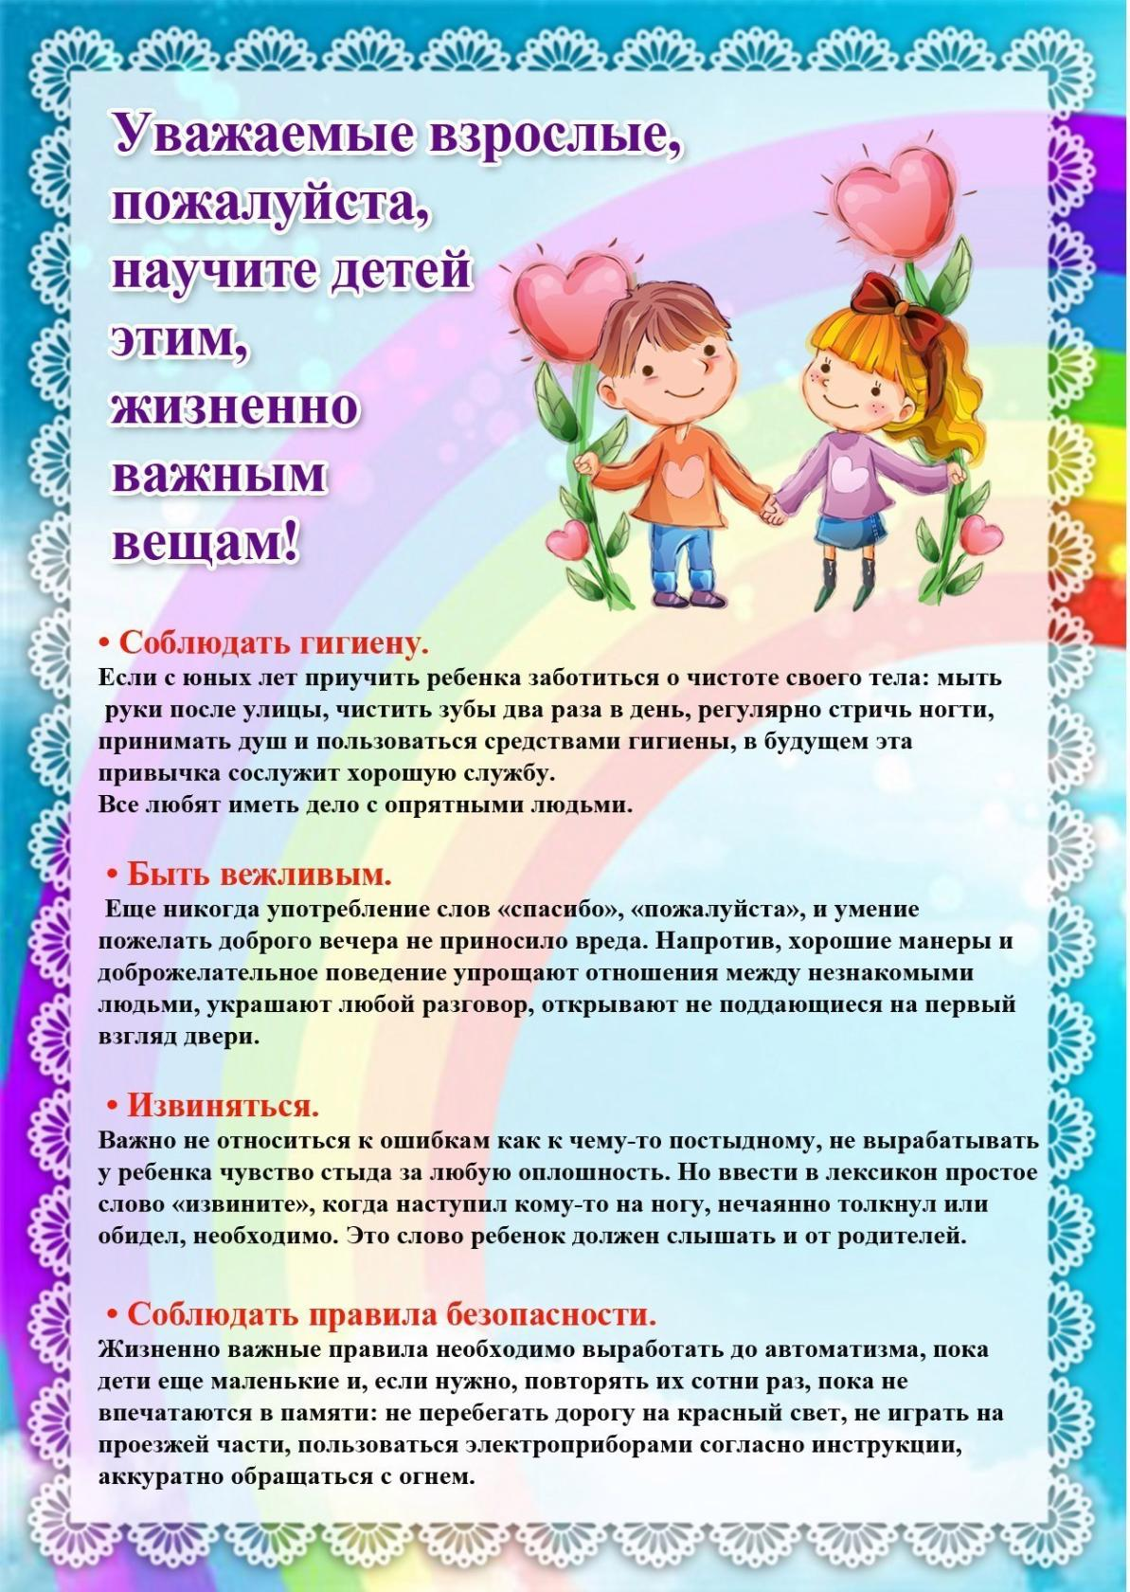](https://ok.ru/dk?cmd=PopLayerPhoto&st.layer.cmd=PopLayerPhotoOuter&st.layer.type=GROUP&st.layer.revNav=off&st.layer.limitedUi=false&st.layer.closeLayers=off&st.layer.sphotoIds=877493076532%3B877493076788%3B877493077044%3B877493077300%3B877493077556%3B877493077812&st.layer.showNav=on&st.layer.photoAlbumId=57249062780980&st.layer.epm=off&st.layer.photoId=877493076532&st.layer.opl=off&st.layer.navStartPhotoId=877493076532&st.layer.sbd=off&st.cmd=userMain&st._aid=GroupTopicLayer_openPhotoLayer)

[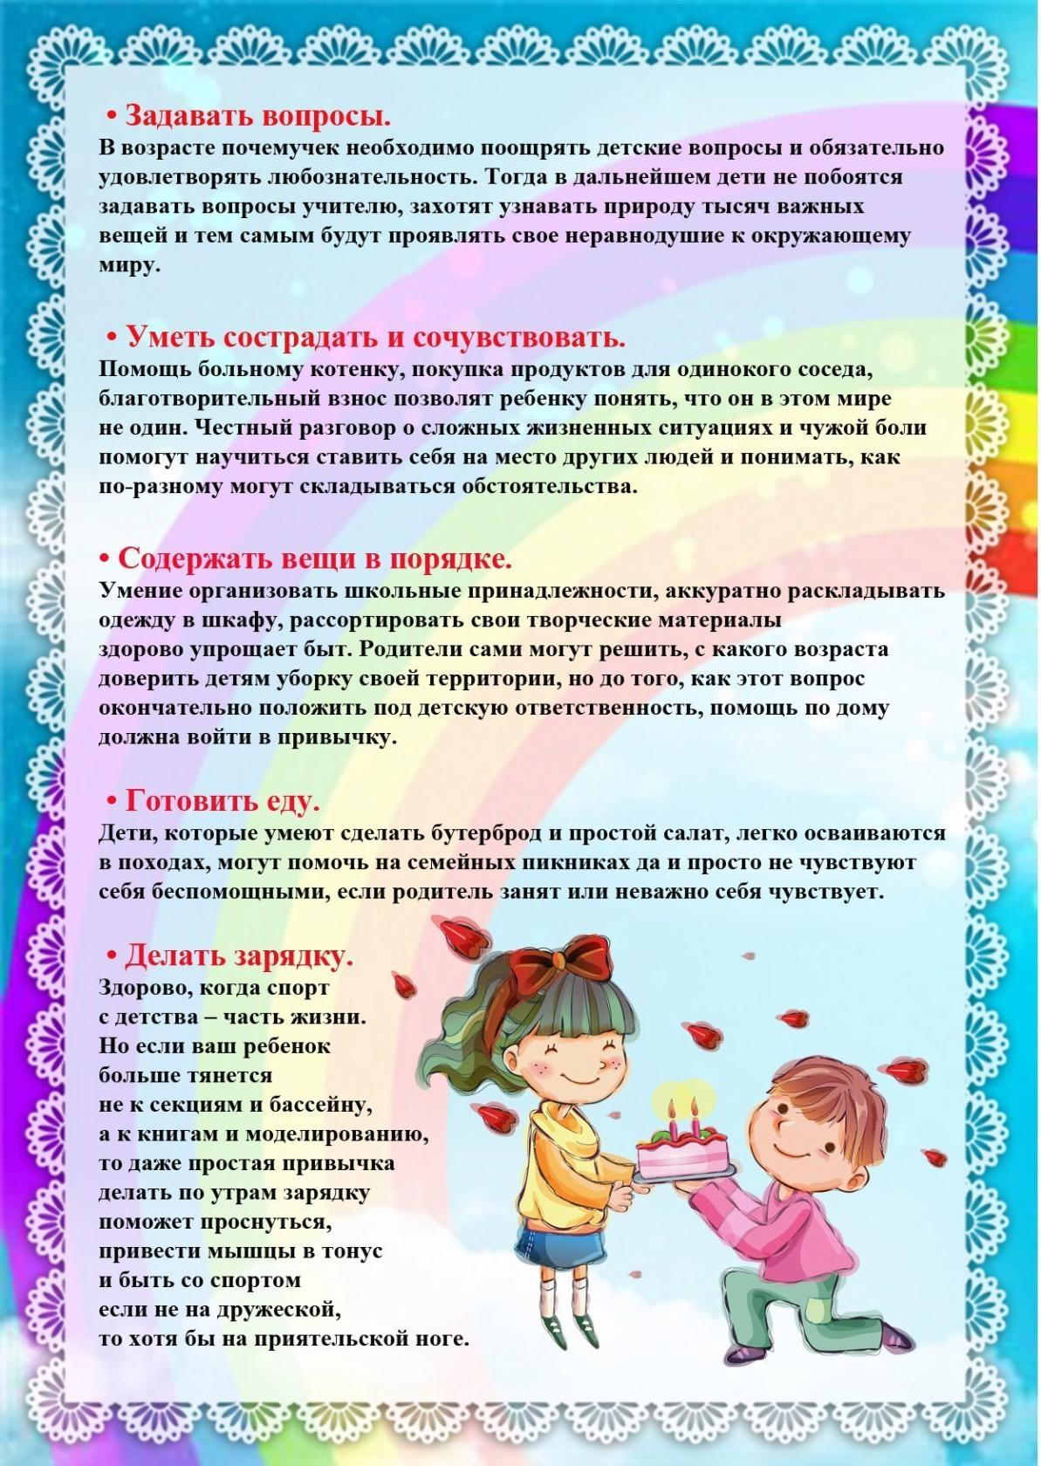](https://ok.ru/dk?cmd=PopLayerPhoto&st.layer.cmd=PopLayerPhotoOuter&st.layer.type=GROUP&st.layer.revNav=off&st.layer.limitedUi=false&st.layer.closeLayers=off&st.layer.sphotoIds=877493076532%3B877493076788%3B877493077044%3B877493077300%3B877493077556%3B877493077812&st.layer.showNav=on&st.layer.photoAlbumId=57249062780980&st.layer.epm=off&st.layer.photoId=877493076788&st.layer.opl=off&st.layer.navStartPhotoId=877493076788&st.layer.sbd=off&st.cmd=userMain&st._aid=GroupTopicLayer_openPhotoLayer)

[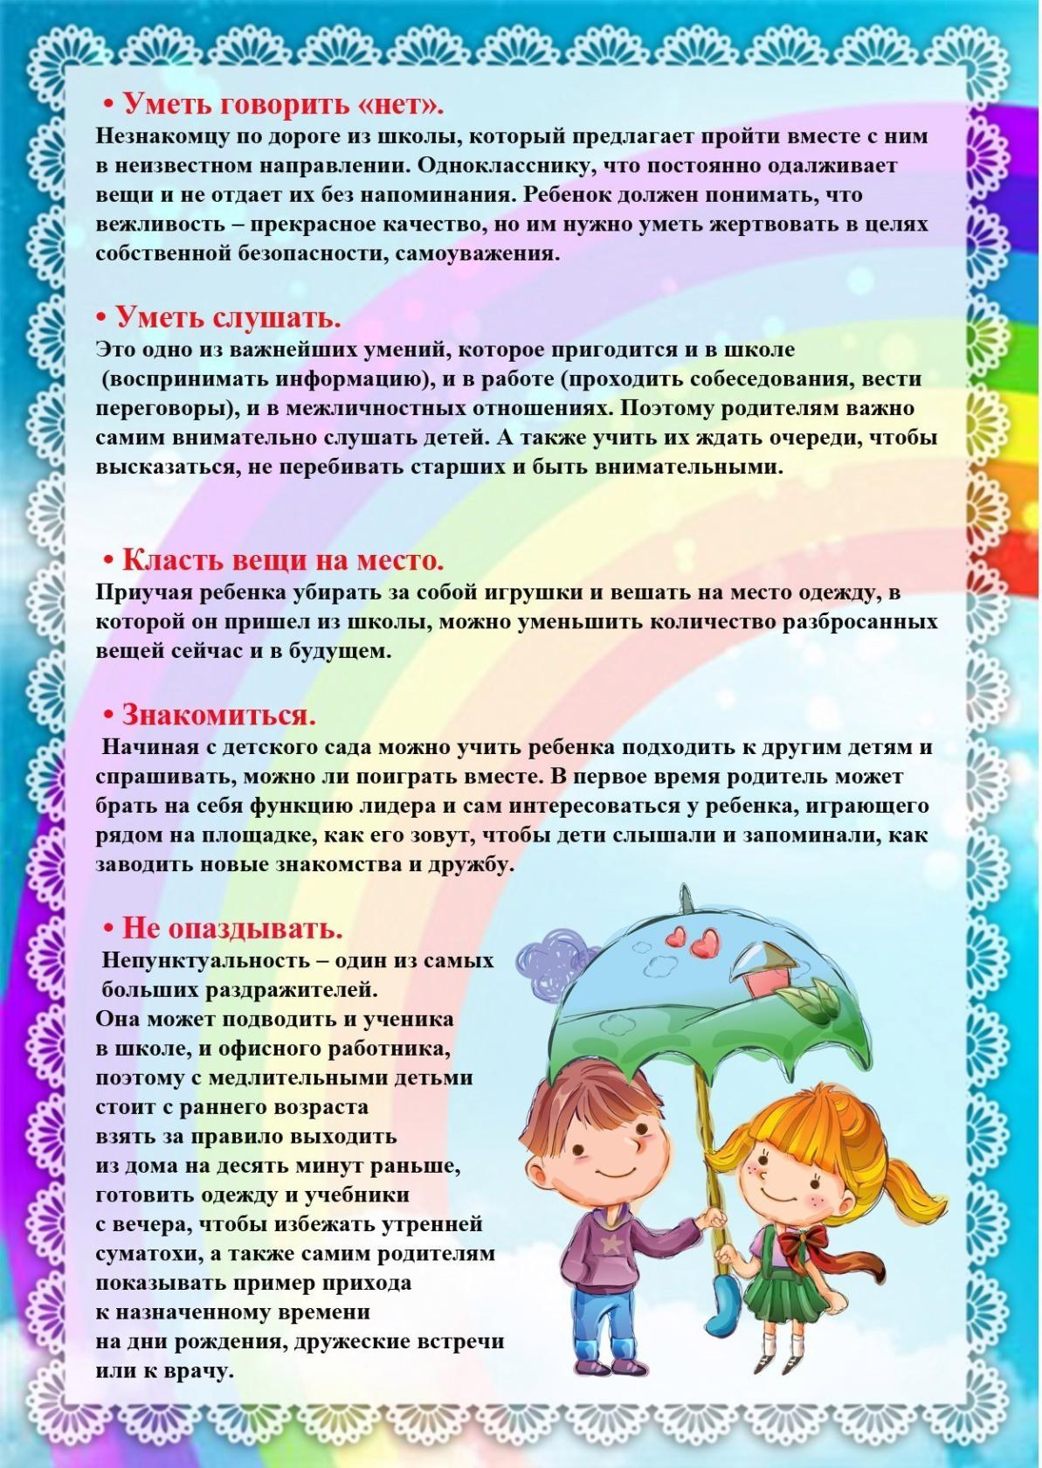](https://ok.ru/dk?cmd=PopLayerPhoto&st.layer.cmd=PopLayerPhotoOuter&st.layer.type=GROUP&st.layer.revNav=off&st.layer.limitedUi=false&st.layer.closeLayers=off&st.layer.sphotoIds=877493076532%3B877493076788%3B877493077044%3B877493077300%3B877493077556%3B877493077812&st.layer.showNav=on&st.layer.photoAlbumId=57249062780980&st.layer.epm=off&st.layer.photoId=877493077044&st.layer.opl=off&st.layer.navStartPhotoId=877493077044&st.layer.sbd=off&st.cmd=userMain&st._aid=GroupTopicLayer_openPhotoLayer)

[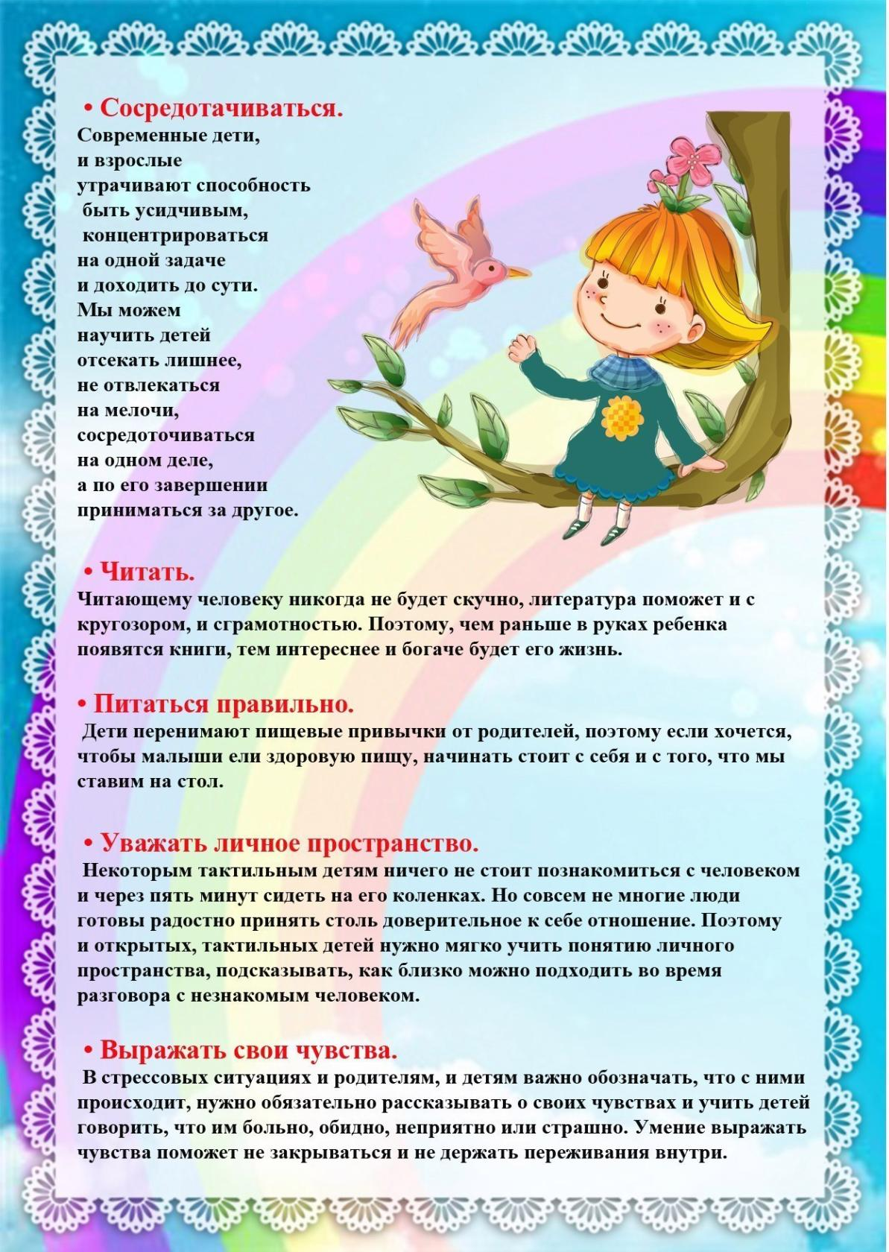](https://ok.ru/dk?cmd=PopLayerPhoto&st.layer.cmd=PopLayerPhotoOuter&st.layer.type=GROUP&st.layer.revNav=off&st.layer.limitedUi=false&st.layer.closeLayers=off&st.layer.sphotoIds=877493076532%3B877493076788%3B877493077044%3B877493077300%3B877493077556%3B877493077812&st.layer.showNav=on&st.layer.photoAlbumId=57249062780980&st.layer.epm=off&st.layer.photoId=877493077300&st.layer.opl=off&st.layer.navStartPhotoId=877493077300&st.layer.sbd=off&st.cmd=userMain&st._aid=GroupTopicLayer_openPhotoLayer)

[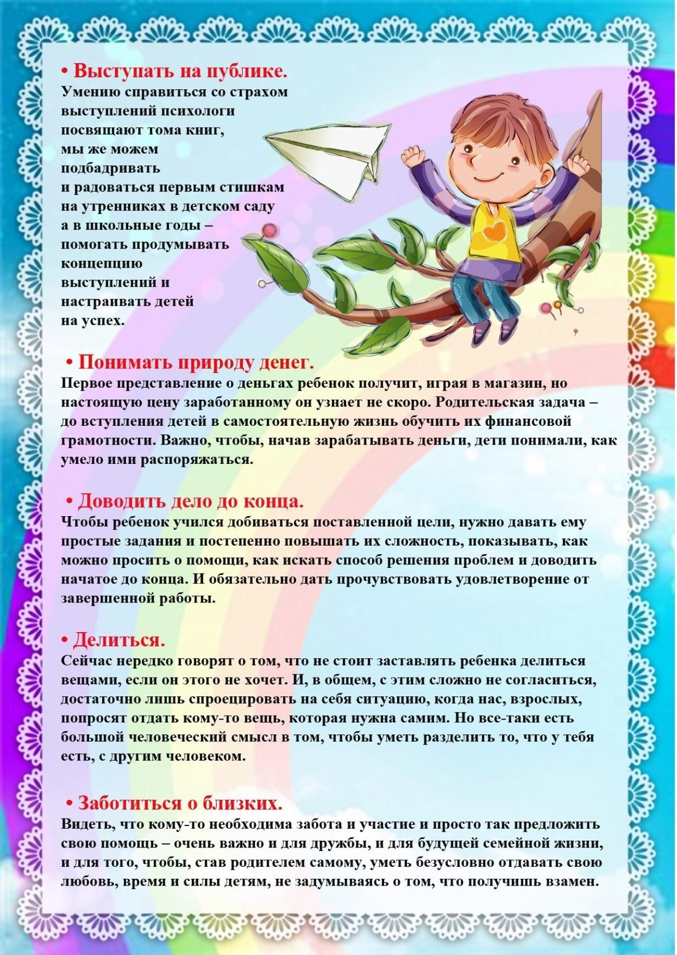](https://ok.ru/dk?cmd=PopLayerPhoto&st.layer.cmd=PopLayerPhotoOuter&st.layer.type=GROUP&st.layer.revNav=off&st.layer.limitedUi=false&st.layer.closeLayers=off&st.layer.sphotoIds=877493076532%3B877493076788%3B877493077044%3B877493077300%3B877493077556%3B877493077812&st.layer.showNav=on&st.layer.photoAlbumId=57249062780980&st.layer.epm=off&st.layer.photoId=877493077556&st.layer.opl=off&st.layer.navStartPhotoId=877493077556&st.layer.sbd=off&st.cmd=userMain&st._aid=GroupTopicLayer_openPhotoLayer)

[](https://ok.ru/dk?cmd=PopLayerPhoto&st.layer.cmd=PopLayerPhotoOuter&st.layer.type=GROUP&st.layer.revNav=off&st.layer.limitedUi=false&st.layer.closeLayers=off&st.layer.sphotoIds=877493076532%3B877493076788%3B877493077044%3B877493077300%3B877493077556%3B877493077812&st.layer.showNav=on&st.layer.photoAlbumId=57249062780980&st.layer.epm=off&st.layer.photoId=877493077812&st.layer.opl=off&st.layer.navStartPhotoId=877493077812&st.layer.sbd=off&st.cmd=userMain&st._aid=GroupTopicLayer_openPhotoLayer)