[](https://ok.ru/dk?cmd=PopLayerPhoto&st.layer.cmd=PopLayerPhotoOuter&st.layer.type=GROUP&st.layer.revNav=off&st.layer.limitedUi=false&st.layer.closeLayers=off&st.layer.sphotoIds=865782795075;865782794819;865782794563;865782794307;865782794051;865782793795&st.layer.showNav=on&st.layer.photoAlbumId=53073113251907&st.layer.epm=off&st.layer.photoId=865782795075&st.layer.opl=off&st.layer.navStartPhotoId=865782795075&st.layer.sbd=off&st.cmd=userMain&st._aid=GroupTopicLayer_openPhotoLayer)

[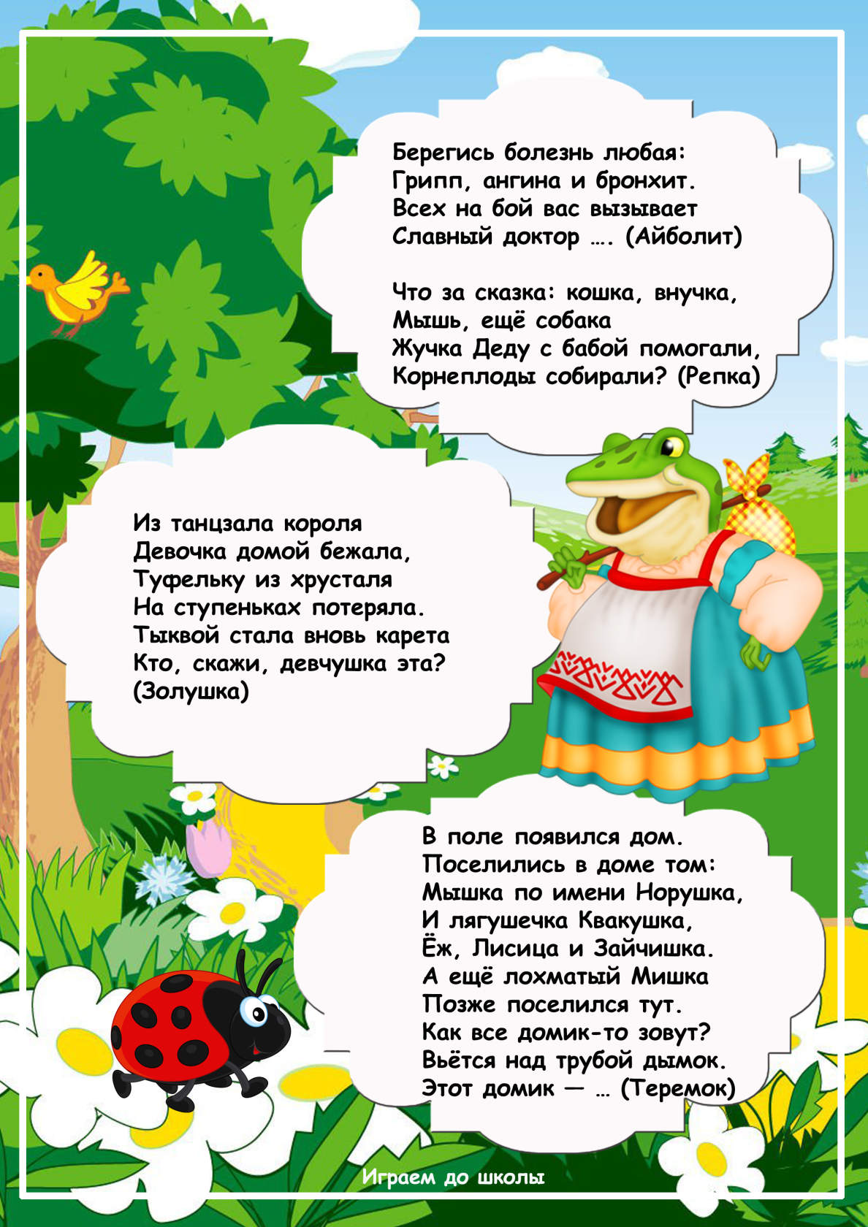](https://ok.ru/dk?cmd=PopLayerPhoto&st.layer.cmd=PopLayerPhotoOuter&st.layer.type=GROUP&st.layer.revNav=off&st.layer.limitedUi=false&st.layer.closeLayers=off&st.layer.sphotoIds=865782795075;865782794819;865782794563;865782794307;865782794051;865782793795&st.layer.showNav=on&st.layer.photoAlbumId=53073113251907&st.layer.epm=off&st.layer.photoId=865782794819&st.layer.opl=off&st.layer.navStartPhotoId=865782794819&st.layer.sbd=off&st.cmd=userMain&st._aid=GroupTopicLayer_openPhotoLayer)

[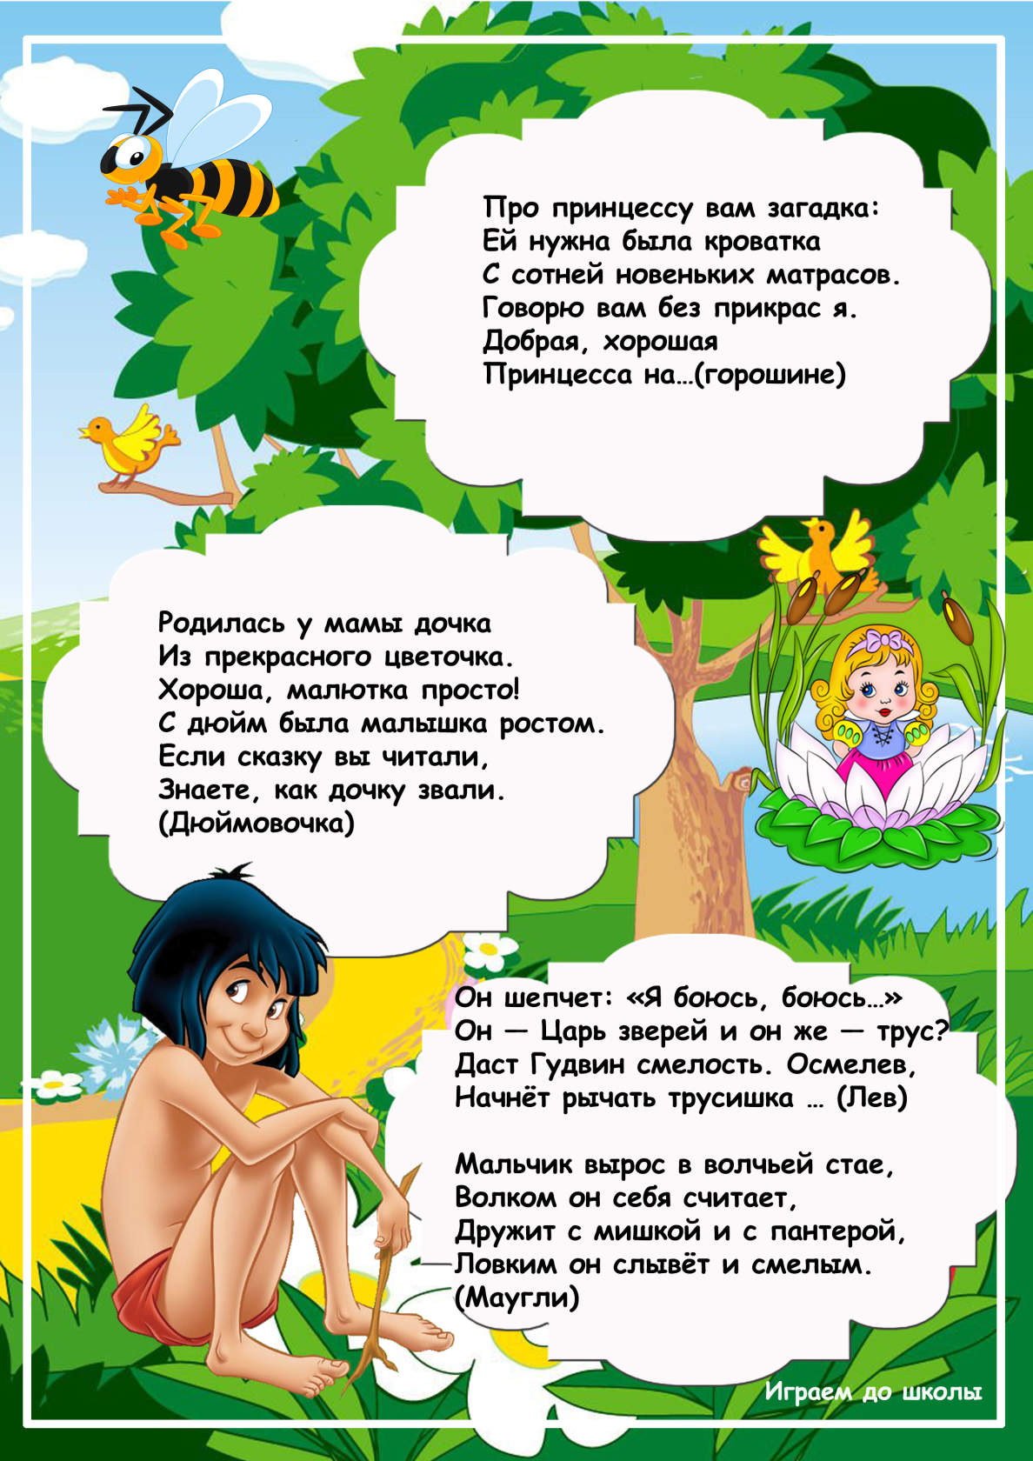](https://ok.ru/dk?cmd=PopLayerPhoto&st.layer.cmd=PopLayerPhotoOuter&st.layer.type=GROUP&st.layer.revNav=off&st.layer.limitedUi=false&st.layer.closeLayers=off&st.layer.sphotoIds=865782795075;865782794819;865782794563;865782794307;865782794051;865782793795&st.layer.showNav=on&st.layer.photoAlbumId=53073113251907&st.layer.epm=off&st.layer.photoId=865782794563&st.layer.opl=off&st.layer.navStartPhotoId=865782794563&st.layer.sbd=off&st.cmd=userMain&st._aid=GroupTopicLayer_openPhotoLayer)

[](https://ok.ru/dk?cmd=PopLayerPhoto&st.layer.cmd=PopLayerPhotoOuter&st.layer.type=GROUP&st.layer.revNav=off&st.layer.limitedUi=false&st.layer.closeLayers=off&st.layer.sphotoIds=865782795075;865782794819;865782794563;865782794307;865782794051;865782793795&st.layer.showNav=on&st.layer.photoAlbumId=53073113251907&st.layer.epm=off&st.layer.photoId=865782794307&st.layer.opl=off&st.layer.navStartPhotoId=865782794307&st.layer.sbd=off&st.cmd=userMain&st._aid=GroupTopicLayer_openPhotoLayer)

[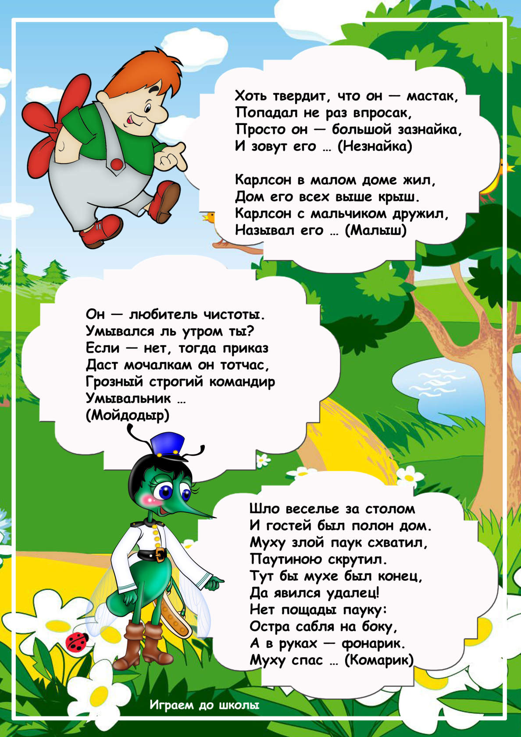](https://ok.ru/dk?cmd=PopLayerPhoto&st.layer.cmd=PopLayerPhotoOuter&st.layer.type=GROUP&st.layer.revNav=off&st.layer.limitedUi=false&st.layer.closeLayers=off&st.layer.sphotoIds=865782795075;865782794819;865782794563;865782794307;865782794051;865782793795&st.layer.showNav=on&st.layer.photoAlbumId=53073113251907&st.layer.epm=off&st.layer.photoId=865782794051&st.layer.opl=off&st.layer.navStartPhotoId=865782794051&st.layer.sbd=off&st.cmd=userMain&st._aid=GroupTopicLayer_openPhotoLayer)

[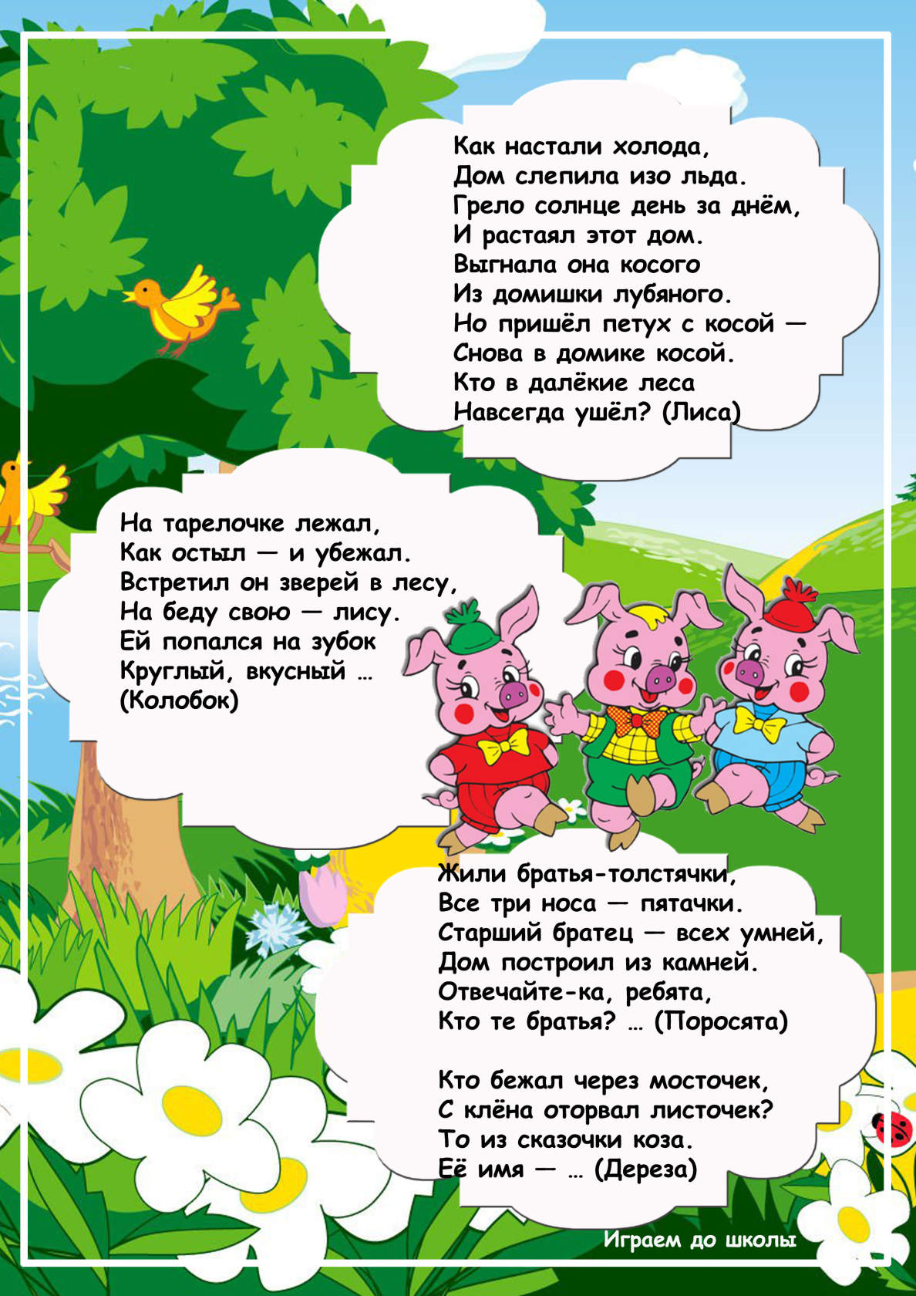](https://ok.ru/dk?cmd=PopLayerPhoto&st.layer.cmd=PopLayerPhotoOuter&st.layer.type=GROUP&st.layer.revNav=off&st.layer.limitedUi=false&st.layer.closeLayers=off&st.layer.sphotoIds=865782795075;865782794819;865782794563;865782794307;865782794051;865782793795&st.layer.showNav=on&st.layer.photoAlbumId=53073113251907&st.layer.epm=off&st.layer.photoId=865782793795&st.layer.opl=off&st.layer.navStartPhotoId=865782793795&st.layer.sbd=off&st.cmd=userMain&st._aid=GroupTopicLayer_openPhotoLayer)