[](https://ok.ru/dk?cmd=PopLayerPhoto&st.layer.cmd=PopLayerPhotoOuter&st.layer.type=GROUP&st.layer.revNav=off&st.layer.limitedUi=false&st.layer.closeLayers=off&st.layer.sphotoIds=865581837123;865581836867;865581836611;865581836355&st.layer.showNav=on&st.layer.photoAlbumId=53073113251907&st.layer.epm=off&st.layer.photoId=865581837123&st.layer.opl=off&st.layer.navStartPhotoId=865581837123&st.layer.sbd=off&st.cmd=userMain&st._aid=GroupTopicLayer_openPhotoLayer)

[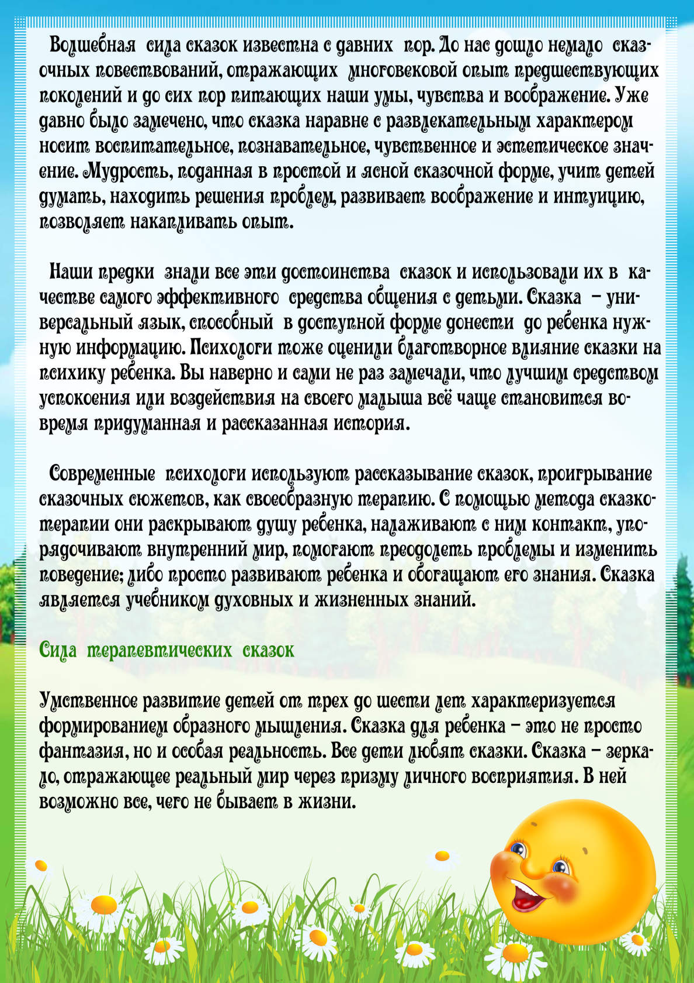](https://ok.ru/dk?cmd=PopLayerPhoto&st.layer.cmd=PopLayerPhotoOuter&st.layer.type=GROUP&st.layer.revNav=off&st.layer.limitedUi=false&st.layer.closeLayers=off&st.layer.sphotoIds=865581837123;865581836867;865581836611;865581836355&st.layer.showNav=on&st.layer.photoAlbumId=53073113251907&st.layer.epm=off&st.layer.photoId=865581836867&st.layer.opl=off&st.layer.navStartPhotoId=865581836867&st.layer.sbd=off&st.cmd=userMain&st._aid=GroupTopicLayer_openPhotoLayer)

[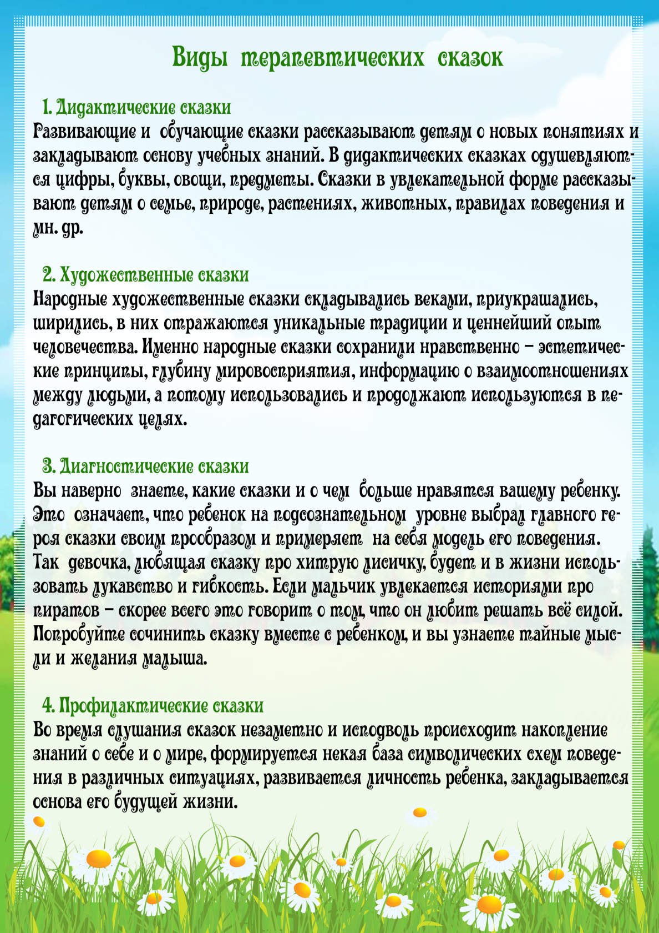](https://ok.ru/dk?cmd=PopLayerPhoto&st.layer.cmd=PopLayerPhotoOuter&st.layer.type=GROUP&st.layer.revNav=off&st.layer.limitedUi=false&st.layer.closeLayers=off&st.layer.sphotoIds=865581837123;865581836867;865581836611;865581836355&st.layer.showNav=on&st.layer.photoAlbumId=53073113251907&st.layer.epm=off&st.layer.photoId=865581836611&st.layer.opl=off&st.layer.navStartPhotoId=865581836611&st.layer.sbd=off&st.cmd=userMain&st._aid=GroupTopicLayer_openPhotoLayer)

[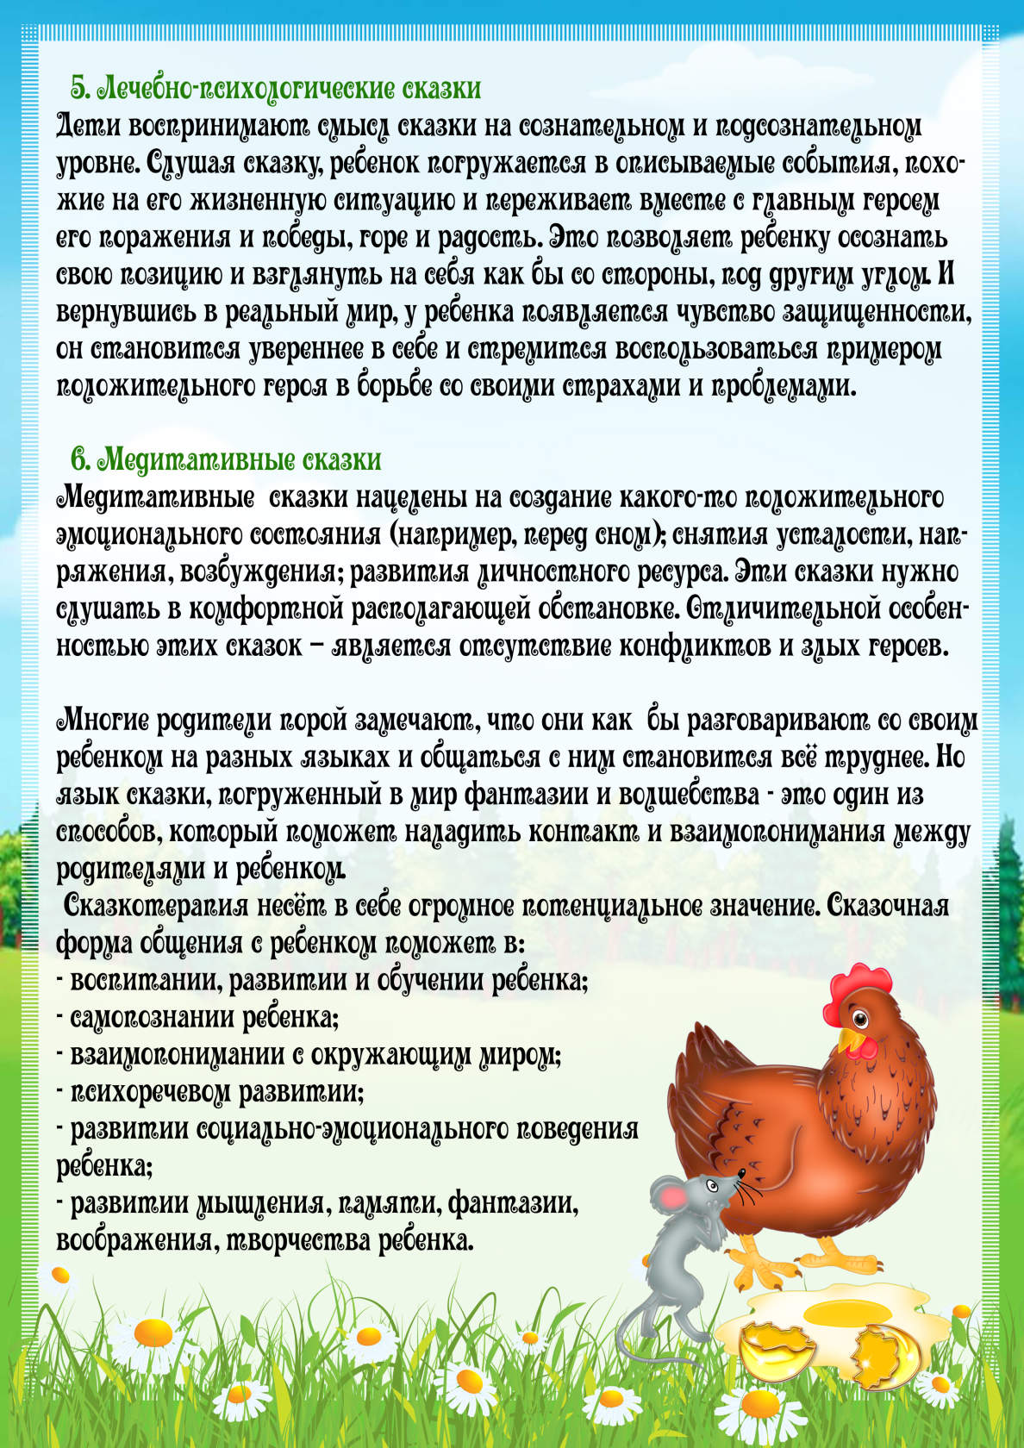](https://ok.ru/dk?cmd=PopLayerPhoto&st.layer.cmd=PopLayerPhotoOuter&st.layer.type=GROUP&st.layer.revNav=off&st.layer.limitedUi=false&st.layer.closeLayers=off&st.layer.sphotoIds=865581837123;865581836867;865581836611;865581836355&st.layer.showNav=on&st.layer.photoAlbumId=53073113251907&st.layer.epm=off&st.layer.photoId=865581836355&st.layer.opl=off&st.layer.navStartPhotoId=865581836355&st.layer.sbd=off&st.cmd=userMain&st._aid=GroupTopicLayer_openPhotoLayer)