[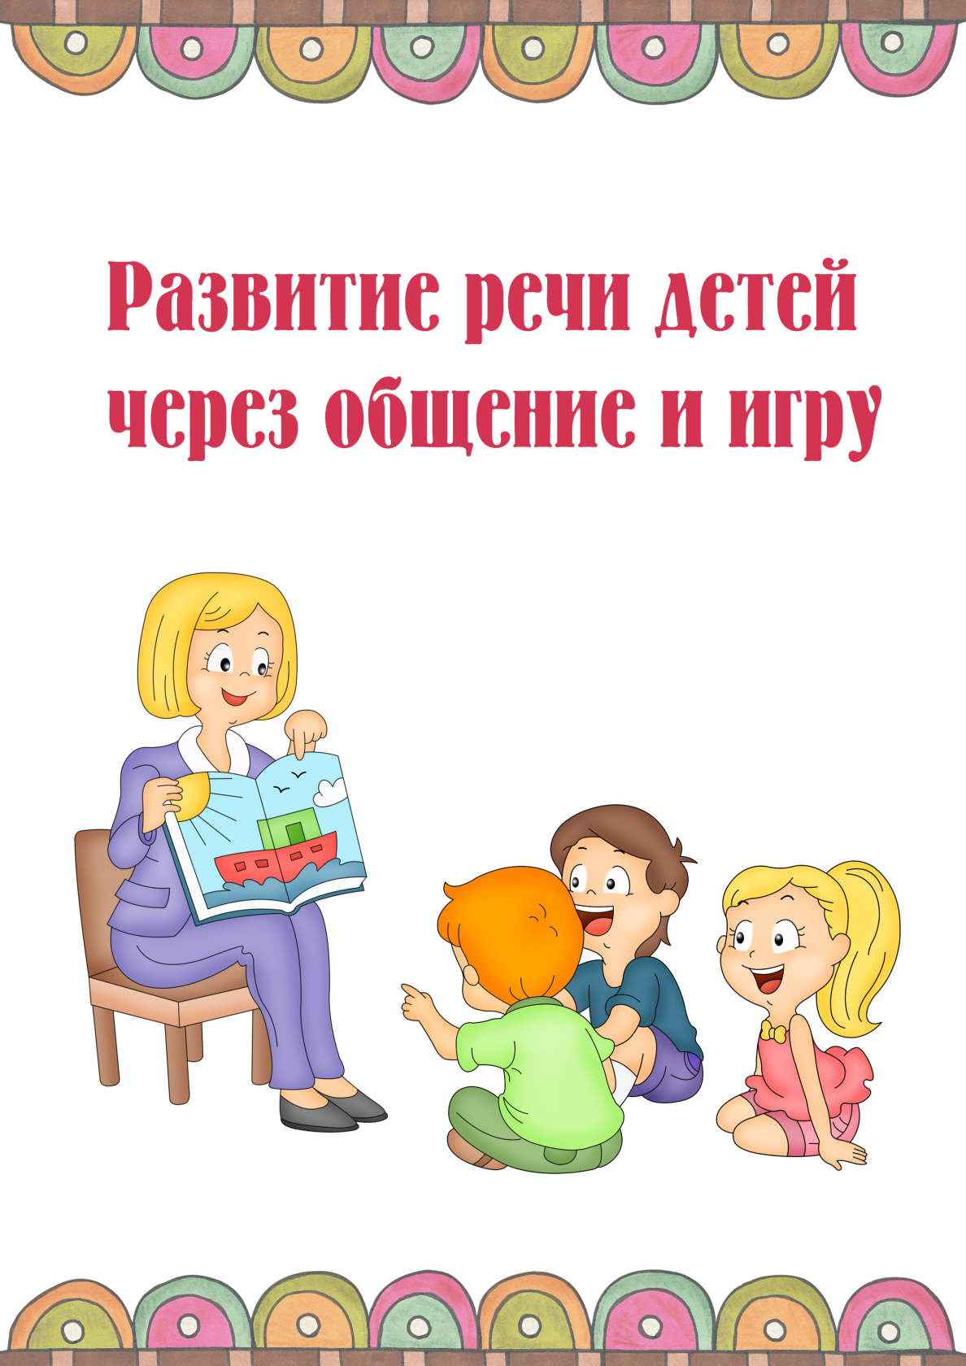](https://ok.ru/dk?cmd=PopLayerPhoto&st.layer.cmd=PopLayerPhotoOuter&st.layer.type=GROUP&st.layer.revNav=off&st.layer.limitedUi=false&st.layer.closeLayers=off&st.layer.sphotoIds=866062305603;866062305347;866062305091;866062304835;866062304579&st.layer.showNav=on&st.layer.photoAlbumId=53073113251907&st.layer.epm=off&st.layer.photoId=866062305603&st.layer.opl=off&st.layer.navStartPhotoId=866062305603&st.layer.sbd=off&st.cmd=userMain&st._aid=GroupTopicLayer_openPhotoLayer)

[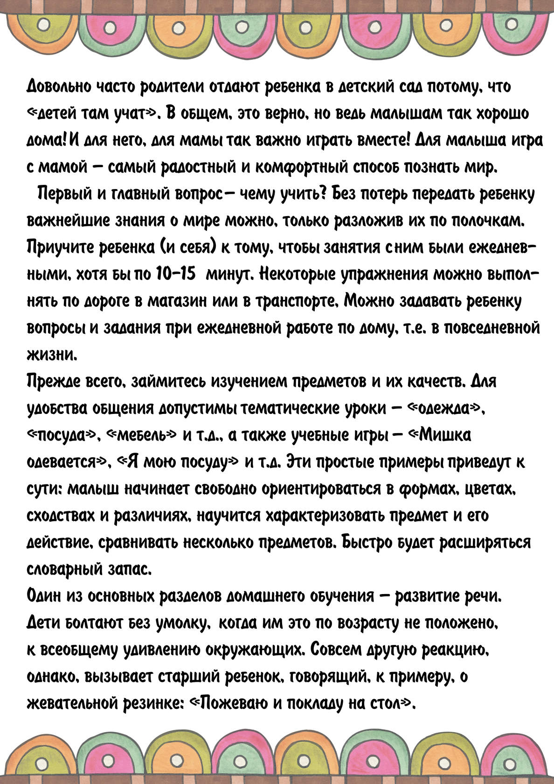](https://ok.ru/dk?cmd=PopLayerPhoto&st.layer.cmd=PopLayerPhotoOuter&st.layer.type=GROUP&st.layer.revNav=off&st.layer.limitedUi=false&st.layer.closeLayers=off&st.layer.sphotoIds=866062305603;866062305347;866062305091;866062304835;866062304579&st.layer.showNav=on&st.layer.photoAlbumId=53073113251907&st.layer.epm=off&st.layer.photoId=866062305347&st.layer.opl=off&st.layer.navStartPhotoId=866062305347&st.layer.sbd=off&st.cmd=userMain&st._aid=GroupTopicLayer_openPhotoLayer)

[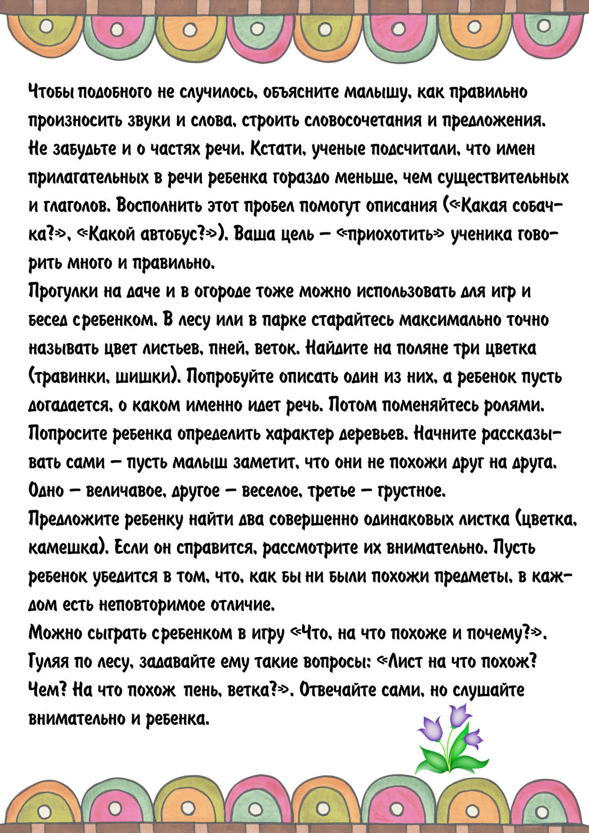](https://ok.ru/dk?cmd=PopLayerPhoto&st.layer.cmd=PopLayerPhotoOuter&st.layer.type=GROUP&st.layer.revNav=off&st.layer.limitedUi=false&st.layer.closeLayers=off&st.layer.sphotoIds=866062305603;866062305347;866062305091;866062304835;866062304579&st.layer.showNav=on&st.layer.photoAlbumId=53073113251907&st.layer.epm=off&st.layer.photoId=866062305091&st.layer.opl=off&st.layer.navStartPhotoId=866062305091&st.layer.sbd=off&st.cmd=userMain&st._aid=GroupTopicLayer_openPhotoLayer)

[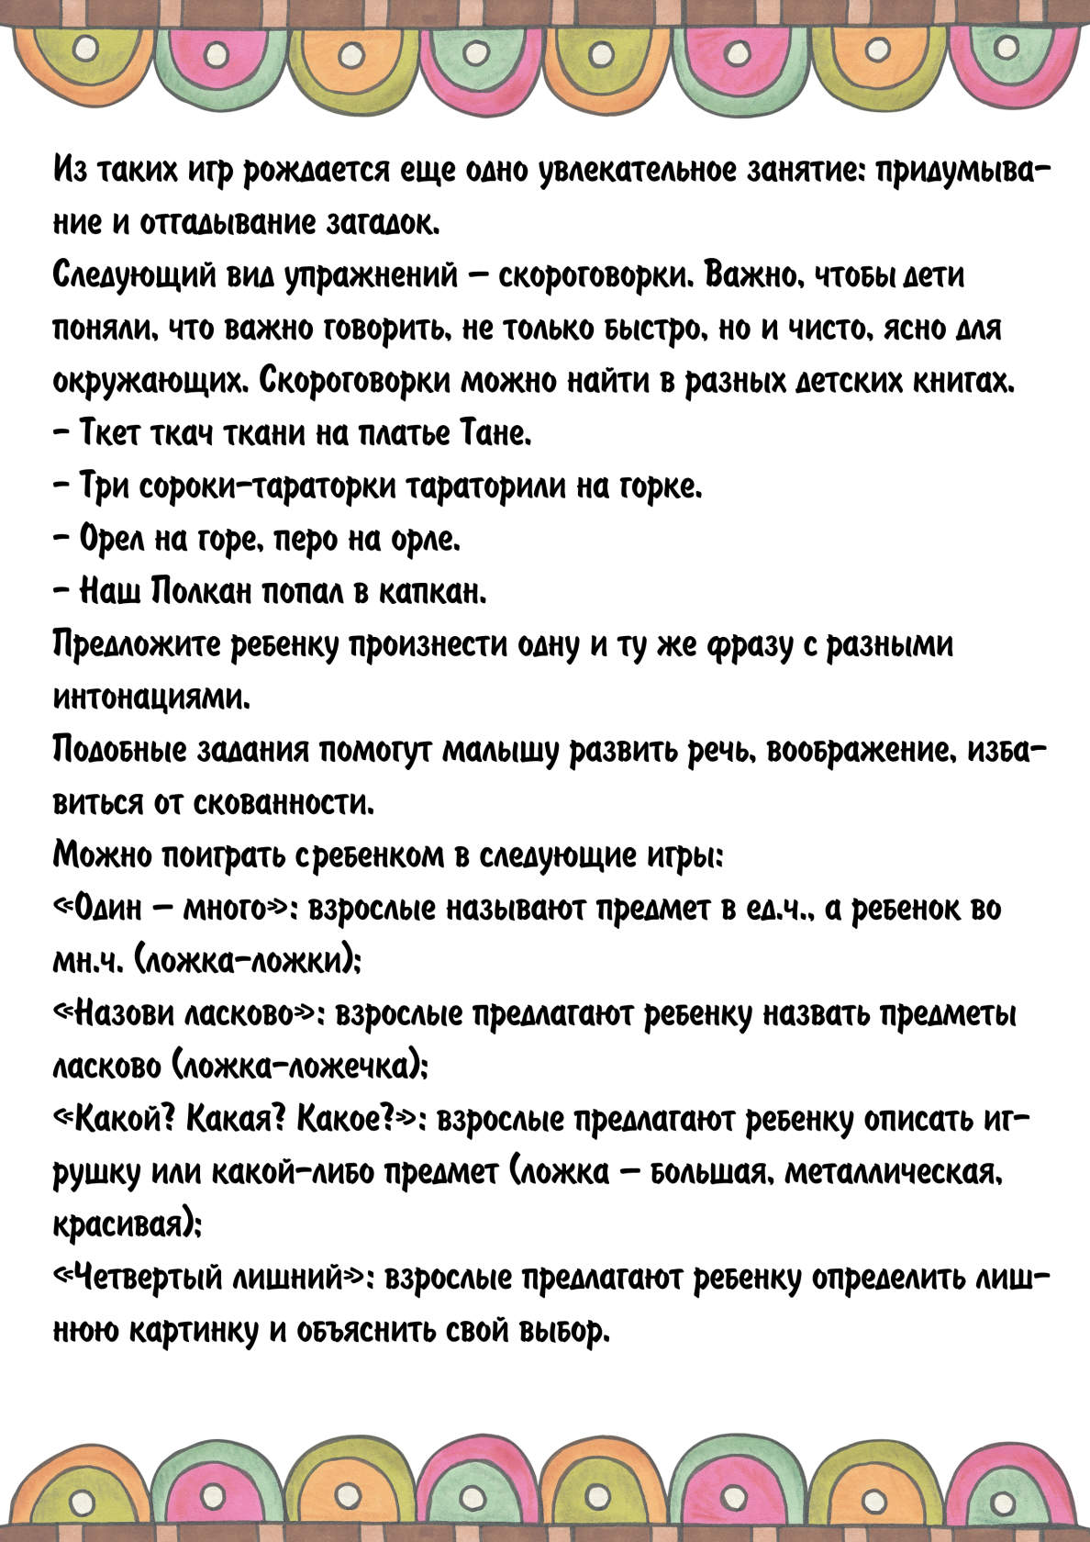](https://ok.ru/dk?cmd=PopLayerPhoto&st.layer.cmd=PopLayerPhotoOuter&st.layer.type=GROUP&st.layer.revNav=off&st.layer.limitedUi=false&st.layer.closeLayers=off&st.layer.sphotoIds=866062305603;866062305347;866062305091;866062304835;866062304579&st.layer.showNav=on&st.layer.photoAlbumId=53073113251907&st.layer.epm=off&st.layer.photoId=866062304835&st.layer.opl=off&st.layer.navStartPhotoId=866062304835&st.layer.sbd=off&st.cmd=userMain&st._aid=GroupTopicLayer_openPhotoLayer)

[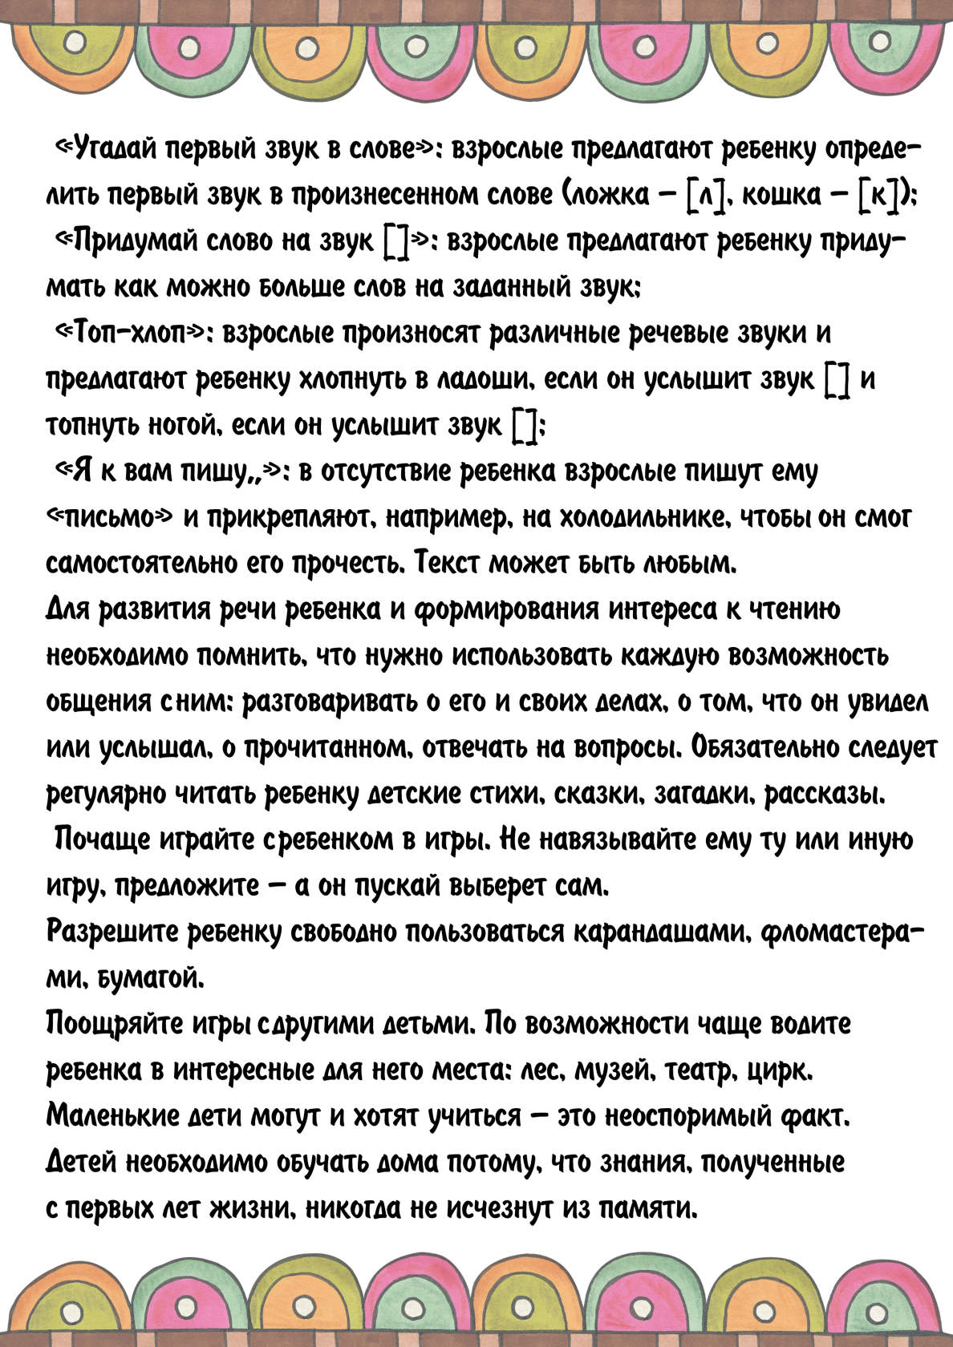](https://ok.ru/dk?cmd=PopLayerPhoto&st.layer.cmd=PopLayerPhotoOuter&st.layer.type=GROUP&st.layer.revNav=off&st.layer.limitedUi=false&st.layer.closeLayers=off&st.layer.sphotoIds=866062305603;866062305347;866062305091;866062304835;866062304579&st.layer.showNav=on&st.layer.photoAlbumId=53073113251907&st.layer.epm=off&st.layer.photoId=866062304579&st.layer.opl=off&st.layer.navStartPhotoId=866062304579&st.layer.sbd=off&st.cmd=userMain&st._aid=GroupTopicLayer_openPhotoLayer)