Объемные поделки из бумаги.

[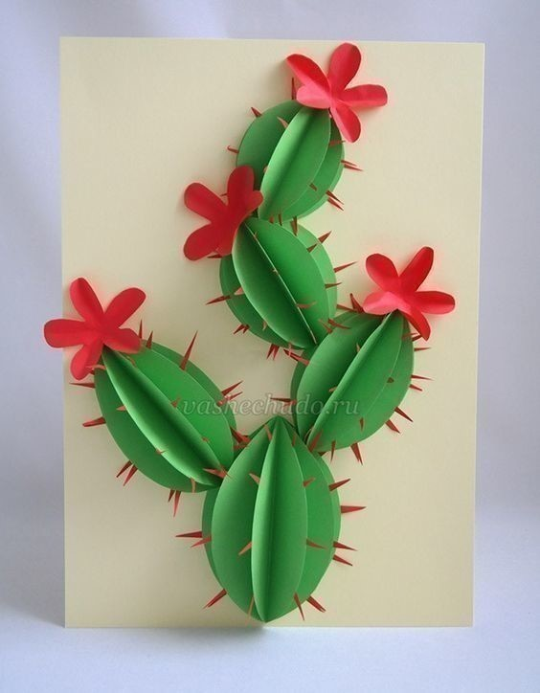](https://ok.ru/dk?cmd=PopLayerPhoto&st.layer.cmd=PopLayerPhotoOuter&st.layer.type=GROUP&st.layer.revNav=off&st.layer.limitedUi=false&st.layer.closeLayers=off&st.layer.sphotoIds=877132468020;877132468276;877132468532;877132468788;877132469044;877132469300;877132469556;877132469812;877132470068;877132470324&st.layer.showNav=on&st.layer.photoAlbumId=57249062780980&st.layer.epm=off&st.layer.photoId=877132468020&st.layer.opl=off&st.layer.navStartPhotoId=877132468020&st.layer.sbd=off&st.cmd=userMain&st._aid=GroupTopicLayer_openPhotoLayer)

[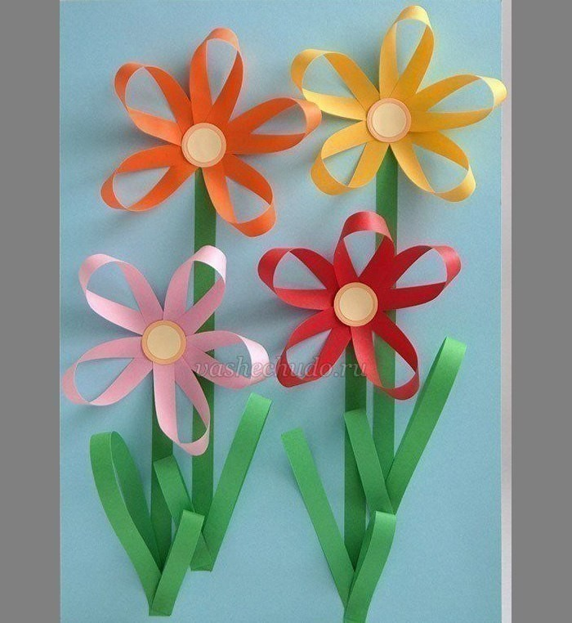](https://ok.ru/dk?cmd=PopLayerPhoto&st.layer.cmd=PopLayerPhotoOuter&st.layer.type=GROUP&st.layer.revNav=off&st.layer.limitedUi=false&st.layer.closeLayers=off&st.layer.sphotoIds=877132468020;877132468276;877132468532;877132468788;877132469044;877132469300;877132469556;877132469812;877132470068;877132470324&st.layer.showNav=on&st.layer.photoAlbumId=57249062780980&st.layer.epm=off&st.layer.photoId=877132468276&st.layer.opl=off&st.layer.navStartPhotoId=877132468276&st.layer.sbd=off&st.cmd=userMain&st._aid=GroupTopicLayer_openPhotoLayer)

[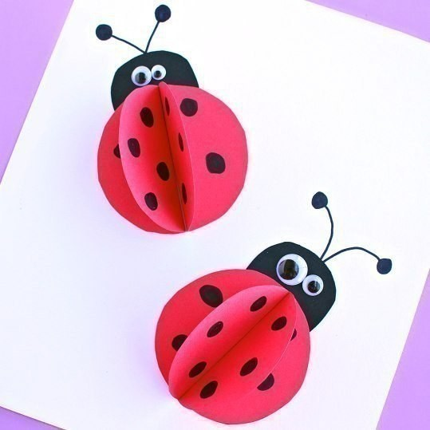](https://ok.ru/dk?cmd=PopLayerPhoto&st.layer.cmd=PopLayerPhotoOuter&st.layer.type=GROUP&st.layer.revNav=off&st.layer.limitedUi=false&st.layer.closeLayers=off&st.layer.sphotoIds=877132468020;877132468276;877132468532;877132468788;877132469044;877132469300;877132469556;877132469812;877132470068;877132470324&st.layer.showNav=on&st.layer.photoAlbumId=57249062780980&st.layer.epm=off&st.layer.photoId=877132468532&st.layer.opl=off&st.layer.navStartPhotoId=877132468532&st.layer.sbd=off&st.cmd=userMain&st._aid=GroupTopicLayer_openPhotoLayer)

[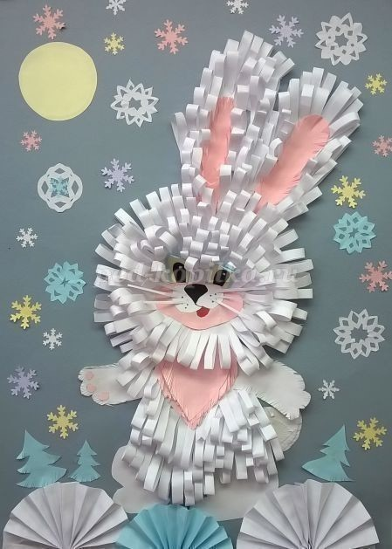](https://ok.ru/dk?cmd=PopLayerPhoto&st.layer.cmd=PopLayerPhotoOuter&st.layer.type=GROUP&st.layer.revNav=off&st.layer.limitedUi=false&st.layer.closeLayers=off&st.layer.sphotoIds=877132468020;877132468276;877132468532;877132468788;877132469044;877132469300;877132469556;877132469812;877132470068;877132470324&st.layer.showNav=on&st.layer.photoAlbumId=57249062780980&st.layer.epm=off&st.layer.photoId=877132468788&st.layer.opl=off&st.layer.navStartPhotoId=877132468788&st.layer.sbd=off&st.cmd=userMain&st._aid=GroupTopicLayer_openPhotoLayer)

[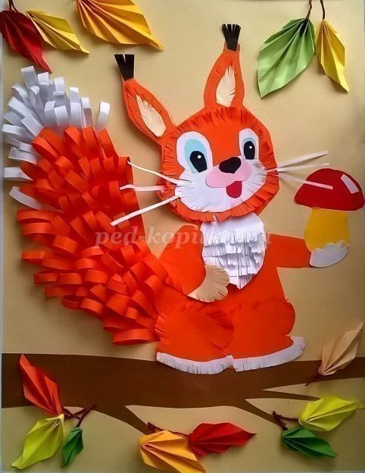](https://ok.ru/dk?cmd=PopLayerPhoto&st.layer.cmd=PopLayerPhotoOuter&st.layer.type=GROUP&st.layer.revNav=off&st.layer.limitedUi=false&st.layer.closeLayers=off&st.layer.sphotoIds=877132468020;877132468276;877132468532;877132468788;877132469044;877132469300;877132469556;877132469812;877132470068;877132470324&st.layer.showNav=on&st.layer.photoAlbumId=57249062780980&st.layer.epm=off&st.layer.photoId=877132469044&st.layer.opl=off&st.layer.navStartPhotoId=877132469044&st.layer.sbd=off&st.cmd=userMain&st._aid=GroupTopicLayer_openPhotoLayer)

[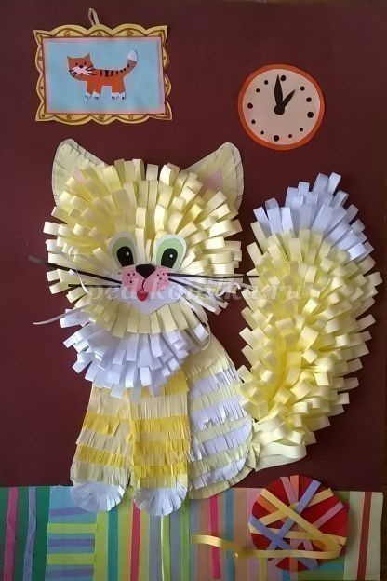](https://ok.ru/dk?cmd=PopLayerPhoto&st.layer.cmd=PopLayerPhotoOuter&st.layer.type=GROUP&st.layer.revNav=off&st.layer.limitedUi=false&st.layer.closeLayers=off&st.layer.sphotoIds=877132468020;877132468276;877132468532;877132468788;877132469044;877132469300;877132469556;877132469812;877132470068;877132470324&st.layer.showNav=on&st.layer.photoAlbumId=57249062780980&st.layer.epm=off&st.layer.photoId=877132469300&st.layer.opl=off&st.layer.navStartPhotoId=877132469300&st.layer.sbd=off&st.cmd=userMain&st._aid=GroupTopicLayer_openPhotoLayer)

[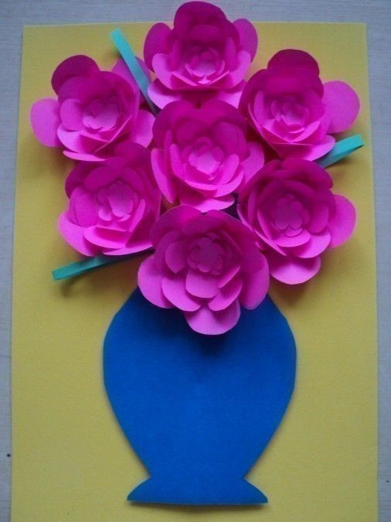](https://ok.ru/dk?cmd=PopLayerPhoto&st.layer.cmd=PopLayerPhotoOuter&st.layer.type=GROUP&st.layer.revNav=off&st.layer.limitedUi=false&st.layer.closeLayers=off&st.layer.sphotoIds=877132468020;877132468276;877132468532;877132468788;877132469044;877132469300;877132469556;877132469812;877132470068;877132470324&st.layer.showNav=on&st.layer.photoAlbumId=57249062780980&st.layer.epm=off&st.layer.photoId=877132469812&st.layer.opl=off&st.layer.navStartPhotoId=877132469812&st.layer.sbd=off&st.cmd=userMain&st._aid=GroupTopicLayer_openPhotoLayer)

[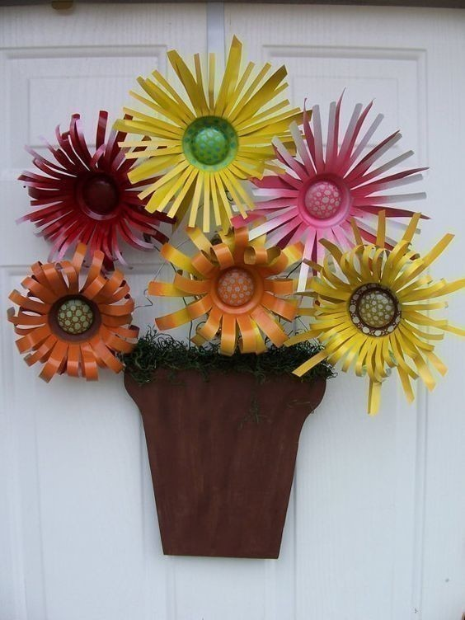](https://ok.ru/dk?cmd=PopLayerPhoto&st.layer.cmd=PopLayerPhotoOuter&st.layer.type=GROUP&st.layer.revNav=off&st.layer.limitedUi=false&st.layer.closeLayers=off&st.layer.sphotoIds=877132468020;877132468276;877132468532;877132468788;877132469044;877132469300;877132469556;877132469812;877132470068;877132470324&st.layer.showNav=on&st.layer.photoAlbumId=57249062780980&st.layer.epm=off&st.layer.photoId=877132470068&st.layer.opl=off&st.layer.navStartPhotoId=877132470068&st.layer.sbd=off&st.cmd=userMain&st._aid=GroupTopicLayer_openPhotoLayer)