**33 СКОРОГОВОРКИ. МНЕМОТАБЛИЦЫ ДЛЯ ЗАУЧИВАНИЯ**

[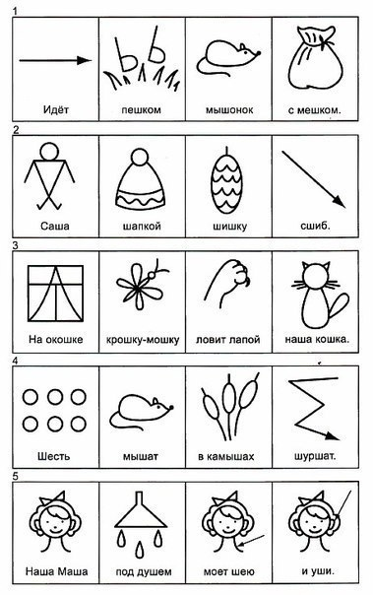](https://ok.ru/dk?cmd=PopLayerPhoto&st.layer.cmd=PopLayerPhotoOuter&st.layer.type=GROUP&st.layer.revNav=off&st.layer.limitedUi=false&st.layer.closeLayers=off&st.layer.sphotoIds=873586883228;873586884252;873586887324;873586889372;873586890652;873586892444;873586896028;873586898332;873586901148&st.layer.showNav=on&st.layer.photoAlbumId=53850107609244&st.layer.epm=off&st.layer.photoId=873586883228&st.layer.opl=off&st.layer.navStartPhotoId=873586883228&st.layer.sbd=off&st.cmd=userMain&st._aid=GroupTopicLayer_openPhotoLayer)

[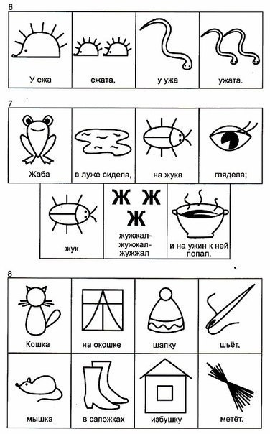](https://ok.ru/dk?cmd=PopLayerPhoto&st.layer.cmd=PopLayerPhotoOuter&st.layer.type=GROUP&st.layer.revNav=off&st.layer.limitedUi=false&st.layer.closeLayers=off&st.layer.sphotoIds=873586883228;873586884252;873586887324;873586889372;873586890652;873586892444;873586896028;873586898332;873586901148&st.layer.showNav=on&st.layer.photoAlbumId=53850107609244&st.layer.epm=off&st.layer.photoId=873586884252&st.layer.opl=off&st.layer.navStartPhotoId=873586884252&st.layer.sbd=off&st.cmd=userMain&st._aid=GroupTopicLayer_openPhotoLayer)

[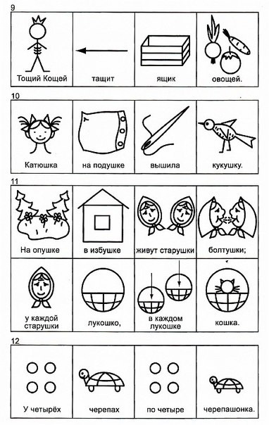](https://ok.ru/dk?cmd=PopLayerPhoto&st.layer.cmd=PopLayerPhotoOuter&st.layer.type=GROUP&st.layer.revNav=off&st.layer.limitedUi=false&st.layer.closeLayers=off&st.layer.sphotoIds=873586883228;873586884252;873586887324;873586889372;873586890652;873586892444;873586896028;873586898332;873586901148&st.layer.showNav=on&st.layer.photoAlbumId=53850107609244&st.layer.epm=off&st.layer.photoId=873586887324&st.layer.opl=off&st.layer.navStartPhotoId=873586887324&st.layer.sbd=off&st.cmd=userMain&st._aid=GroupTopicLayer_openPhotoLayer)

[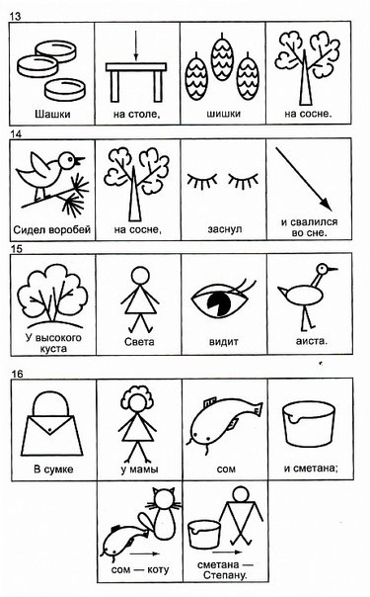](https://ok.ru/dk?cmd=PopLayerPhoto&st.layer.cmd=PopLayerPhotoOuter&st.layer.type=GROUP&st.layer.revNav=off&st.layer.limitedUi=false&st.layer.closeLayers=off&st.layer.sphotoIds=873586883228;873586884252;873586887324;873586889372;873586890652;873586892444;873586896028;873586898332;873586901148&st.layer.showNav=on&st.layer.photoAlbumId=53850107609244&st.layer.epm=off&st.layer.photoId=873586889372&st.layer.opl=off&st.layer.navStartPhotoId=873586889372&st.layer.sbd=off&st.cmd=userMain&st._aid=GroupTopicLayer_openPhotoLayer)

[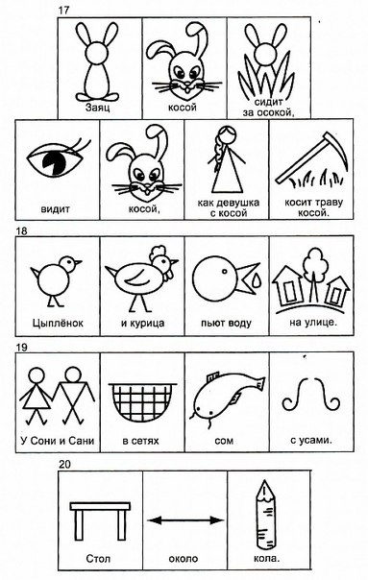](https://ok.ru/dk?cmd=PopLayerPhoto&st.layer.cmd=PopLayerPhotoOuter&st.layer.type=GROUP&st.layer.revNav=off&st.layer.limitedUi=false&st.layer.closeLayers=off&st.layer.sphotoIds=873586883228;873586884252;873586887324;873586889372;873586890652;873586892444;873586896028;873586898332;873586901148&st.layer.showNav=on&st.layer.photoAlbumId=53850107609244&st.layer.epm=off&st.layer.photoId=873586890652&st.layer.opl=off&st.layer.navStartPhotoId=873586890652&st.layer.sbd=off&st.cmd=userMain&st._aid=GroupTopicLayer_openPhotoLayer)

[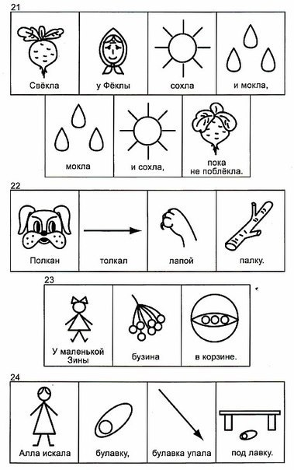](https://ok.ru/dk?cmd=PopLayerPhoto&st.layer.cmd=PopLayerPhotoOuter&st.layer.type=GROUP&st.layer.revNav=off&st.layer.limitedUi=false&st.layer.closeLayers=off&st.layer.sphotoIds=873586883228;873586884252;873586887324;873586889372;873586890652;873586892444;873586896028;873586898332;873586901148&st.layer.showNav=on&st.layer.photoAlbumId=53850107609244&st.layer.epm=off&st.layer.photoId=873586892444&st.layer.opl=off&st.layer.navStartPhotoId=873586892444&st.layer.sbd=off&st.cmd=userMain&st._aid=GroupTopicLayer_openPhotoLayer)

[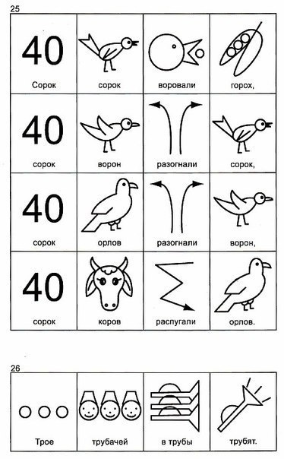](https://ok.ru/dk?cmd=PopLayerPhoto&st.layer.cmd=PopLayerPhotoOuter&st.layer.type=GROUP&st.layer.revNav=off&st.layer.limitedUi=false&st.layer.closeLayers=off&st.layer.sphotoIds=873586883228;873586884252;873586887324;873586889372;873586890652;873586892444;873586896028;873586898332;873586901148&st.layer.showNav=on&st.layer.photoAlbumId=53850107609244&st.layer.epm=off&st.layer.photoId=873586896028&st.layer.opl=off&st.layer.navStartPhotoId=873586896028&st.layer.sbd=off&st.cmd=userMain&st._aid=GroupTopicLayer_openPhotoLayer)

[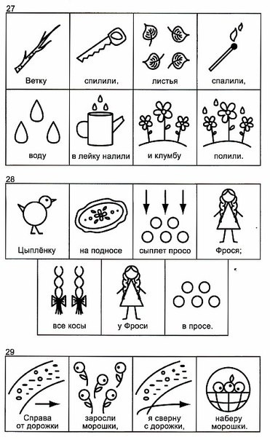](https://ok.ru/dk?cmd=PopLayerPhoto&st.layer.cmd=PopLayerPhotoOuter&st.layer.type=GROUP&st.layer.revNav=off&st.layer.limitedUi=false&st.layer.closeLayers=off&st.layer.sphotoIds=873586883228;873586884252;873586887324;873586889372;873586890652;873586892444;873586896028;873586898332;873586901148&st.layer.showNav=on&st.layer.photoAlbumId=53850107609244&st.layer.epm=off&st.layer.photoId=873586898332&st.layer.opl=off&st.layer.navStartPhotoId=873586898332&st.layer.sbd=off&st.cmd=userMain&st._aid=GroupTopicLayer_openPhotoLayer)

[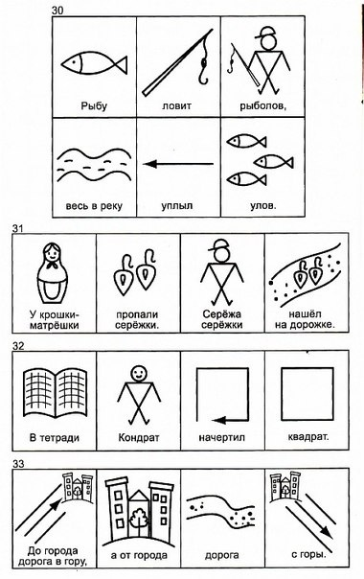](https://ok.ru/dk?cmd=PopLayerPhoto&st.layer.cmd=PopLayerPhotoOuter&st.layer.type=GROUP&st.layer.revNav=off&st.layer.limitedUi=false&st.layer.closeLayers=off&st.layer.sphotoIds=873586883228;873586884252;873586887324;873586889372;873586890652;873586892444;873586896028;873586898332;873586901148&st.layer.showNav=on&st.layer.photoAlbumId=53850107609244&st.layer.epm=off&st.layer.photoId=873586901148&st.layer.opl=off&st.layer.navStartPhotoId=873586901148&st.layer.sbd=off&st.cmd=userMain&st._aid=GroupTopicLayer_openPhotoLayer)