[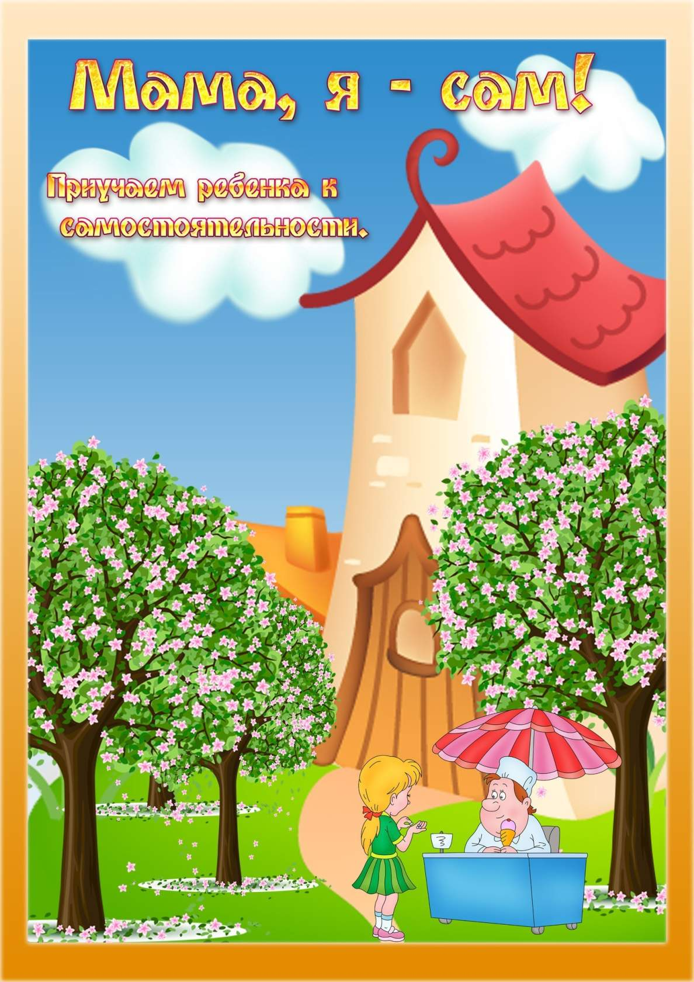](https://ok.ru/dk?cmd=PopLayerPhoto&st.layer.cmd=PopLayerPhotoOuter&st.layer.type=GROUP&st.layer.revNav=off&st.layer.limitedUi=false&st.layer.closeLayers=off&st.layer.sphotoIds=877435491380%3B877435491636%3B877435491892%3B877435492148%3B877435492404%3B877435492660&st.layer.showNav=on&st.layer.photoAlbumId=57249062780980&st.layer.epm=off&st.layer.photoId=877435491380&st.layer.opl=off&st.layer.navStartPhotoId=877435491380&st.layer.sbd=off&st.cmd=userMain&st._aid=GroupTopicLayer_openPhotoLayer)

[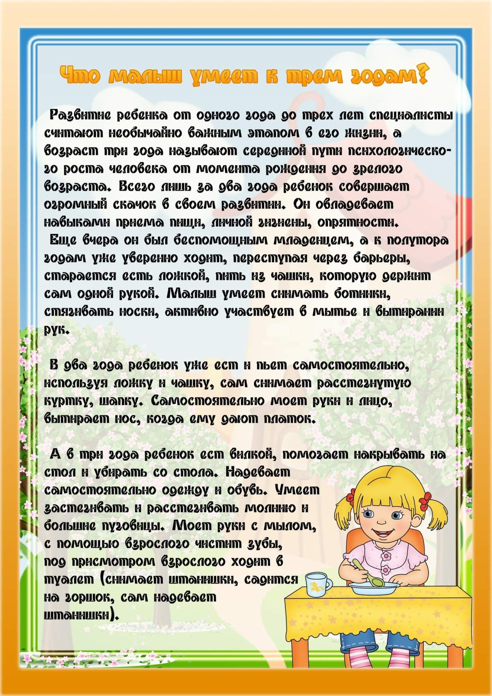](https://ok.ru/dk?cmd=PopLayerPhoto&st.layer.cmd=PopLayerPhotoOuter&st.layer.type=GROUP&st.layer.revNav=off&st.layer.limitedUi=false&st.layer.closeLayers=off&st.layer.sphotoIds=877435491380%3B877435491636%3B877435491892%3B877435492148%3B877435492404%3B877435492660&st.layer.showNav=on&st.layer.photoAlbumId=57249062780980&st.layer.epm=off&st.layer.photoId=877435491636&st.layer.opl=off&st.layer.navStartPhotoId=877435491636&st.layer.sbd=off&st.cmd=userMain&st._aid=GroupTopicLayer_openPhotoLayer)

[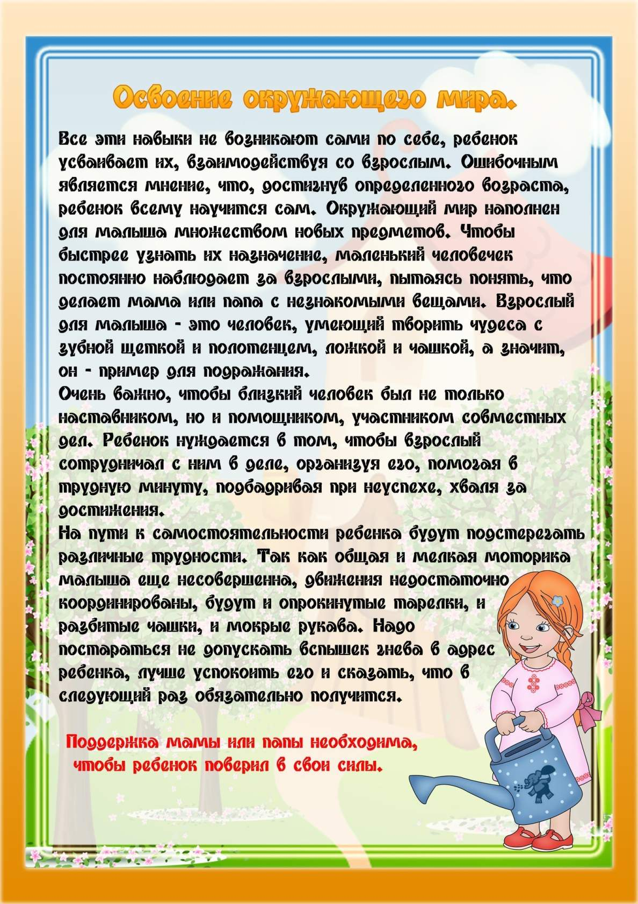](https://ok.ru/dk?cmd=PopLayerPhoto&st.layer.cmd=PopLayerPhotoOuter&st.layer.type=GROUP&st.layer.revNav=off&st.layer.limitedUi=false&st.layer.closeLayers=off&st.layer.sphotoIds=877435491380%3B877435491636%3B877435491892%3B877435492148%3B877435492404%3B877435492660&st.layer.showNav=on&st.layer.photoAlbumId=57249062780980&st.layer.epm=off&st.layer.photoId=877435491892&st.layer.opl=off&st.layer.navStartPhotoId=877435491892&st.layer.sbd=off&st.cmd=userMain&st._aid=GroupTopicLayer_openPhotoLayer)

[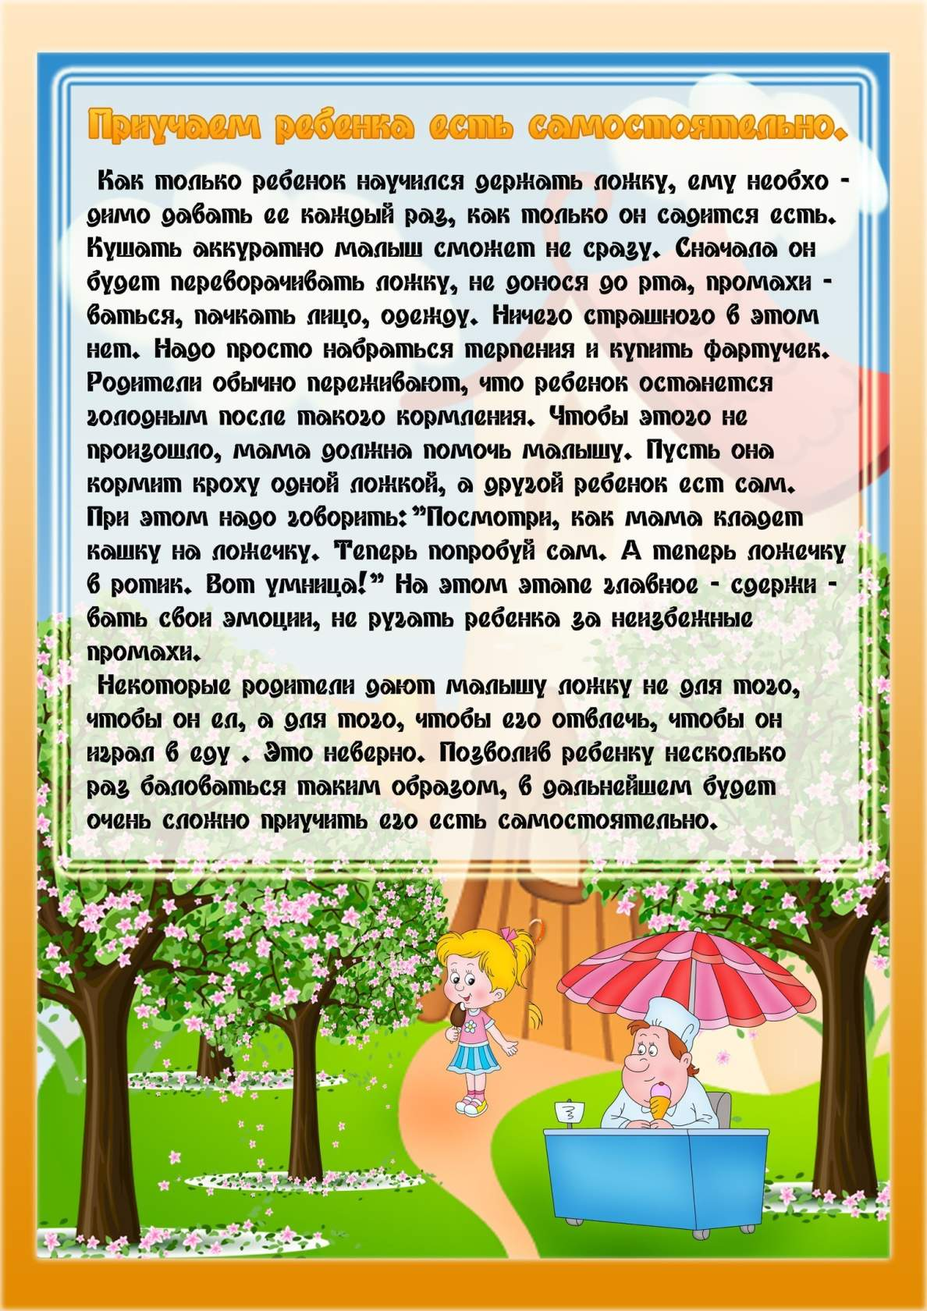](https://ok.ru/dk?cmd=PopLayerPhoto&st.layer.cmd=PopLayerPhotoOuter&st.layer.type=GROUP&st.layer.revNav=off&st.layer.limitedUi=false&st.layer.closeLayers=off&st.layer.sphotoIds=877435491380%3B877435491636%3B877435491892%3B877435492148%3B877435492404%3B877435492660&st.layer.showNav=on&st.layer.photoAlbumId=57249062780980&st.layer.epm=off&st.layer.photoId=877435492148&st.layer.opl=off&st.layer.navStartPhotoId=877435492148&st.layer.sbd=off&st.cmd=userMain&st._aid=GroupTopicLayer_openPhotoLayer)

[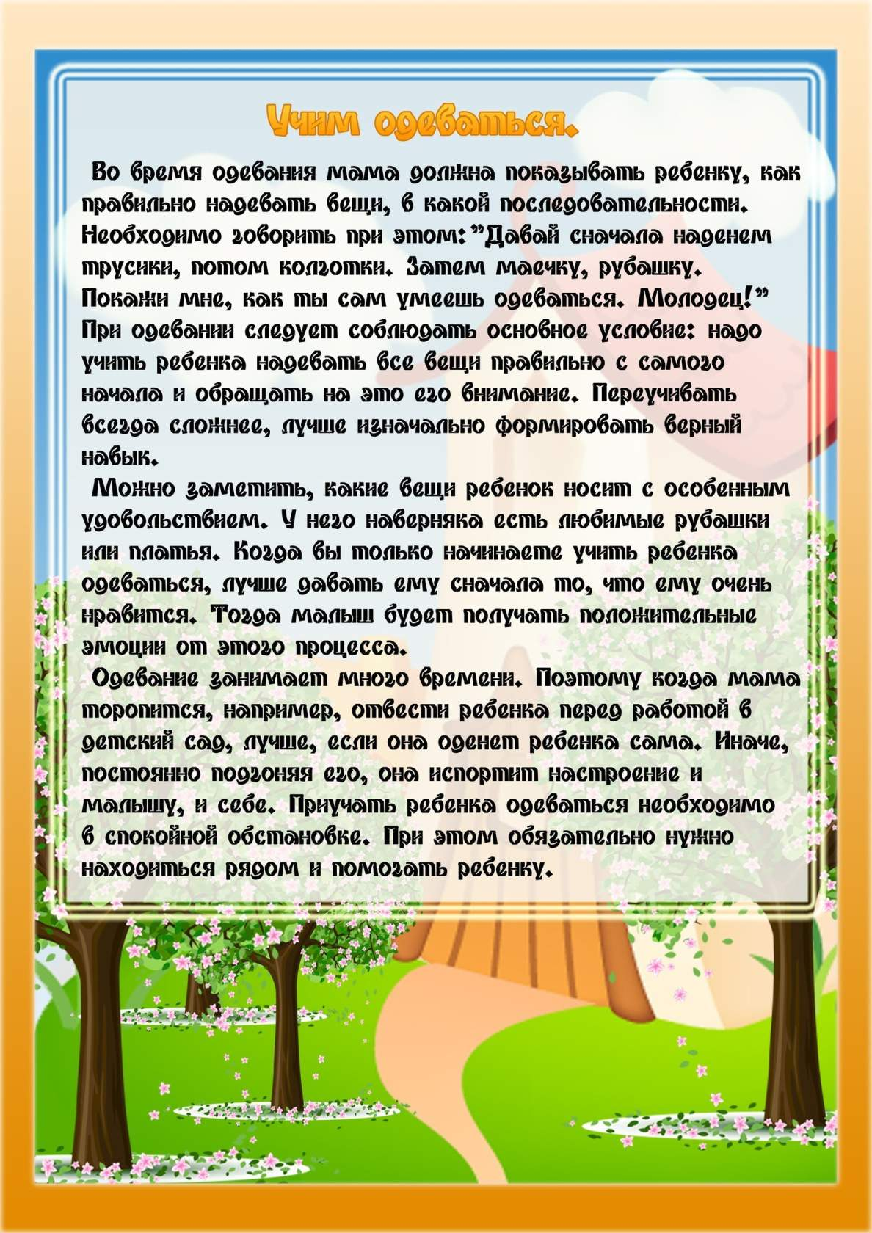](https://ok.ru/dk?cmd=PopLayerPhoto&st.layer.cmd=PopLayerPhotoOuter&st.layer.type=GROUP&st.layer.revNav=off&st.layer.limitedUi=false&st.layer.closeLayers=off&st.layer.sphotoIds=877435491380%3B877435491636%3B877435491892%3B877435492148%3B877435492404%3B877435492660&st.layer.showNav=on&st.layer.photoAlbumId=57249062780980&st.layer.epm=off&st.layer.photoId=877435492660&st.layer.opl=off&st.layer.navStartPhotoId=877435492660&st.layer.sbd=off&st.cmd=userMain&st._aid=GroupTopicLayer_openPhotoLayer)