[](https://ok.ru/dk?cmd=PopLayerPhoto&st.layer.cmd=PopLayerPhotoOuter&st.layer.type=GROUP&st.layer.revNav=off&st.layer.limitedUi=false&st.layer.closeLayers=off&st.layer.sphotoIds=877276592436%3B877276592692%3B877276592948%3B877276593204%3B877276593460&st.layer.showNav=on&st.layer.photoAlbumId=57249062780980&st.layer.epm=off&st.layer.photoId=877276592436&st.layer.opl=off&st.layer.navStartPhotoId=877276592436&st.layer.sbd=off&st.cmd=userMain&st._aid=GroupTopicLayer_openPhotoLayer)

[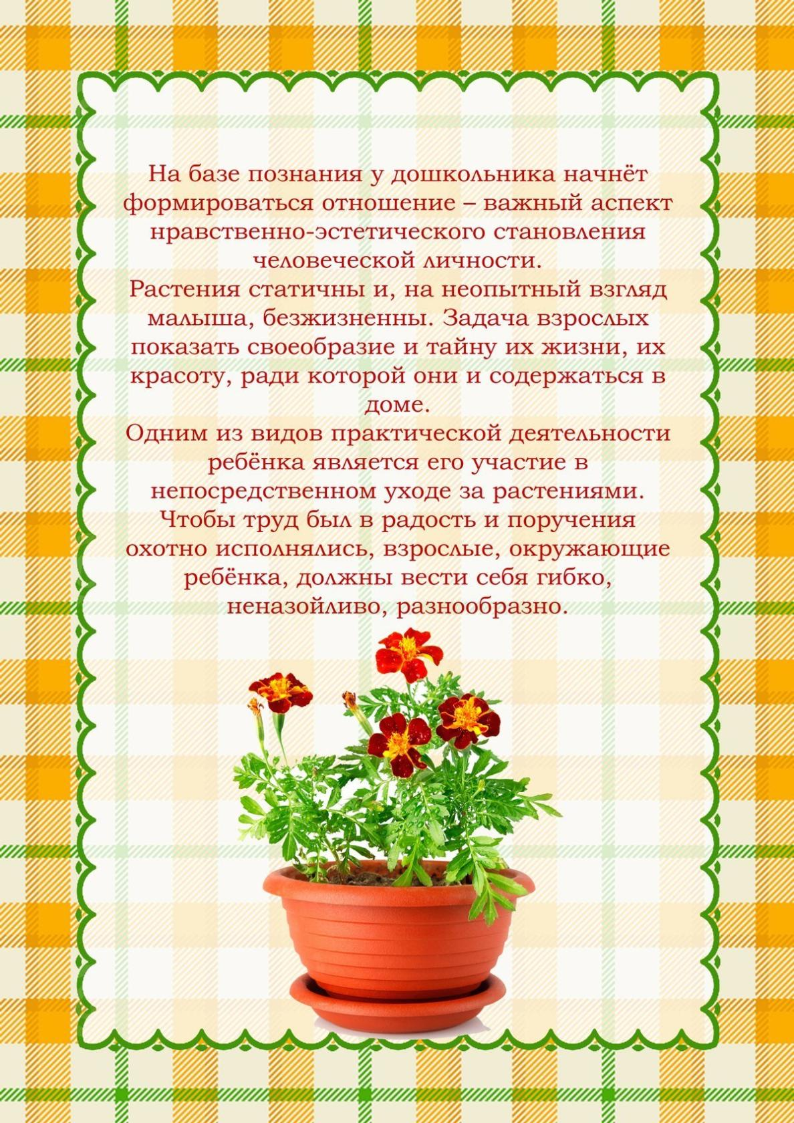](https://ok.ru/dk?cmd=PopLayerPhoto&st.layer.cmd=PopLayerPhotoOuter&st.layer.type=GROUP&st.layer.revNav=off&st.layer.limitedUi=false&st.layer.closeLayers=off&st.layer.sphotoIds=877276592436%3B877276592692%3B877276592948%3B877276593204%3B877276593460&st.layer.showNav=on&st.layer.photoAlbumId=57249062780980&st.layer.epm=off&st.layer.photoId=877276592692&st.layer.opl=off&st.layer.navStartPhotoId=877276592692&st.layer.sbd=off&st.cmd=userMain&st._aid=GroupTopicLayer_openPhotoLayer)

[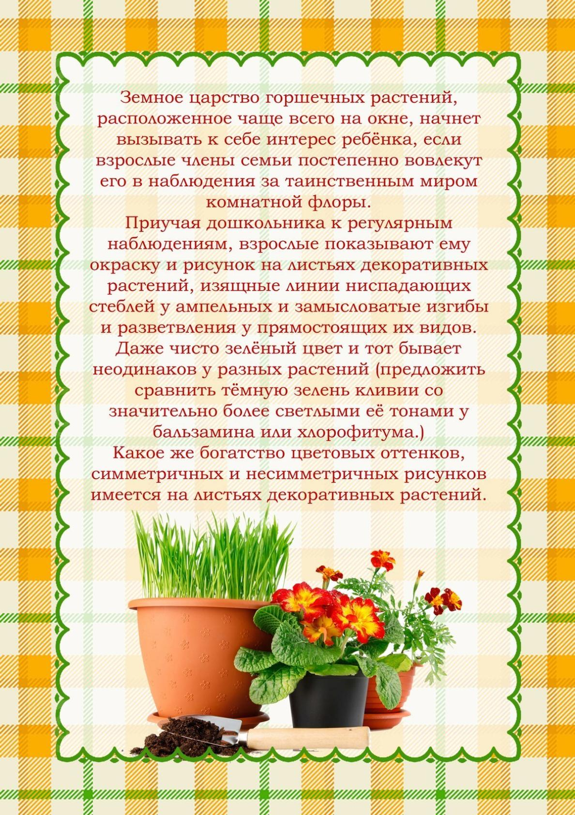](https://ok.ru/dk?cmd=PopLayerPhoto&st.layer.cmd=PopLayerPhotoOuter&st.layer.type=GROUP&st.layer.revNav=off&st.layer.limitedUi=false&st.layer.closeLayers=off&st.layer.sphotoIds=877276592436%3B877276592692%3B877276592948%3B877276593204%3B877276593460&st.layer.showNav=on&st.layer.photoAlbumId=57249062780980&st.layer.epm=off&st.layer.photoId=877276592948&st.layer.opl=off&st.layer.navStartPhotoId=877276592948&st.layer.sbd=off&st.cmd=userMain&st._aid=GroupTopicLayer_openPhotoLayer)

[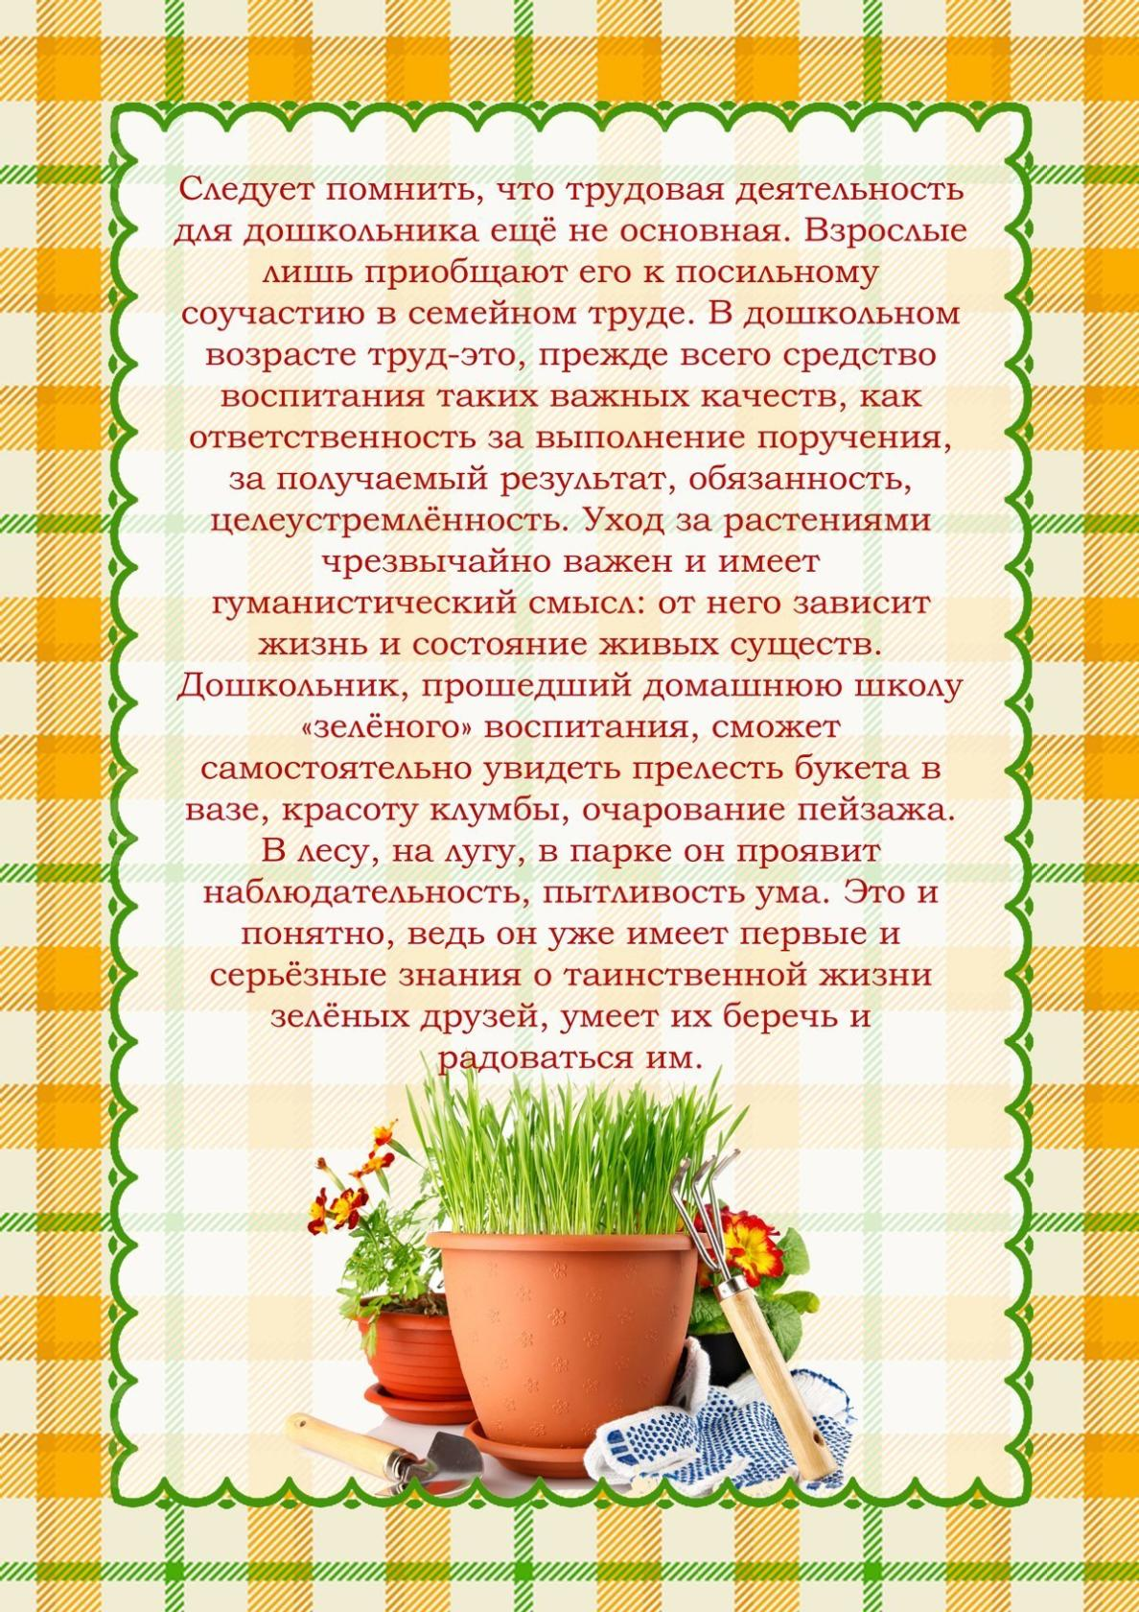](https://ok.ru/dk?cmd=PopLayerPhoto&st.layer.cmd=PopLayerPhotoOuter&st.layer.type=GROUP&st.layer.revNav=off&st.layer.limitedUi=false&st.layer.closeLayers=off&st.layer.sphotoIds=877276592436%3B877276592692%3B877276592948%3B877276593204%3B877276593460&st.layer.showNav=on&st.layer.photoAlbumId=57249062780980&st.layer.epm=off&st.layer.photoId=877276593204&st.layer.opl=off&st.layer.navStartPhotoId=877276593204&st.layer.sbd=off&st.cmd=userMain&st._aid=GroupTopicLayer_openPhotoLayer)

[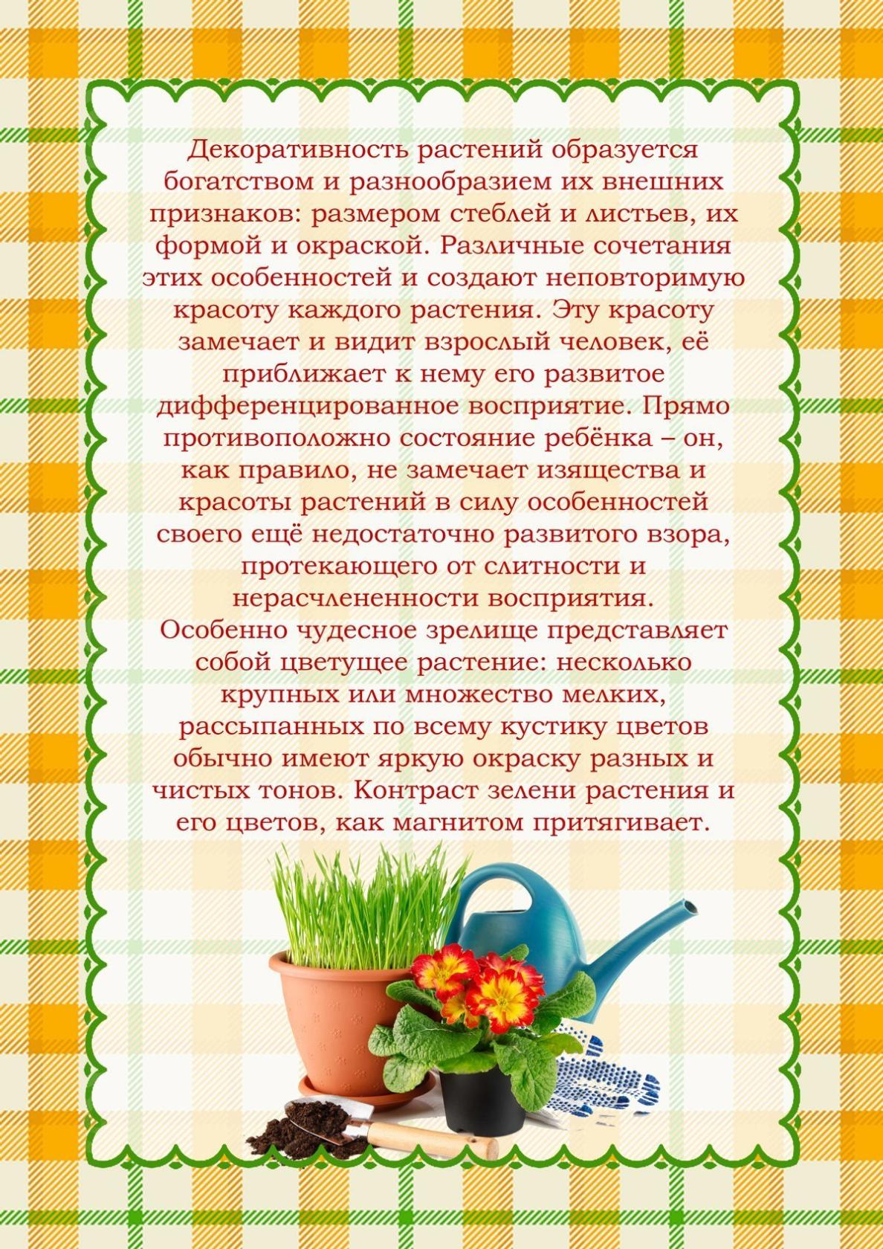](https://ok.ru/dk?cmd=PopLayerPhoto&st.layer.cmd=PopLayerPhotoOuter&st.layer.type=GROUP&st.layer.revNav=off&st.layer.limitedUi=false&st.layer.closeLayers=off&st.layer.sphotoIds=877276592436%3B877276592692%3B877276592948%3B877276593204%3B877276593460&st.layer.showNav=on&st.layer.photoAlbumId=57249062780980&st.layer.epm=off&st.layer.photoId=877276593460&st.layer.opl=off&st.layer.navStartPhotoId=877276593460&st.layer.sbd=off&st.cmd=userMain&st._aid=GroupTopicLayer_openPhotoLayer)