[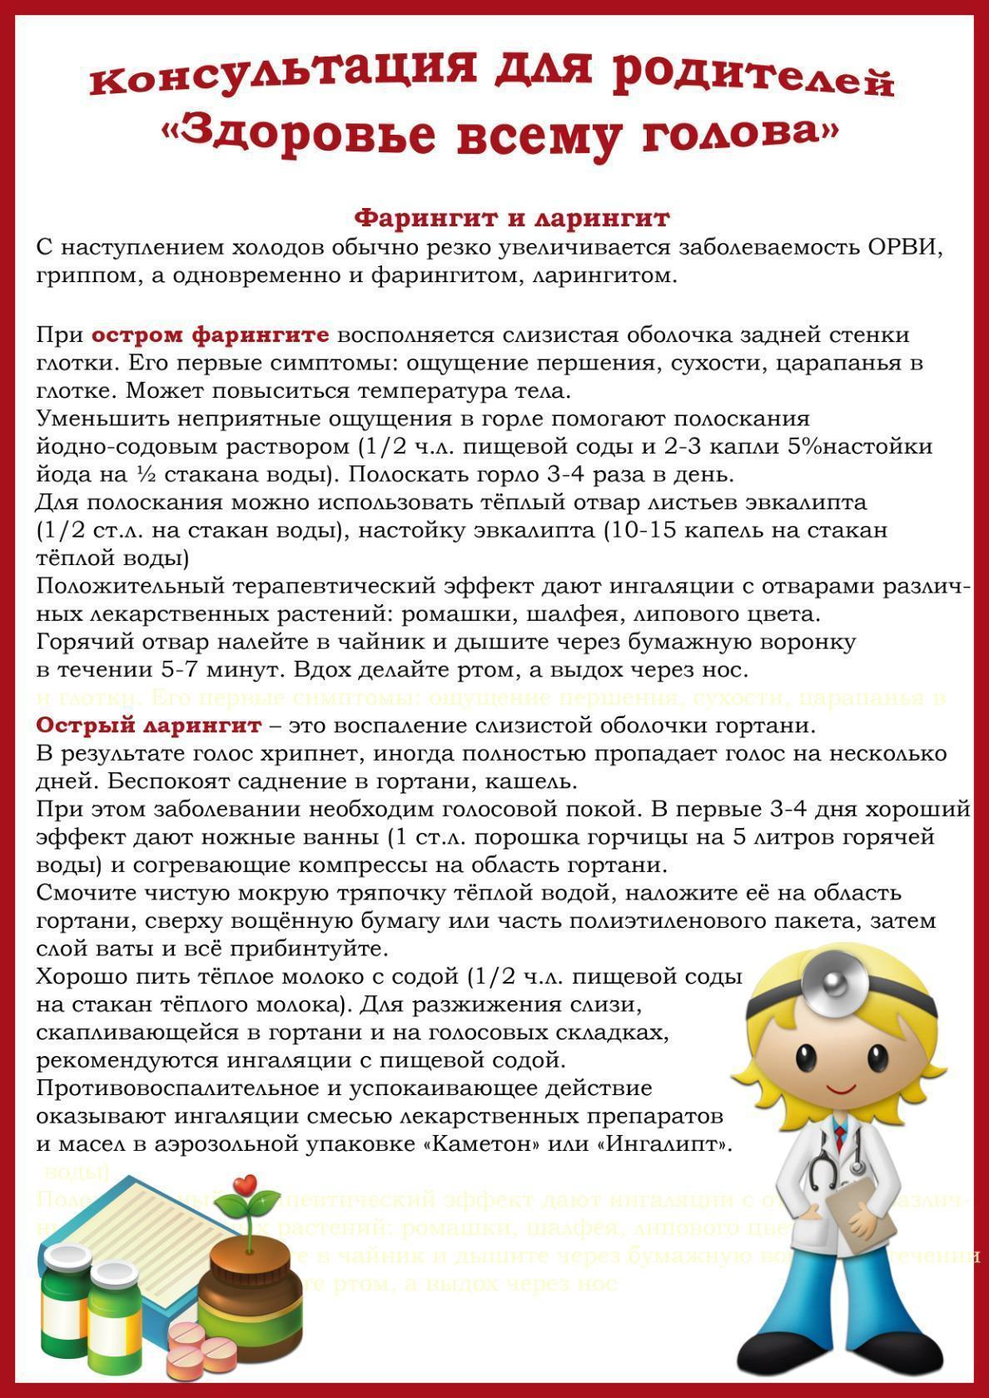](https://ok.ru/dk?cmd=PopLayerPhoto&st.layer.cmd=PopLayerPhotoOuter&st.layer.type=GROUP&st.layer.revNav=off&st.layer.limitedUi=false&st.layer.closeLayers=off&st.layer.sphotoIds=877271910196%3B877271910452%3B877271910708%3B877271910964%3B877271911220%3B877271911476&st.layer.showNav=on&st.layer.photoAlbumId=57249062780980&st.layer.epm=off&st.layer.photoId=877271910196&st.layer.opl=off&st.layer.navStartPhotoId=877271910196&st.layer.sbd=off&st.cmd=userMain&st._aid=GroupTopicLayer_openPhotoLayer)

[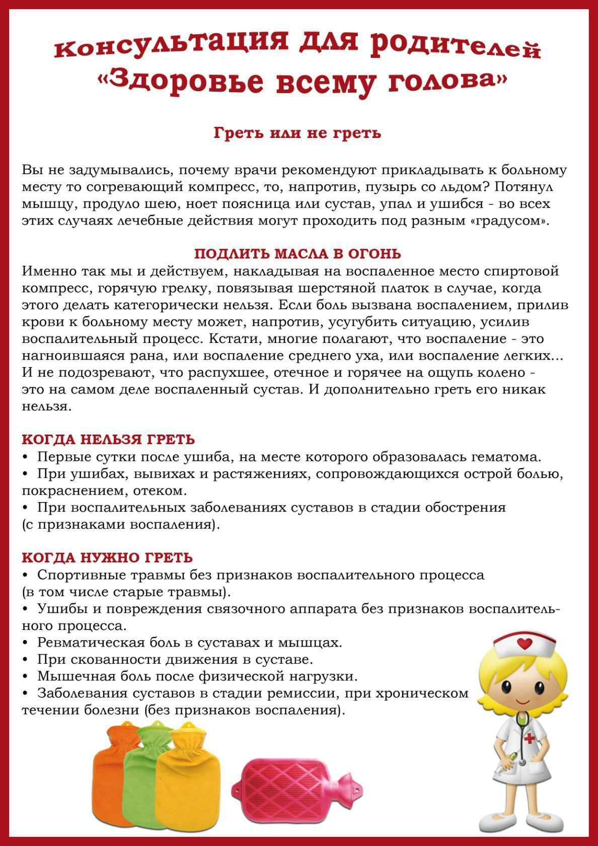](https://ok.ru/dk?cmd=PopLayerPhoto&st.layer.cmd=PopLayerPhotoOuter&st.layer.type=GROUP&st.layer.revNav=off&st.layer.limitedUi=false&st.layer.closeLayers=off&st.layer.sphotoIds=877271910196%3B877271910452%3B877271910708%3B877271910964%3B877271911220%3B877271911476&st.layer.showNav=on&st.layer.photoAlbumId=57249062780980&st.layer.epm=off&st.layer.photoId=877271910452&st.layer.opl=off&st.layer.navStartPhotoId=877271910452&st.layer.sbd=off&st.cmd=userMain&st._aid=GroupTopicLayer_openPhotoLayer)

[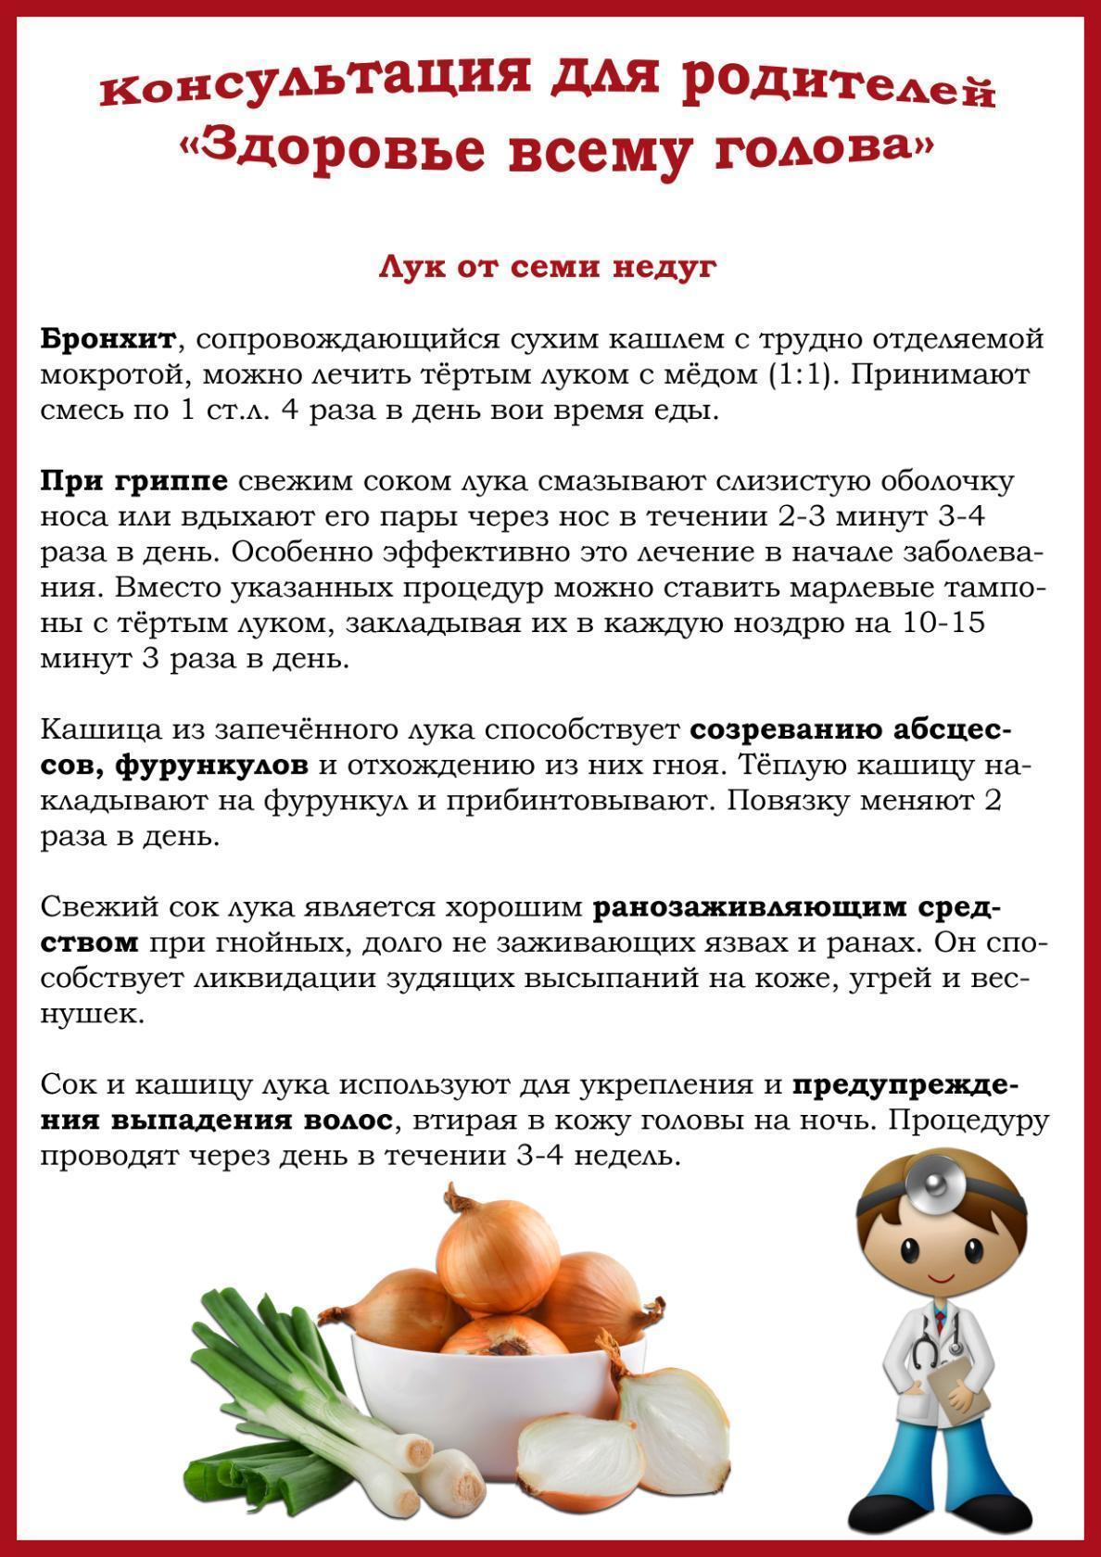](https://ok.ru/dk?cmd=PopLayerPhoto&st.layer.cmd=PopLayerPhotoOuter&st.layer.type=GROUP&st.layer.revNav=off&st.layer.limitedUi=false&st.layer.closeLayers=off&st.layer.sphotoIds=877271910196%3B877271910452%3B877271910708%3B877271910964%3B877271911220%3B877271911476&st.layer.showNav=on&st.layer.photoAlbumId=57249062780980&st.layer.epm=off&st.layer.photoId=877271910708&st.layer.opl=off&st.layer.navStartPhotoId=877271910708&st.layer.sbd=off&st.cmd=userMain&st._aid=GroupTopicLayer_openPhotoLayer)

[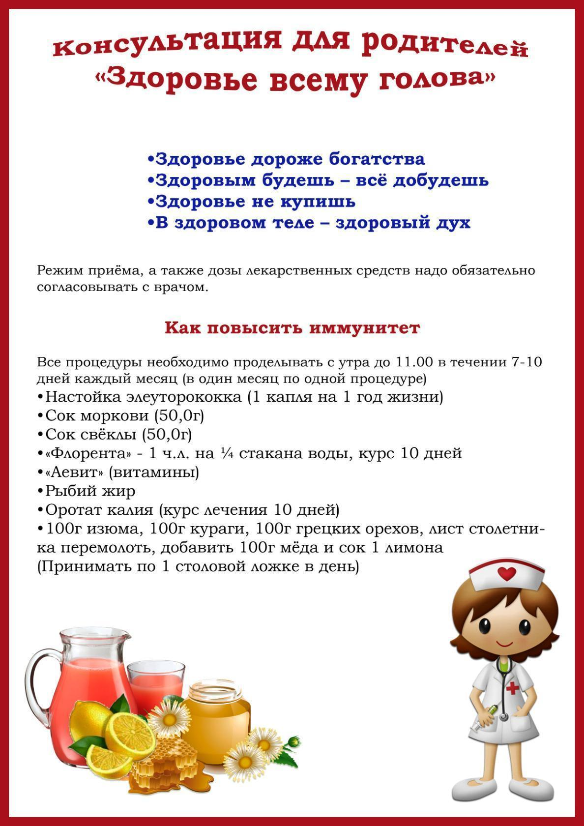](https://ok.ru/dk?cmd=PopLayerPhoto&st.layer.cmd=PopLayerPhotoOuter&st.layer.type=GROUP&st.layer.revNav=off&st.layer.limitedUi=false&st.layer.closeLayers=off&st.layer.sphotoIds=877271910196%3B877271910452%3B877271910708%3B877271910964%3B877271911220%3B877271911476&st.layer.showNav=on&st.layer.photoAlbumId=57249062780980&st.layer.epm=off&st.layer.photoId=877271910964&st.layer.opl=off&st.layer.navStartPhotoId=877271910964&st.layer.sbd=off&st.cmd=userMain&st._aid=GroupTopicLayer_openPhotoLayer)

[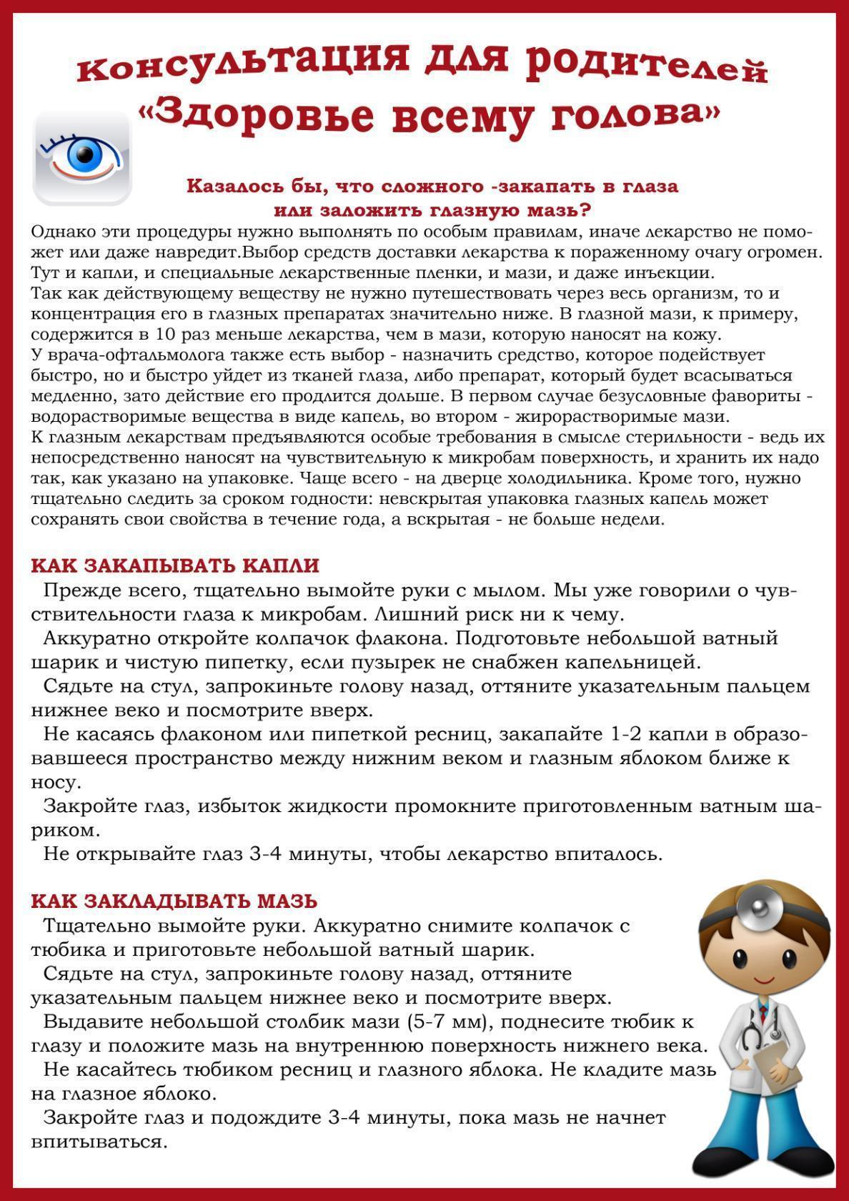](https://ok.ru/dk?cmd=PopLayerPhoto&st.layer.cmd=PopLayerPhotoOuter&st.layer.type=GROUP&st.layer.revNav=off&st.layer.limitedUi=false&st.layer.closeLayers=off&st.layer.sphotoIds=877271910196%3B877271910452%3B877271910708%3B877271910964%3B877271911220%3B877271911476&st.layer.showNav=on&st.layer.photoAlbumId=57249062780980&st.layer.epm=off&st.layer.photoId=877271911220&st.layer.opl=off&st.layer.navStartPhotoId=877271911220&st.layer.sbd=off&st.cmd=userMain&st._aid=GroupTopicLayer_openPhotoLayer)

[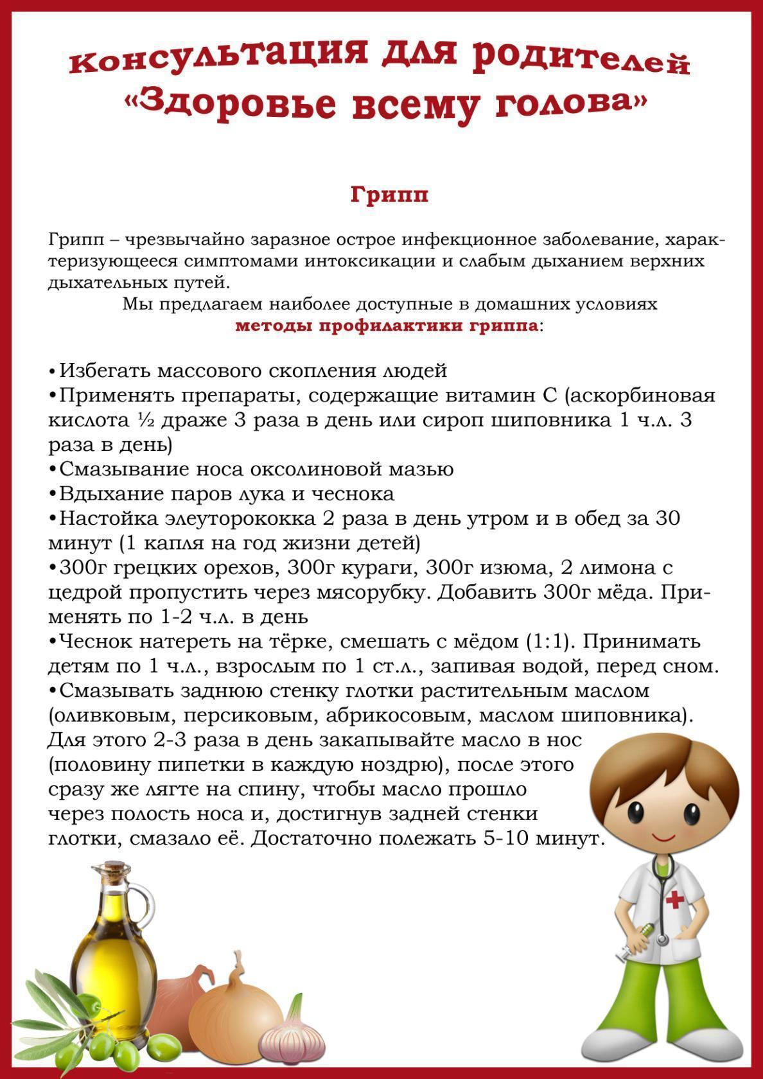](https://ok.ru/dk?cmd=PopLayerPhoto&st.layer.cmd=PopLayerPhotoOuter&st.layer.type=GROUP&st.layer.revNav=off&st.layer.limitedUi=false&st.layer.closeLayers=off&st.layer.sphotoIds=877271910196%3B877271910452%3B877271910708%3B877271910964%3B877271911220%3B877271911476&st.layer.showNav=on&st.layer.photoAlbumId=57249062780980&st.layer.epm=off&st.layer.photoId=877271911476&st.layer.opl=off&st.layer.navStartPhotoId=877271911476&st.layer.sbd=off&st.cmd=userMain&st._aid=GroupTopicLayer_openPhotoLayer)