[](https://ok.ru/dk?cmd=PopLayerPhoto&st.layer.cmd=PopLayerPhotoOuter&st.layer.type=GROUP&st.layer.revNav=off&st.layer.limitedUi=false&st.layer.closeLayers=off&st.layer.sphotoIds=877269344564%3B877269344820%3B877269345076%3B877269345332%3B877269345588%3B877269345844%3B877269346100&st.layer.showNav=on&st.layer.photoAlbumId=57249062780980&st.layer.epm=off&st.layer.photoId=877269344564&st.layer.opl=off&st.layer.navStartPhotoId=877269344564&st.layer.sbd=off&st.cmd=userMain&st._aid=GroupTopicLayer_openPhotoLayer)

[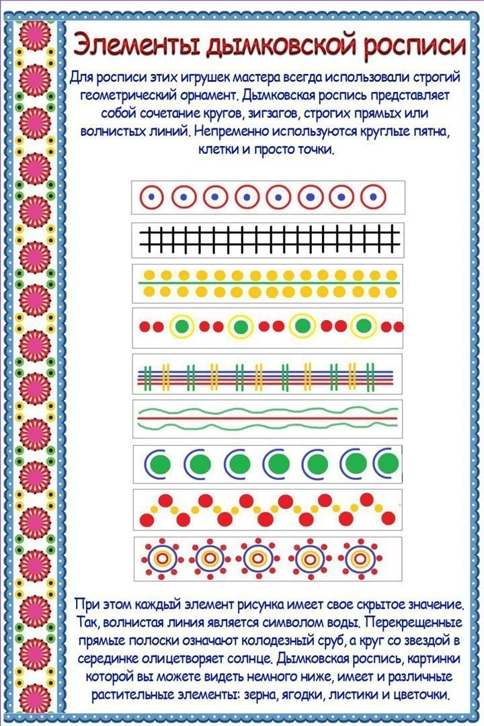](https://ok.ru/dk?cmd=PopLayerPhoto&st.layer.cmd=PopLayerPhotoOuter&st.layer.type=GROUP&st.layer.revNav=off&st.layer.limitedUi=false&st.layer.closeLayers=off&st.layer.sphotoIds=877269344564%3B877269344820%3B877269345076%3B877269345332%3B877269345588%3B877269345844%3B877269346100&st.layer.showNav=on&st.layer.photoAlbumId=57249062780980&st.layer.epm=off&st.layer.photoId=877269344820&st.layer.opl=off&st.layer.navStartPhotoId=877269344820&st.layer.sbd=off&st.cmd=userMain&st._aid=GroupTopicLayer_openPhotoLayer)

[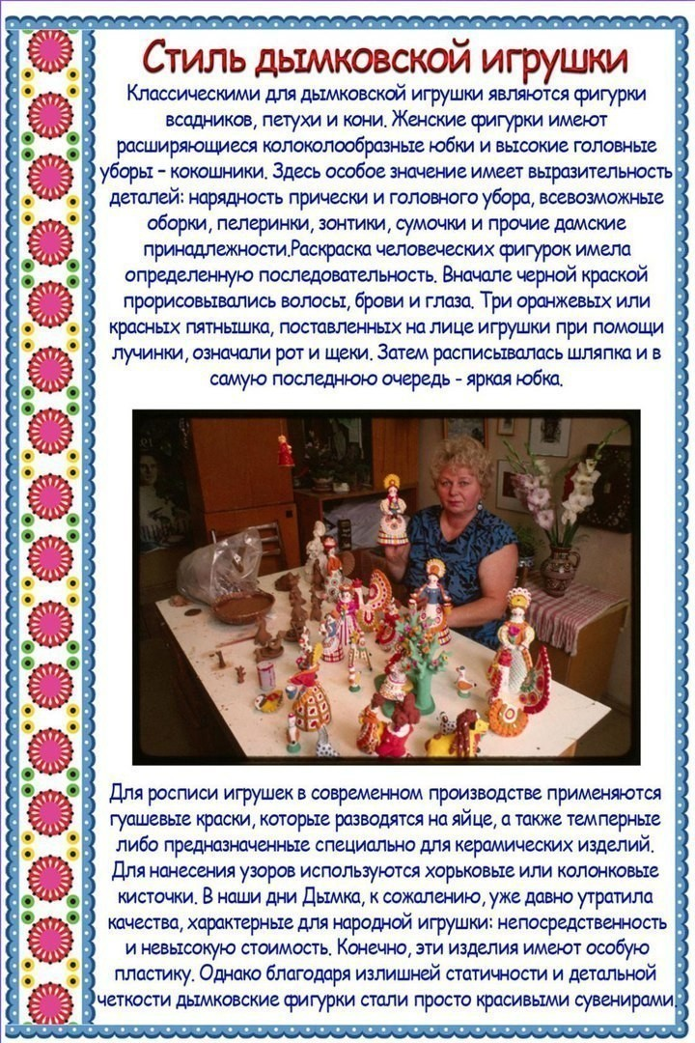](https://ok.ru/dk?cmd=PopLayerPhoto&st.layer.cmd=PopLayerPhotoOuter&st.layer.type=GROUP&st.layer.revNav=off&st.layer.limitedUi=false&st.layer.closeLayers=off&st.layer.sphotoIds=877269344564%3B877269344820%3B877269345076%3B877269345332%3B877269345588%3B877269345844%3B877269346100&st.layer.showNav=on&st.layer.photoAlbumId=57249062780980&st.layer.epm=off&st.layer.photoId=877269345076&st.layer.opl=off&st.layer.navStartPhotoId=877269345076&st.layer.sbd=off&st.cmd=userMain&st._aid=GroupTopicLayer_openPhotoLayer)

[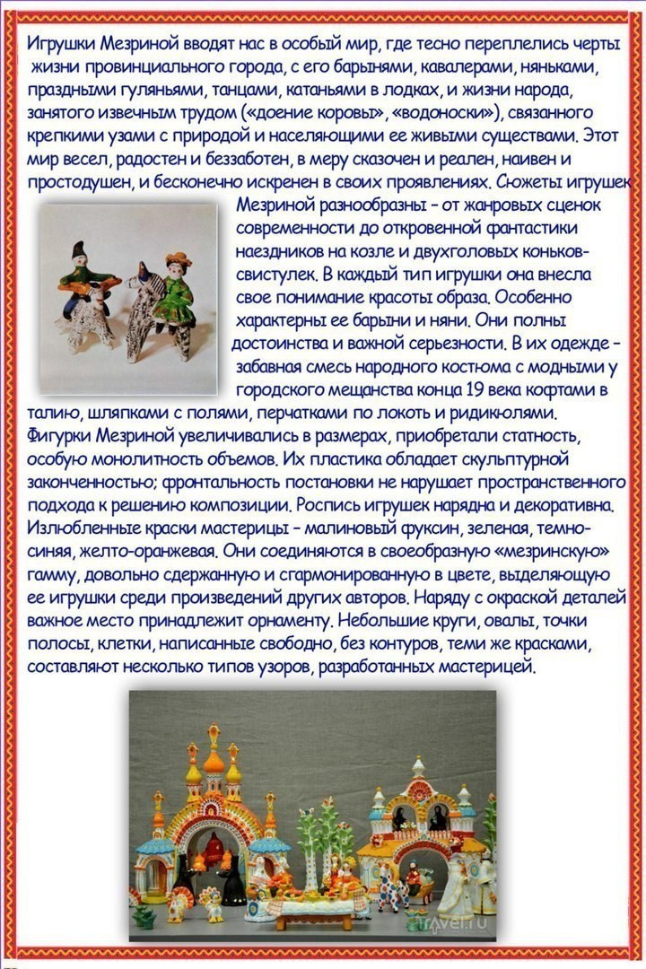](https://ok.ru/dk?cmd=PopLayerPhoto&st.layer.cmd=PopLayerPhotoOuter&st.layer.type=GROUP&st.layer.revNav=off&st.layer.limitedUi=false&st.layer.closeLayers=off&st.layer.sphotoIds=877269344564%3B877269344820%3B877269345076%3B877269345332%3B877269345588%3B877269345844%3B877269346100&st.layer.showNav=on&st.layer.photoAlbumId=57249062780980&st.layer.epm=off&st.layer.photoId=877269345332&st.layer.opl=off&st.layer.navStartPhotoId=877269345332&st.layer.sbd=off&st.cmd=userMain&st._aid=GroupTopicLayer_openPhotoLayer)

[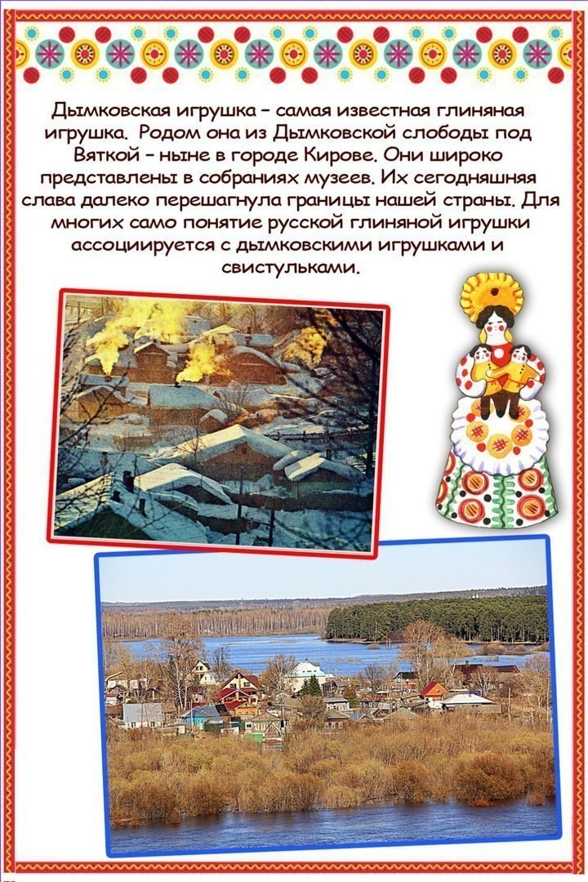](https://ok.ru/dk?cmd=PopLayerPhoto&st.layer.cmd=PopLayerPhotoOuter&st.layer.type=GROUP&st.layer.revNav=off&st.layer.limitedUi=false&st.layer.closeLayers=off&st.layer.sphotoIds=877269344564%3B877269344820%3B877269345076%3B877269345332%3B877269345588%3B877269345844%3B877269346100&st.layer.showNav=on&st.layer.photoAlbumId=57249062780980&st.layer.epm=off&st.layer.photoId=877269345588&st.layer.opl=off&st.layer.navStartPhotoId=877269345588&st.layer.sbd=off&st.cmd=userMain&st._aid=GroupTopicLayer_openPhotoLayer)

[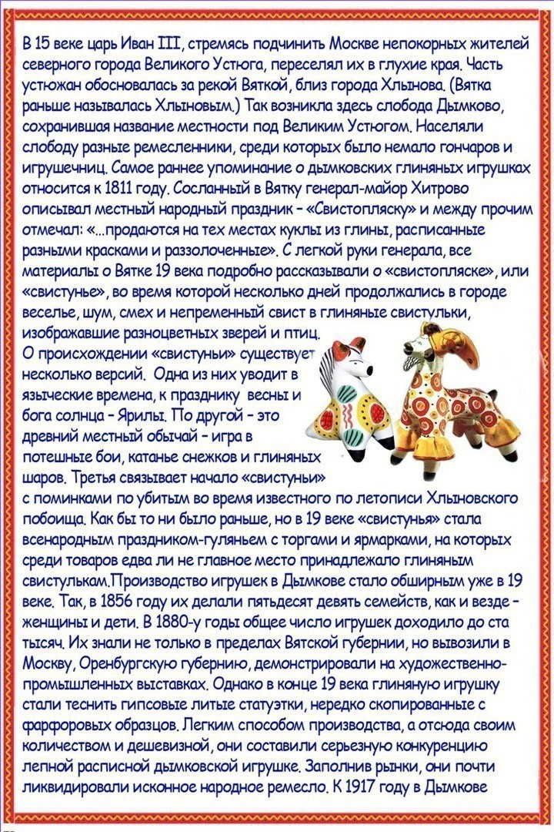](https://ok.ru/dk?cmd=PopLayerPhoto&st.layer.cmd=PopLayerPhotoOuter&st.layer.type=GROUP&st.layer.revNav=off&st.layer.limitedUi=false&st.layer.closeLayers=off&st.layer.sphotoIds=877269344564%3B877269344820%3B877269345076%3B877269345332%3B877269345588%3B877269345844%3B877269346100&st.layer.showNav=on&st.layer.photoAlbumId=57249062780980&st.layer.epm=off&st.layer.photoId=877269345844&st.layer.opl=off&st.layer.navStartPhotoId=877269345844&st.layer.sbd=off&st.cmd=userMain&st._aid=GroupTopicLayer_openPhotoLayer)

[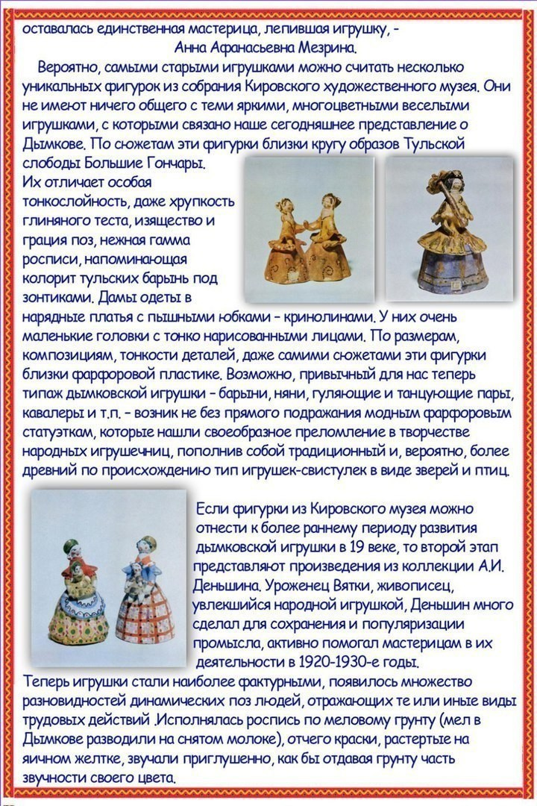](https://ok.ru/dk?cmd=PopLayerPhoto&st.layer.cmd=PopLayerPhotoOuter&st.layer.type=GROUP&st.layer.revNav=off&st.layer.limitedUi=false&st.layer.closeLayers=off&st.layer.sphotoIds=877269344564%3B877269344820%3B877269345076%3B877269345332%3B877269345588%3B877269345844%3B877269346100&st.layer.showNav=on&st.layer.photoAlbumId=57249062780980&st.layer.epm=off&st.layer.photoId=877269346100&st.layer.opl=off&st.layer.navStartPhotoId=877269346100&st.layer.sbd=off&st.cmd=userMain&st._aid=GroupTopicLayer_openPhotoLayer)