Графические диктанты

[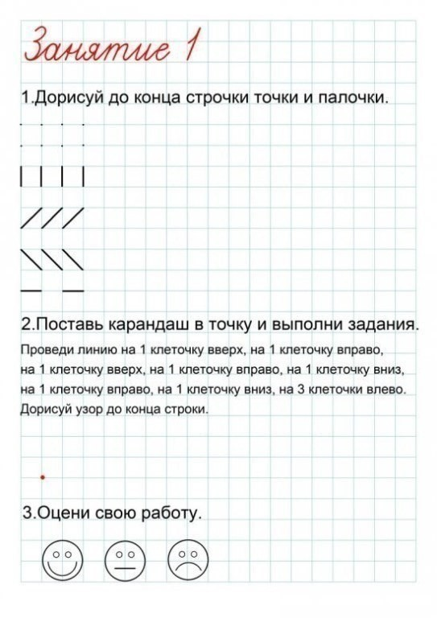](https://ok.ru/dk?cmd=PopLayerPhoto&st.layer.cmd=PopLayerPhotoOuter&st.layer.type=GROUP&st.layer.revNav=off&st.layer.limitedUi=false&st.layer.closeLayers=off&st.layer.sphotoIds=877675272756%3B877675273012%3B877675273268%3B877675273524%3B877675273780%3B877675274036%3B877675274292%3B877675274548%3B877675274804%3B877675275060&st.layer.showNav=on&st.layer.photoAlbumId=57249062780980&st.layer.epm=off&st.layer.photoId=877675272756&st.layer.opl=off&st.layer.navStartPhotoId=877675272756&st.layer.sbd=off&st.cmd=userMain&st._aid=GroupTopicLayer_openPhotoLayer)

[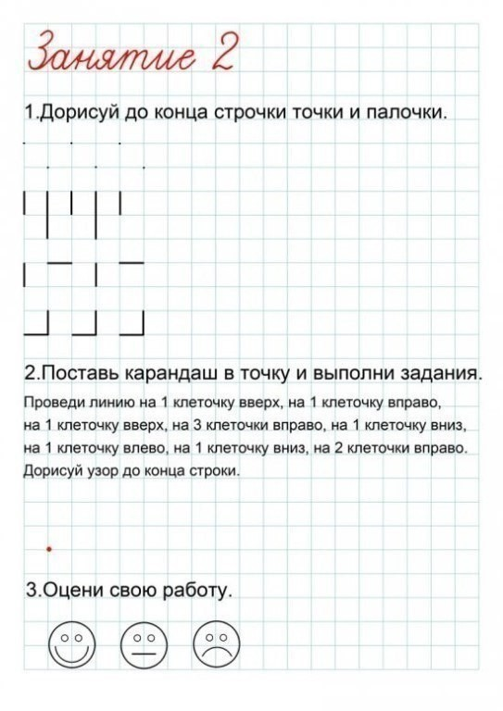](https://ok.ru/dk?cmd=PopLayerPhoto&st.layer.cmd=PopLayerPhotoOuter&st.layer.type=GROUP&st.layer.revNav=off&st.layer.limitedUi=false&st.layer.closeLayers=off&st.layer.sphotoIds=877675272756%3B877675273012%3B877675273268%3B877675273524%3B877675273780%3B877675274036%3B877675274292%3B877675274548%3B877675274804%3B877675275060&st.layer.showNav=on&st.layer.photoAlbumId=57249062780980&st.layer.epm=off&st.layer.photoId=877675273012&st.layer.opl=off&st.layer.navStartPhotoId=877675273012&st.layer.sbd=off&st.cmd=userMain&st._aid=GroupTopicLayer_openPhotoLayer)

[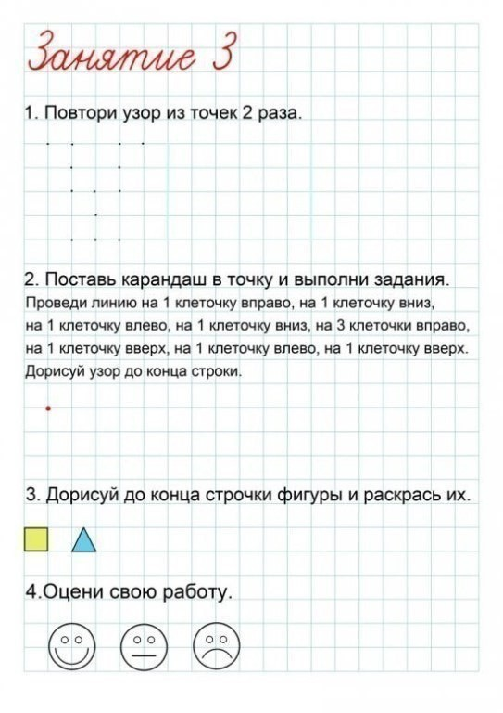](https://ok.ru/dk?cmd=PopLayerPhoto&st.layer.cmd=PopLayerPhotoOuter&st.layer.type=GROUP&st.layer.revNav=off&st.layer.limitedUi=false&st.layer.closeLayers=off&st.layer.sphotoIds=877675272756%3B877675273012%3B877675273268%3B877675273524%3B877675273780%3B877675274036%3B877675274292%3B877675274548%3B877675274804%3B877675275060&st.layer.showNav=on&st.layer.photoAlbumId=57249062780980&st.layer.epm=off&st.layer.photoId=877675273268&st.layer.opl=off&st.layer.navStartPhotoId=877675273268&st.layer.sbd=off&st.cmd=userMain&st._aid=GroupTopicLayer_openPhotoLayer)

[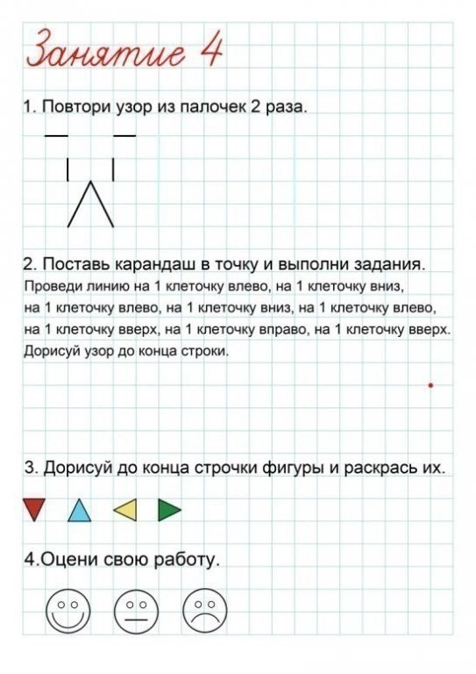](https://ok.ru/dk?cmd=PopLayerPhoto&st.layer.cmd=PopLayerPhotoOuter&st.layer.type=GROUP&st.layer.revNav=off&st.layer.limitedUi=false&st.layer.closeLayers=off&st.layer.sphotoIds=877675272756%3B877675273012%3B877675273268%3B877675273524%3B877675273780%3B877675274036%3B877675274292%3B877675274548%3B877675274804%3B877675275060&st.layer.showNav=on&st.layer.photoAlbumId=57249062780980&st.layer.epm=off&st.layer.photoId=877675273524&st.layer.opl=off&st.layer.navStartPhotoId=877675273524&st.layer.sbd=off&st.cmd=userMain&st._aid=GroupTopicLayer_openPhotoLayer)

[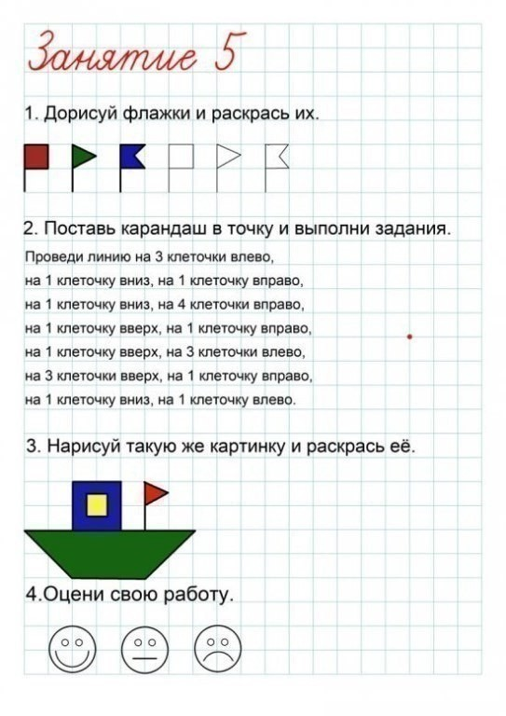](https://ok.ru/dk?cmd=PopLayerPhoto&st.layer.cmd=PopLayerPhotoOuter&st.layer.type=GROUP&st.layer.revNav=off&st.layer.limitedUi=false&st.layer.closeLayers=off&st.layer.sphotoIds=877675272756%3B877675273012%3B877675273268%3B877675273524%3B877675273780%3B877675274036%3B877675274292%3B877675274548%3B877675274804%3B877675275060&st.layer.showNav=on&st.layer.photoAlbumId=57249062780980&st.layer.epm=off&st.layer.photoId=877675273780&st.layer.opl=off&st.layer.navStartPhotoId=877675273780&st.layer.sbd=off&st.cmd=userMain&st._aid=GroupTopicLayer_openPhotoLayer)

[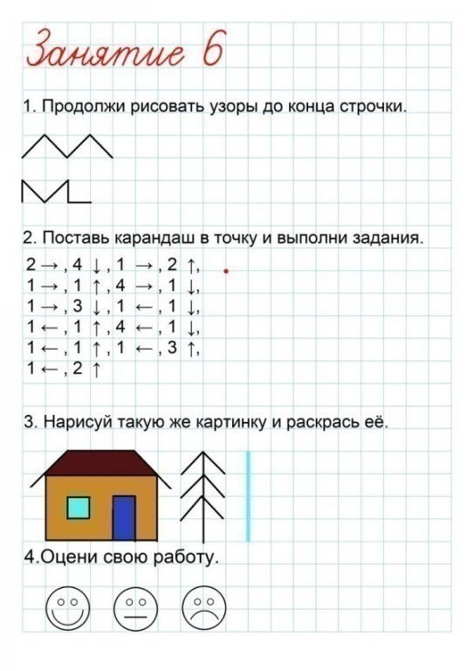](https://ok.ru/dk?cmd=PopLayerPhoto&st.layer.cmd=PopLayerPhotoOuter&st.layer.type=GROUP&st.layer.revNav=off&st.layer.limitedUi=false&st.layer.closeLayers=off&st.layer.sphotoIds=877675272756%3B877675273012%3B877675273268%3B877675273524%3B877675273780%3B877675274036%3B877675274292%3B877675274548%3B877675274804%3B877675275060&st.layer.showNav=on&st.layer.photoAlbumId=57249062780980&st.layer.epm=off&st.layer.photoId=877675274036&st.layer.opl=off&st.layer.navStartPhotoId=877675274036&st.layer.sbd=off&st.cmd=userMain&st._aid=GroupTopicLayer_openPhotoLayer)

[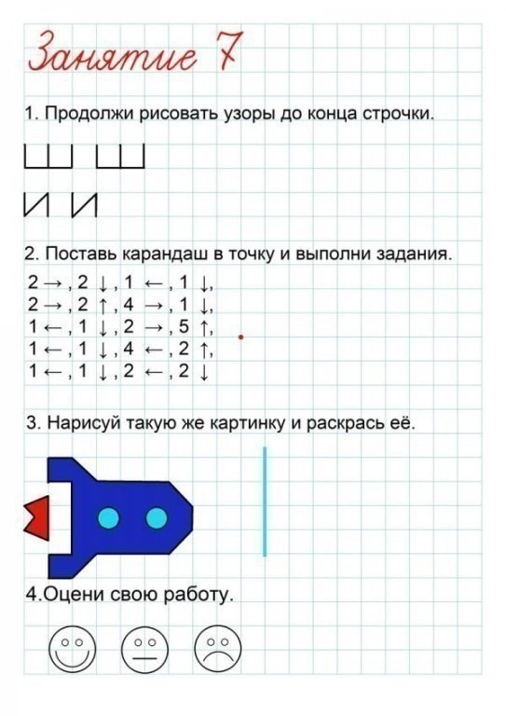](https://ok.ru/dk?cmd=PopLayerPhoto&st.layer.cmd=PopLayerPhotoOuter&st.layer.type=GROUP&st.layer.revNav=off&st.layer.limitedUi=false&st.layer.closeLayers=off&st.layer.sphotoIds=877675272756%3B877675273012%3B877675273268%3B877675273524%3B877675273780%3B877675274036%3B877675274292%3B877675274548%3B877675274804%3B877675275060&st.layer.showNav=on&st.layer.photoAlbumId=57249062780980&st.layer.epm=off&st.layer.photoId=877675274292&st.layer.opl=off&st.layer.navStartPhotoId=877675274292&st.layer.sbd=off&st.cmd=userMain&st._aid=GroupTopicLayer_openPhotoLayer)

[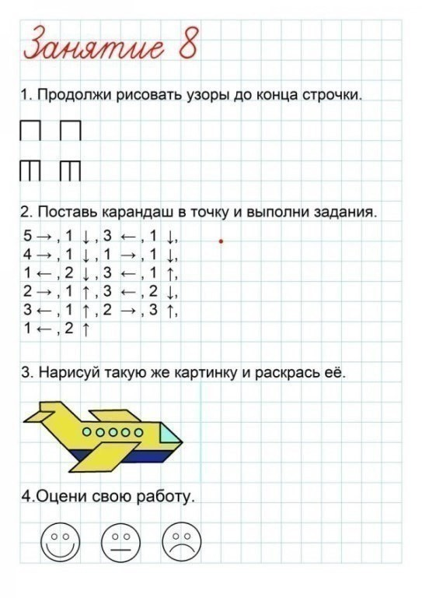](https://ok.ru/dk?cmd=PopLayerPhoto&st.layer.cmd=PopLayerPhotoOuter&st.layer.type=GROUP&st.layer.revNav=off&st.layer.limitedUi=false&st.layer.closeLayers=off&st.layer.sphotoIds=877675272756%3B877675273012%3B877675273268%3B877675273524%3B877675273780%3B877675274036%3B877675274292%3B877675274548%3B877675274804%3B877675275060&st.layer.showNav=on&st.layer.photoAlbumId=57249062780980&st.layer.epm=off&st.layer.photoId=877675274548&st.layer.opl=off&st.layer.navStartPhotoId=877675274548&st.layer.sbd=off&st.cmd=userMain&st._aid=GroupTopicLayer_openPhotoLayer)

[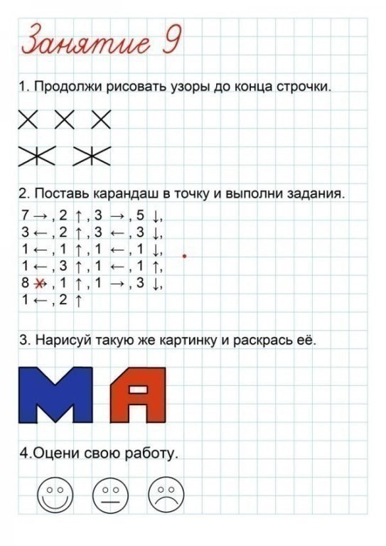](https://ok.ru/dk?cmd=PopLayerPhoto&st.layer.cmd=PopLayerPhotoOuter&st.layer.type=GROUP&st.layer.revNav=off&st.layer.limitedUi=false&st.layer.closeLayers=off&st.layer.sphotoIds=877675272756%3B877675273012%3B877675273268%3B877675273524%3B877675273780%3B877675274036%3B877675274292%3B877675274548%3B877675274804%3B877675275060&st.layer.showNav=on&st.layer.photoAlbumId=57249062780980&st.layer.epm=off&st.layer.photoId=877675274804&st.layer.opl=off&st.layer.navStartPhotoId=877675274804&st.layer.sbd=off&st.cmd=userMain&st._aid=GroupTopicLayer_openPhotoLayer)

[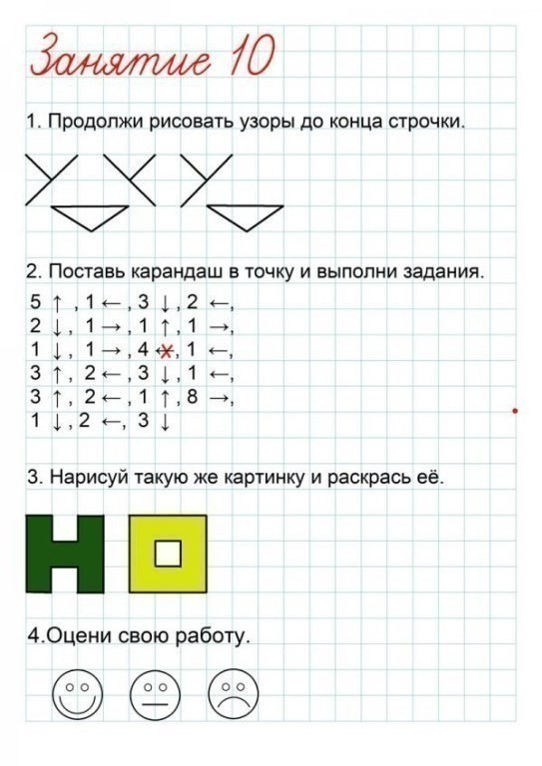](https://ok.ru/dk?cmd=PopLayerPhoto&st.layer.cmd=PopLayerPhotoOuter&st.layer.type=GROUP&st.layer.revNav=off&st.layer.limitedUi=false&st.layer.closeLayers=off&st.layer.sphotoIds=877675272756%3B877675273012%3B877675273268%3B877675273524%3B877675273780%3B877675274036%3B877675274292%3B877675274548%3B877675274804%3B877675275060&st.layer.showNav=on&st.layer.photoAlbumId=57249062780980&st.layer.epm=off&st.layer.photoId=877675275060&st.layer.opl=off&st.layer.navStartPhotoId=877675275060&st.layer.sbd=off&st.cmd=userMain&st._aid=GroupTopicLayer_openPhotoLayer)