[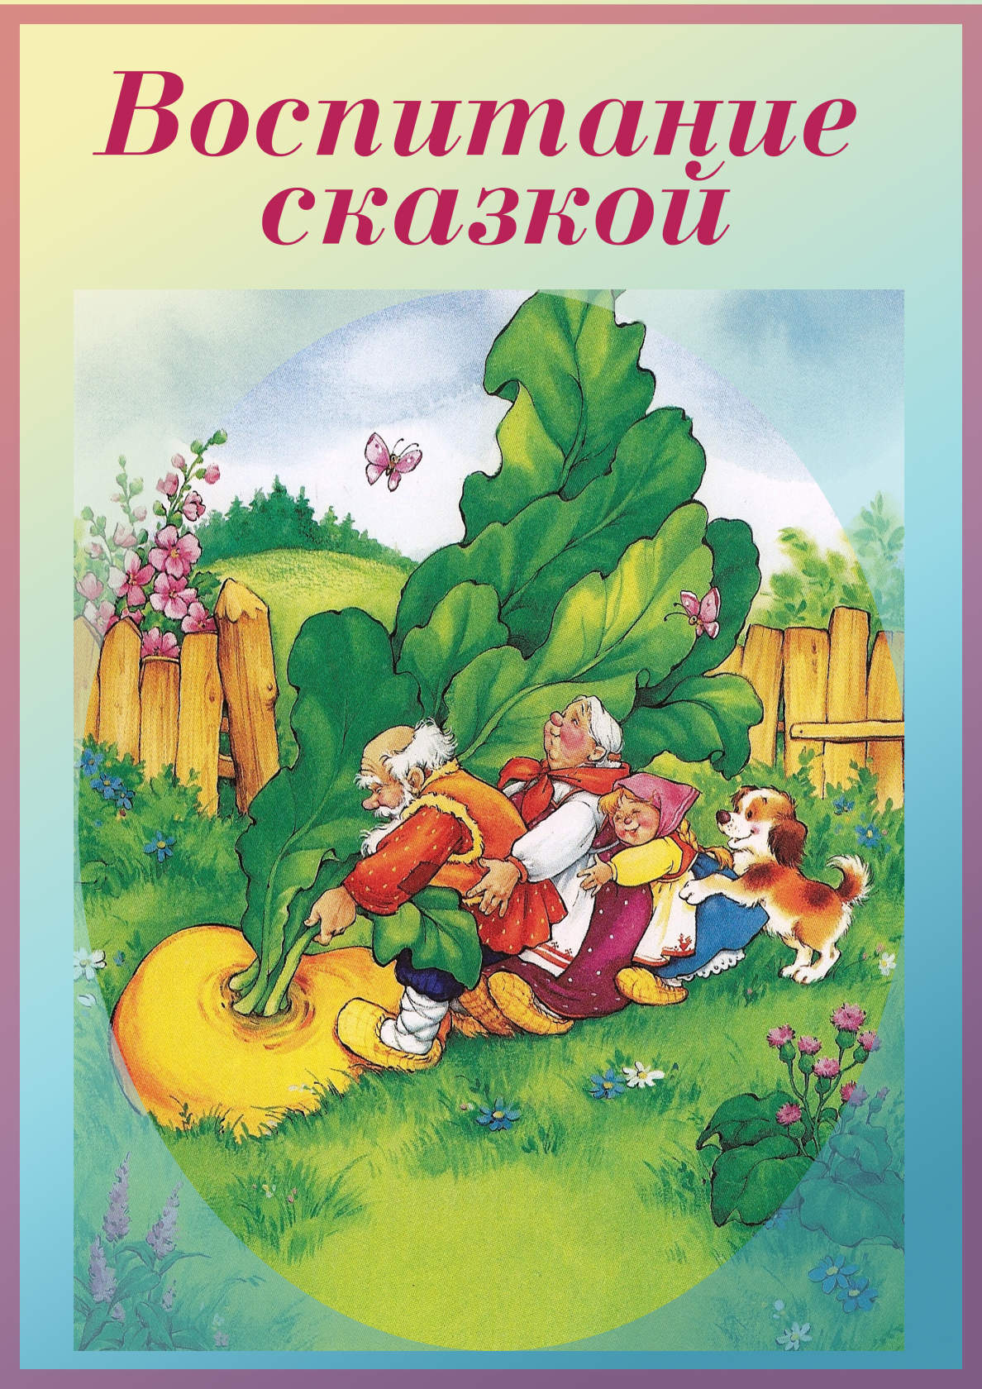](https://ok.ru/dk?cmd=PopLayerPhoto&st.layer.cmd=PopLayerPhotoOuter&st.layer.type=GROUP&st.layer.revNav=off&st.layer.limitedUi=false&st.layer.closeLayers=off&st.layer.sphotoIds=866490453059;866490452803;866490452547;866490452291;866490452035;866490451779&st.layer.showNav=on&st.layer.photoAlbumId=53073113251907&st.layer.epm=off&st.layer.photoId=866490453059&st.layer.opl=off&st.layer.navStartPhotoId=866490453059&st.layer.sbd=off&st.cmd=userMain&st._aid=GroupTopicLayer_openPhotoLayer)

[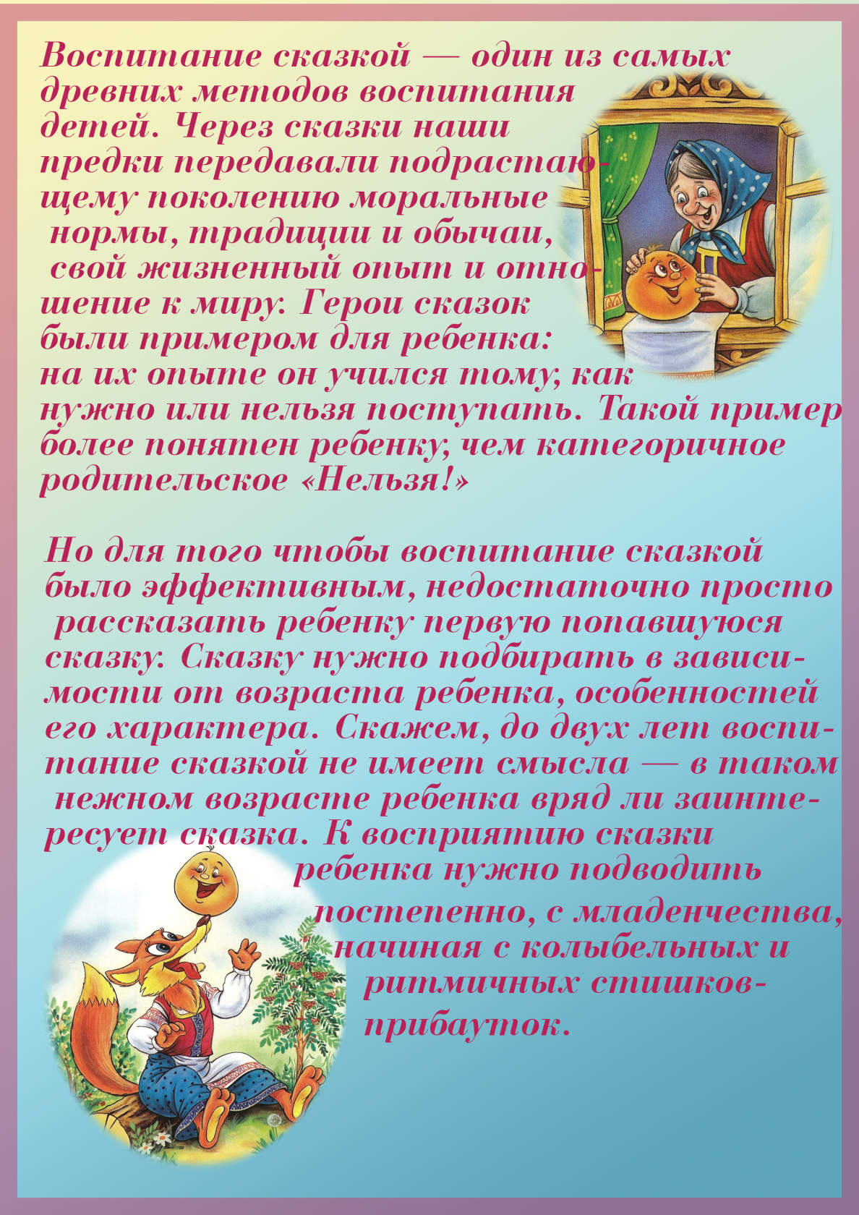](https://ok.ru/dk?cmd=PopLayerPhoto&st.layer.cmd=PopLayerPhotoOuter&st.layer.type=GROUP&st.layer.revNav=off&st.layer.limitedUi=false&st.layer.closeLayers=off&st.layer.sphotoIds=866490453059;866490452803;866490452547;866490452291;866490452035;866490451779&st.layer.showNav=on&st.layer.photoAlbumId=53073113251907&st.layer.epm=off&st.layer.photoId=866490452803&st.layer.opl=off&st.layer.navStartPhotoId=866490452803&st.layer.sbd=off&st.cmd=userMain&st._aid=GroupTopicLayer_openPhotoLayer)

[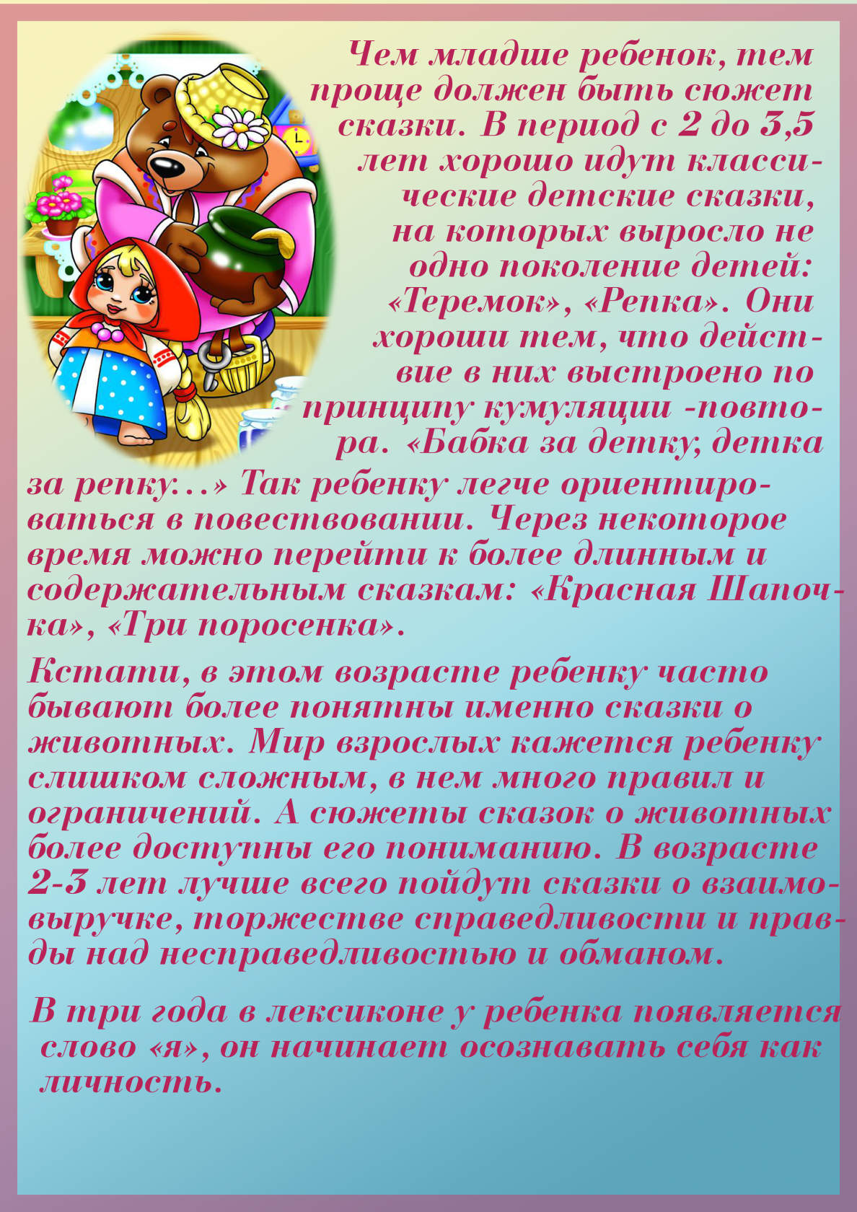](https://ok.ru/dk?cmd=PopLayerPhoto&st.layer.cmd=PopLayerPhotoOuter&st.layer.type=GROUP&st.layer.revNav=off&st.layer.limitedUi=false&st.layer.closeLayers=off&st.layer.sphotoIds=866490453059;866490452803;866490452547;866490452291;866490452035;866490451779&st.layer.showNav=on&st.layer.photoAlbumId=53073113251907&st.layer.epm=off&st.layer.photoId=866490452547&st.layer.opl=off&st.layer.navStartPhotoId=866490452547&st.layer.sbd=off&st.cmd=userMain&st._aid=GroupTopicLayer_openPhotoLayer)

[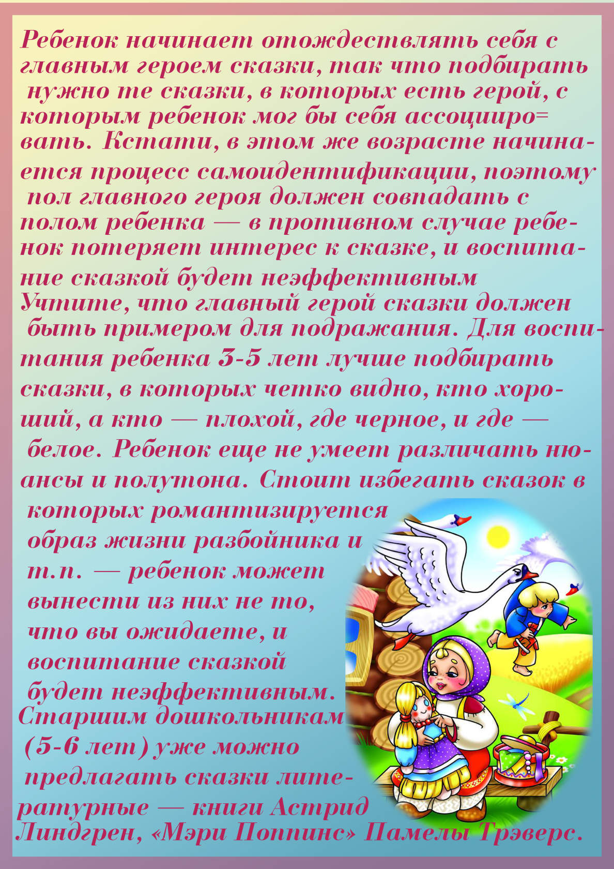](https://ok.ru/dk?cmd=PopLayerPhoto&st.layer.cmd=PopLayerPhotoOuter&st.layer.type=GROUP&st.layer.revNav=off&st.layer.limitedUi=false&st.layer.closeLayers=off&st.layer.sphotoIds=866490453059;866490452803;866490452547;866490452291;866490452035;866490451779&st.layer.showNav=on&st.layer.photoAlbumId=53073113251907&st.layer.epm=off&st.layer.photoId=866490452291&st.layer.opl=off&st.layer.navStartPhotoId=866490452291&st.layer.sbd=off&st.cmd=userMain&st._aid=GroupTopicLayer_openPhotoLayer)

[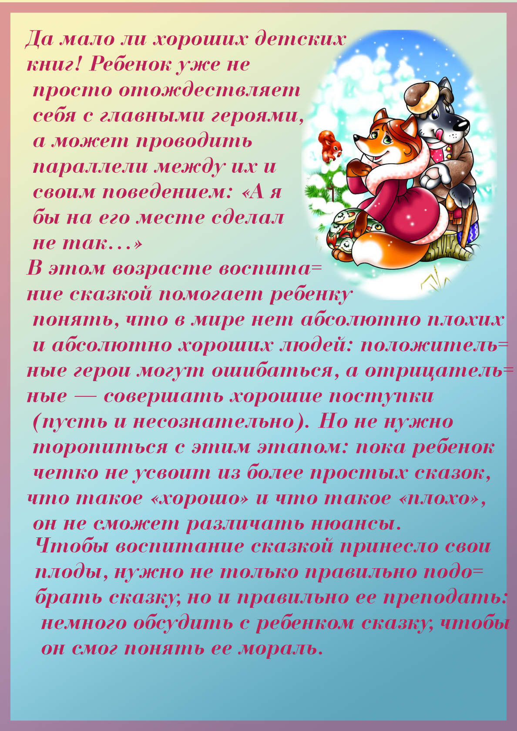](https://ok.ru/dk?cmd=PopLayerPhoto&st.layer.cmd=PopLayerPhotoOuter&st.layer.type=GROUP&st.layer.revNav=off&st.layer.limitedUi=false&st.layer.closeLayers=off&st.layer.sphotoIds=866490453059;866490452803;866490452547;866490452291;866490452035;866490451779&st.layer.showNav=on&st.layer.photoAlbumId=53073113251907&st.layer.epm=off&st.layer.photoId=866490452035&st.layer.opl=off&st.layer.navStartPhotoId=866490452035&st.layer.sbd=off&st.cmd=userMain&st._aid=GroupTopicLayer_openPhotoLayer)

[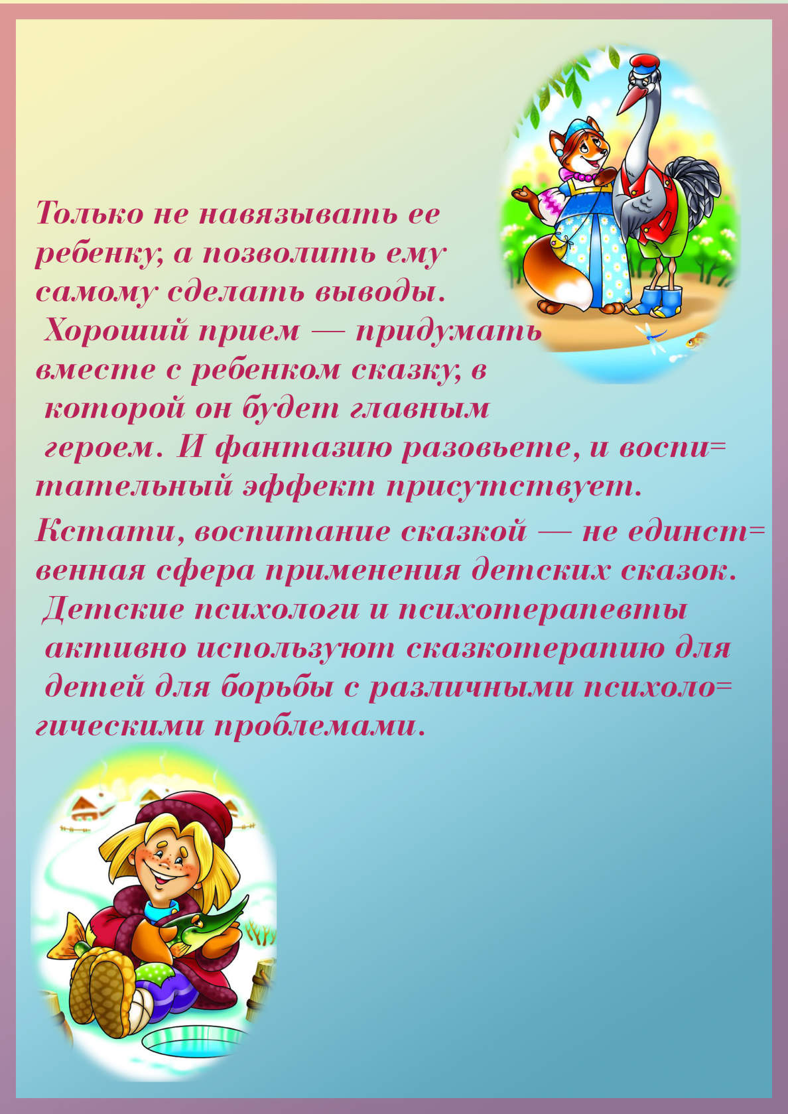](https://ok.ru/dk?cmd=PopLayerPhoto&st.layer.cmd=PopLayerPhotoOuter&st.layer.type=GROUP&st.layer.revNav=off&st.layer.limitedUi=false&st.layer.closeLayers=off&st.layer.sphotoIds=866490453059;866490452803;866490452547;866490452291;866490452035;866490451779&st.layer.showNav=on&st.layer.photoAlbumId=53073113251907&st.layer.epm=off&st.layer.photoId=866490451779&st.layer.opl=off&st.layer.navStartPhotoId=866490451779&st.layer.sbd=off&st.cmd=userMain&st._aid=GroupTopicLayer_openPhotoLayer)