[](https://ok.ru/dk?cmd=PopLayerPhoto&st.layer.cmd=PopLayerPhotoOuter&st.layer.type=GROUP&st.layer.revNav=off&st.layer.limitedUi=false&st.layer.closeLayers=off&st.layer.sphotoIds=877262355508%3B877262355764%3B877262356020%3B877262356276%3B877262356532%3B877262356788%3B877262357044&st.layer.showNav=on&st.layer.photoAlbumId=57249062780980&st.layer.epm=off&st.layer.photoId=877262355508&st.layer.opl=off&st.layer.navStartPhotoId=877262355508&st.layer.sbd=off&st.cmd=userMain&st._aid=GroupTopicLayer_openPhotoLayer)

[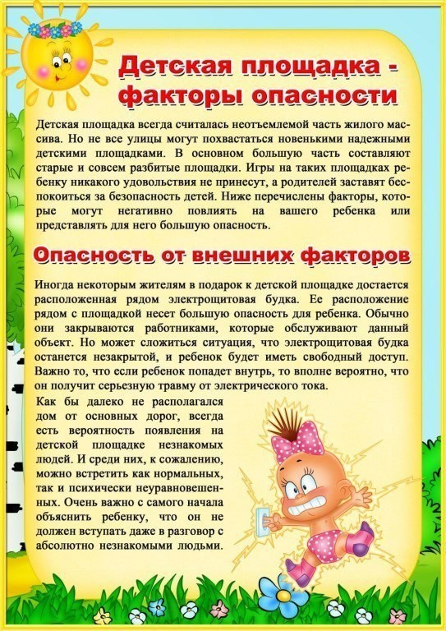](https://ok.ru/dk?cmd=PopLayerPhoto&st.layer.cmd=PopLayerPhotoOuter&st.layer.type=GROUP&st.layer.revNav=off&st.layer.limitedUi=false&st.layer.closeLayers=off&st.layer.sphotoIds=877262355508%3B877262355764%3B877262356020%3B877262356276%3B877262356532%3B877262356788%3B877262357044&st.layer.showNav=on&st.layer.photoAlbumId=57249062780980&st.layer.epm=off&st.layer.photoId=877262355764&st.layer.opl=off&st.layer.navStartPhotoId=877262355764&st.layer.sbd=off&st.cmd=userMain&st._aid=GroupTopicLayer_openPhotoLayer)

[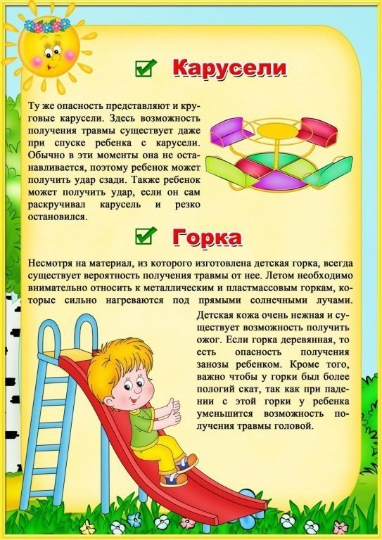](https://ok.ru/dk?cmd=PopLayerPhoto&st.layer.cmd=PopLayerPhotoOuter&st.layer.type=GROUP&st.layer.revNav=off&st.layer.limitedUi=false&st.layer.closeLayers=off&st.layer.sphotoIds=877262355508%3B877262355764%3B877262356020%3B877262356276%3B877262356532%3B877262356788%3B877262357044&st.layer.showNav=on&st.layer.photoAlbumId=57249062780980&st.layer.epm=off&st.layer.photoId=877262356020&st.layer.opl=off&st.layer.navStartPhotoId=877262356020&st.layer.sbd=off&st.cmd=userMain&st._aid=GroupTopicLayer_openPhotoLayer)

[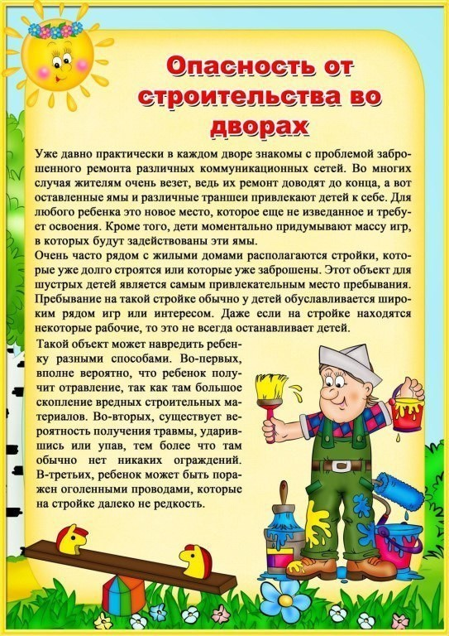](https://ok.ru/dk?cmd=PopLayerPhoto&st.layer.cmd=PopLayerPhotoOuter&st.layer.type=GROUP&st.layer.revNav=off&st.layer.limitedUi=false&st.layer.closeLayers=off&st.layer.sphotoIds=877262355508%3B877262355764%3B877262356020%3B877262356276%3B877262356532%3B877262356788%3B877262357044&st.layer.showNav=on&st.layer.photoAlbumId=57249062780980&st.layer.epm=off&st.layer.photoId=877262356276&st.layer.opl=off&st.layer.navStartPhotoId=877262356276&st.layer.sbd=off&st.cmd=userMain&st._aid=GroupTopicLayer_openPhotoLayer)

[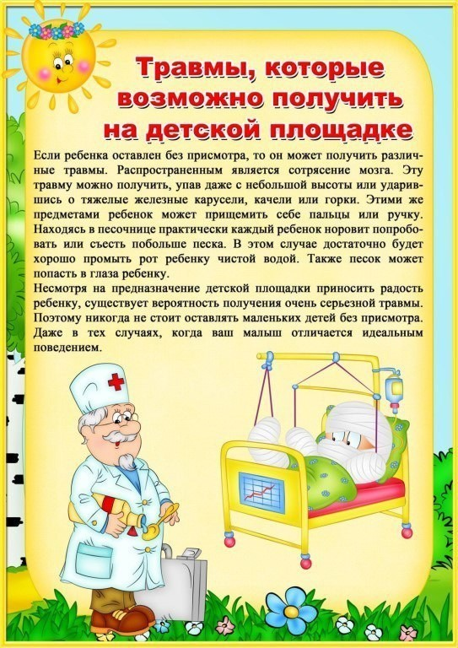](https://ok.ru/dk?cmd=PopLayerPhoto&st.layer.cmd=PopLayerPhotoOuter&st.layer.type=GROUP&st.layer.revNav=off&st.layer.limitedUi=false&st.layer.closeLayers=off&st.layer.sphotoIds=877262355508%3B877262355764%3B877262356020%3B877262356276%3B877262356532%3B877262356788%3B877262357044&st.layer.showNav=on&st.layer.photoAlbumId=57249062780980&st.layer.epm=off&st.layer.photoId=877262356532&st.layer.opl=off&st.layer.navStartPhotoId=877262356532&st.layer.sbd=off&st.cmd=userMain&st._aid=GroupTopicLayer_openPhotoLayer)

[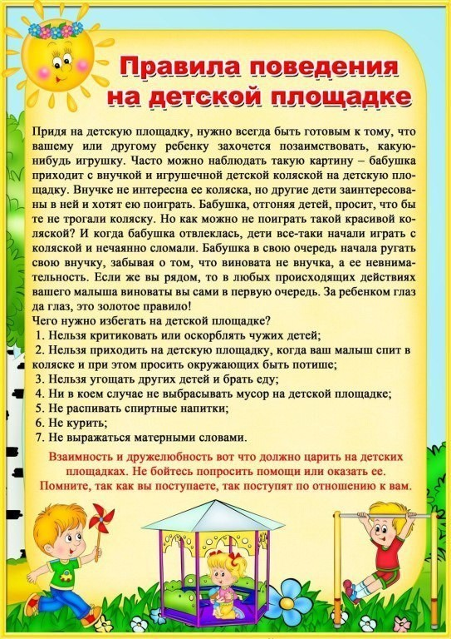](https://ok.ru/dk?cmd=PopLayerPhoto&st.layer.cmd=PopLayerPhotoOuter&st.layer.type=GROUP&st.layer.revNav=off&st.layer.limitedUi=false&st.layer.closeLayers=off&st.layer.sphotoIds=877262355508%3B877262355764%3B877262356020%3B877262356276%3B877262356532%3B877262356788%3B877262357044&st.layer.showNav=on&st.layer.photoAlbumId=57249062780980&st.layer.epm=off&st.layer.photoId=877262356788&st.layer.opl=off&st.layer.navStartPhotoId=877262356788&st.layer.sbd=off&st.cmd=userMain&st._aid=GroupTopicLayer_openPhotoLayer)

[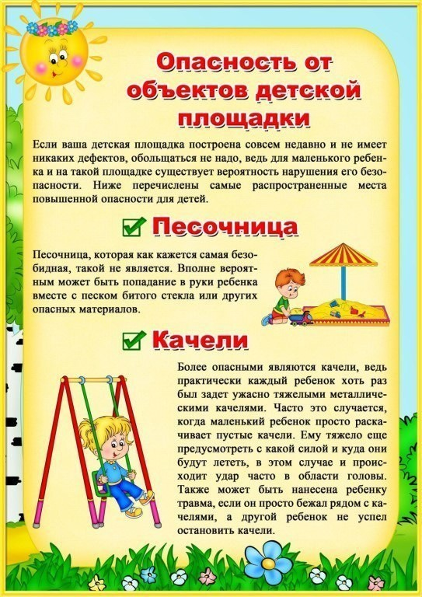](https://ok.ru/dk?cmd=PopLayerPhoto&st.layer.cmd=PopLayerPhotoOuter&st.layer.type=GROUP&st.layer.revNav=off&st.layer.limitedUi=false&st.layer.closeLayers=off&st.layer.sphotoIds=877262355508%3B877262355764%3B877262356020%3B877262356276%3B877262356532%3B877262356788%3B877262357044&st.layer.showNav=on&st.layer.photoAlbumId=57249062780980&st.layer.epm=off&st.layer.photoId=877262357044&st.layer.opl=off&st.layer.navStartPhotoId=877262357044&st.layer.sbd=off&st.cmd=userMain&st._aid=GroupTopicLayer_openPhotoLayer)