**Аппликации из ватных дисков. Идеи для творчества.**

[](https://ok.ru/dk?cmd=PopLayerPhoto&st.layer.cmd=PopLayerPhotoOuter&st.layer.type=GROUP&st.layer.revNav=off&st.layer.limitedUi=false&st.layer.closeLayers=off&st.layer.sphotoIds=877830974004%3B877830974260%3B877830974516%3B877830974772%3B877830975028%3B877830975284%3B877830975540%3B877830975796%3B877830976052%3B877830976308&st.layer.showNav=on&st.layer.photoAlbumId=57249062780980&st.layer.epm=off&st.layer.photoId=877830974004&st.layer.opl=off&st.layer.navStartPhotoId=877830974004&st.layer.sbd=off&st.cmd=userMain&st._aid=GroupTopicLayer_openPhotoLayer)

[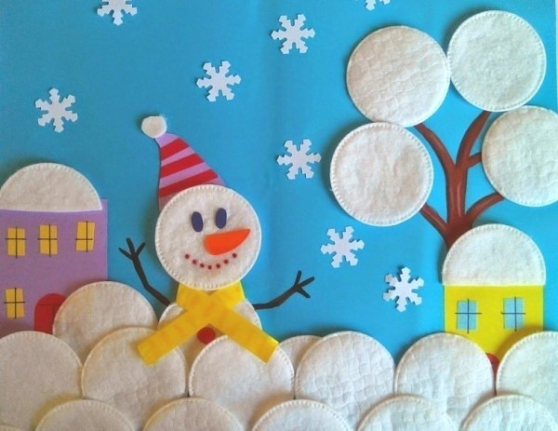](https://ok.ru/dk?cmd=PopLayerPhoto&st.layer.cmd=PopLayerPhotoOuter&st.layer.type=GROUP&st.layer.revNav=off&st.layer.limitedUi=false&st.layer.closeLayers=off&st.layer.sphotoIds=877830974004%3B877830974260%3B877830974516%3B877830974772%3B877830975028%3B877830975284%3B877830975540%3B877830975796%3B877830976052%3B877830976308&st.layer.showNav=on&st.layer.photoAlbumId=57249062780980&st.layer.epm=off&st.layer.photoId=877830974260&st.layer.opl=off&st.layer.navStartPhotoId=877830974260&st.layer.sbd=off&st.cmd=userMain&st._aid=GroupTopicLayer_openPhotoLayer)

[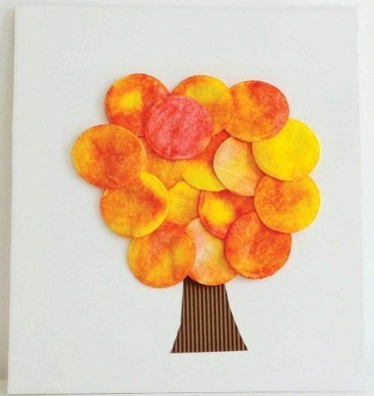](https://ok.ru/dk?cmd=PopLayerPhoto&st.layer.cmd=PopLayerPhotoOuter&st.layer.type=GROUP&st.layer.revNav=off&st.layer.limitedUi=false&st.layer.closeLayers=off&st.layer.sphotoIds=877830974004%3B877830974260%3B877830974516%3B877830974772%3B877830975028%3B877830975284%3B877830975540%3B877830975796%3B877830976052%3B877830976308&st.layer.showNav=on&st.layer.photoAlbumId=57249062780980&st.layer.epm=off&st.layer.photoId=877830974516&st.layer.opl=off&st.layer.navStartPhotoId=877830974516&st.layer.sbd=off&st.cmd=userMain&st._aid=GroupTopicLayer_openPhotoLayer)

[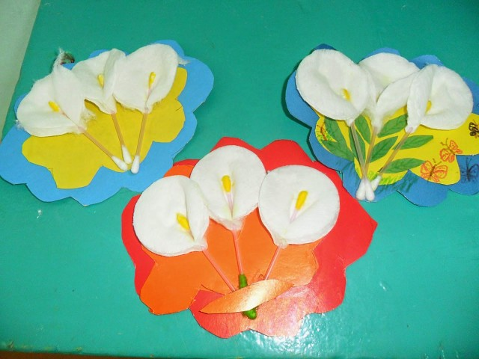](https://ok.ru/dk?cmd=PopLayerPhoto&st.layer.cmd=PopLayerPhotoOuter&st.layer.type=GROUP&st.layer.revNav=off&st.layer.limitedUi=false&st.layer.closeLayers=off&st.layer.sphotoIds=877830974004%3B877830974260%3B877830974516%3B877830974772%3B877830975028%3B877830975284%3B877830975540%3B877830975796%3B877830976052%3B877830976308&st.layer.showNav=on&st.layer.photoAlbumId=57249062780980&st.layer.epm=off&st.layer.photoId=877830974772&st.layer.opl=off&st.layer.navStartPhotoId=877830974772&st.layer.sbd=off&st.cmd=userMain&st._aid=GroupTopicLayer_openPhotoLayer)

[](https://ok.ru/dk?cmd=PopLayerPhoto&st.layer.cmd=PopLayerPhotoOuter&st.layer.type=GROUP&st.layer.revNav=off&st.layer.limitedUi=false&st.layer.closeLayers=off&st.layer.sphotoIds=877830974004%3B877830974260%3B877830974516%3B877830974772%3B877830975028%3B877830975284%3B877830975540%3B877830975796%3B877830976052%3B877830976308&st.layer.showNav=on&st.layer.photoAlbumId=57249062780980&st.layer.epm=off&st.layer.photoId=877830975028&st.layer.opl=off&st.layer.navStartPhotoId=877830975028&st.layer.sbd=off&st.cmd=userMain&st._aid=GroupTopicLayer_openPhotoLayer)

[](https://ok.ru/dk?cmd=PopLayerPhoto&st.layer.cmd=PopLayerPhotoOuter&st.layer.type=GROUP&st.layer.revNav=off&st.layer.limitedUi=false&st.layer.closeLayers=off&st.layer.sphotoIds=877830974004%3B877830974260%3B877830974516%3B877830974772%3B877830975028%3B877830975284%3B877830975540%3B877830975796%3B877830976052%3B877830976308&st.layer.showNav=on&st.layer.photoAlbumId=57249062780980&st.layer.epm=off&st.layer.photoId=877830975284&st.layer.opl=off&st.layer.navStartPhotoId=877830975284&st.layer.sbd=off&st.cmd=userMain&st._aid=GroupTopicLayer_openPhotoLayer)

[](https://ok.ru/dk?cmd=PopLayerPhoto&st.layer.cmd=PopLayerPhotoOuter&st.layer.type=GROUP&st.layer.revNav=off&st.layer.limitedUi=false&st.layer.closeLayers=off&st.layer.sphotoIds=877830974004%3B877830974260%3B877830974516%3B877830974772%3B877830975028%3B877830975284%3B877830975540%3B877830975796%3B877830976052%3B877830976308&st.layer.showNav=on&st.layer.photoAlbumId=57249062780980&st.layer.epm=off&st.layer.photoId=877830975540&st.layer.opl=off&st.layer.navStartPhotoId=877830975540&st.layer.sbd=off&st.cmd=userMain&st._aid=GroupTopicLayer_openPhotoLayer)

[](https://ok.ru/dk?cmd=PopLayerPhoto&st.layer.cmd=PopLayerPhotoOuter&st.layer.type=GROUP&st.layer.revNav=off&st.layer.limitedUi=false&st.layer.closeLayers=off&st.layer.sphotoIds=877830974004%3B877830974260%3B877830974516%3B877830974772%3B877830975028%3B877830975284%3B877830975540%3B877830975796%3B877830976052%3B877830976308&st.layer.showNav=on&st.layer.photoAlbumId=57249062780980&st.layer.epm=off&st.layer.photoId=877830975796&st.layer.opl=off&st.layer.navStartPhotoId=877830975796&st.layer.sbd=off&st.cmd=userMain&st._aid=GroupTopicLayer_openPhotoLayer)

[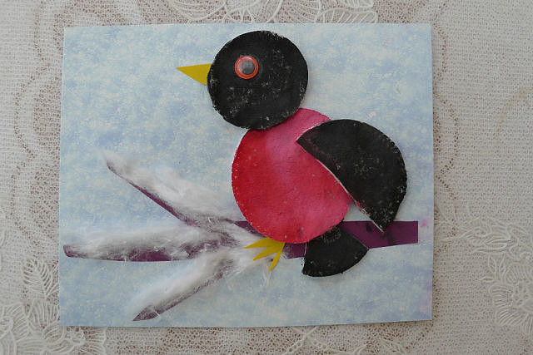](https://ok.ru/dk?cmd=PopLayerPhoto&st.layer.cmd=PopLayerPhotoOuter&st.layer.type=GROUP&st.layer.revNav=off&st.layer.limitedUi=false&st.layer.closeLayers=off&st.layer.sphotoIds=877830974004%3B877830974260%3B877830974516%3B877830974772%3B877830975028%3B877830975284%3B877830975540%3B877830975796%3B877830976052%3B877830976308&st.layer.showNav=on&st.layer.photoAlbumId=57249062780980&st.layer.epm=off&st.layer.photoId=877830976052&st.layer.opl=off&st.layer.navStartPhotoId=877830976052&st.layer.sbd=off&st.cmd=userMain&st._aid=GroupTopicLayer_openPhotoLayer)

[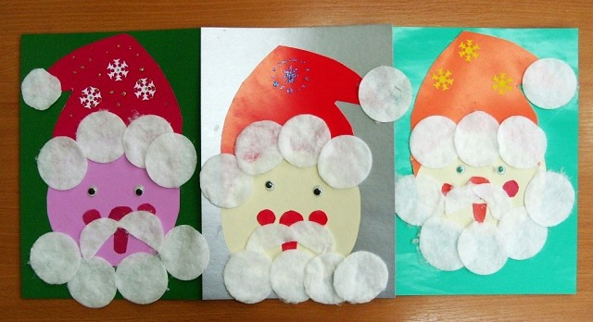](https://ok.ru/dk?cmd=PopLayerPhoto&st.layer.cmd=PopLayerPhotoOuter&st.layer.type=GROUP&st.layer.revNav=off&st.layer.limitedUi=false&st.layer.closeLayers=off&st.layer.sphotoIds=877830974004%3B877830974260%3B877830974516%3B877830974772%3B877830975028%3B877830975284%3B877830975540%3B877830975796%3B877830976052%3B877830976308&st.layer.showNav=on&st.layer.photoAlbumId=57249062780980&st.layer.epm=off&st.layer.photoId=877830976308&st.layer.opl=off&st.layer.navStartPhotoId=877830976308&st.layer.sbd=off&st.cmd=userMain&st._aid=GroupTopicLayer_openPhotoLayer)