[](https://ok.ru/dk?cmd=PopLayerPhoto&st.layer.cmd=PopLayerPhotoOuter&st.layer.type=GROUP&st.layer.revNav=off&st.layer.limitedUi=false&st.layer.closeLayers=off&st.layer.sphotoIds=877365274069%3B877365273813%3B877365273557%3B877365273301%3B877365273045%3B877365272789%3B877365272533%3B877365272277%3B877365272021%3B877365271765%3B877365271509%3B877365271253%3B877365270997%3B877365270741%3B877365270485%3B877365270229%3B877365269973%3B877365269717%3B877365269461%3B877365269205&st.layer.showNav=on&st.layer.photoAlbumId=52406096429269&st.layer.epm=off&st.layer.photoId=877365274069&st.layer.opl=off&st.layer.navStartPhotoId=877365274069&st.layer.sbd=off&st.cmd=userMain&st.openPanel=feed&st._aid=GroupTopicLayer_openPhotoLayer)

[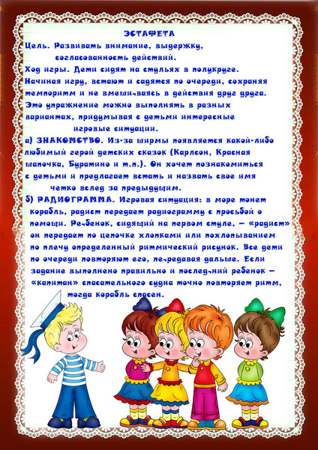](https://ok.ru/dk?cmd=PopLayerPhoto&st.layer.cmd=PopLayerPhotoOuter&st.layer.type=GROUP&st.layer.revNav=off&st.layer.limitedUi=false&st.layer.closeLayers=off&st.layer.sphotoIds=877365274069%3B877365273813%3B877365273557%3B877365273301%3B877365273045%3B877365272789%3B877365272533%3B877365272277%3B877365272021%3B877365271765%3B877365271509%3B877365271253%3B877365270997%3B877365270741%3B877365270485%3B877365270229%3B877365269973%3B877365269717%3B877365269461%3B877365269205&st.layer.showNav=on&st.layer.photoAlbumId=52406096429269&st.layer.epm=off&st.layer.photoId=877365273813&st.layer.opl=off&st.layer.navStartPhotoId=877365273813&st.layer.sbd=off&st.cmd=userMain&st.openPanel=feed&st._aid=GroupTopicLayer_openPhotoLayer)

[](https://ok.ru/dk?cmd=PopLayerPhoto&st.layer.cmd=PopLayerPhotoOuter&st.layer.type=GROUP&st.layer.revNav=off&st.layer.limitedUi=false&st.layer.closeLayers=off&st.layer.sphotoIds=877365274069%3B877365273813%3B877365273557%3B877365273301%3B877365273045%3B877365272789%3B877365272533%3B877365272277%3B877365272021%3B877365271765%3B877365271509%3B877365271253%3B877365270997%3B877365270741%3B877365270485%3B877365270229%3B877365269973%3B877365269717%3B877365269461%3B877365269205&st.layer.showNav=on&st.layer.photoAlbumId=52406096429269&st.layer.epm=off&st.layer.photoId=877365273557&st.layer.opl=off&st.layer.navStartPhotoId=877365273557&st.layer.sbd=off&st.cmd=userMain&st.openPanel=feed&st._aid=GroupTopicLayer_openPhotoLayer)

[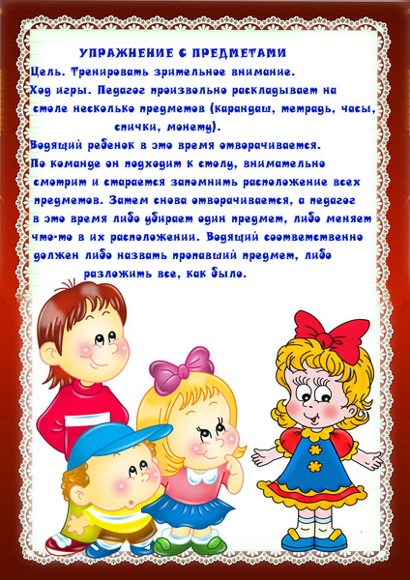](https://ok.ru/dk?cmd=PopLayerPhoto&st.layer.cmd=PopLayerPhotoOuter&st.layer.type=GROUP&st.layer.revNav=off&st.layer.limitedUi=false&st.layer.closeLayers=off&st.layer.sphotoIds=877365274069%3B877365273813%3B877365273557%3B877365273301%3B877365273045%3B877365272789%3B877365272533%3B877365272277%3B877365272021%3B877365271765%3B877365271509%3B877365271253%3B877365270997%3B877365270741%3B877365270485%3B877365270229%3B877365269973%3B877365269717%3B877365269461%3B877365269205&st.layer.showNav=on&st.layer.photoAlbumId=52406096429269&st.layer.epm=off&st.layer.photoId=877365273301&st.layer.opl=off&st.layer.navStartPhotoId=877365273301&st.layer.sbd=off&st.cmd=userMain&st.openPanel=feed&st._aid=GroupTopicLayer_openPhotoLayer)

[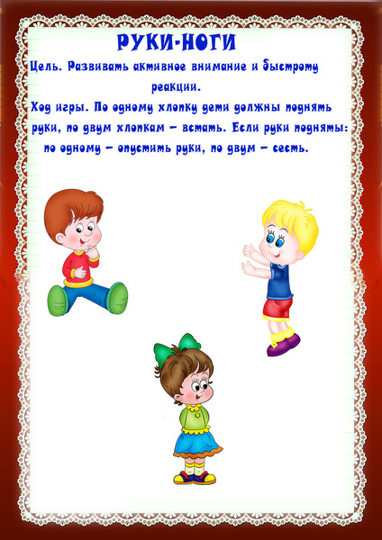](https://ok.ru/dk?cmd=PopLayerPhoto&st.layer.cmd=PopLayerPhotoOuter&st.layer.type=GROUP&st.layer.revNav=off&st.layer.limitedUi=false&st.layer.closeLayers=off&st.layer.sphotoIds=877365274069%3B877365273813%3B877365273557%3B877365273301%3B877365273045%3B877365272789%3B877365272533%3B877365272277%3B877365272021%3B877365271765%3B877365271509%3B877365271253%3B877365270997%3B877365270741%3B877365270485%3B877365270229%3B877365269973%3B877365269717%3B877365269461%3B877365269205&st.layer.showNav=on&st.layer.photoAlbumId=52406096429269&st.layer.epm=off&st.layer.photoId=877365273045&st.layer.opl=off&st.layer.navStartPhotoId=877365273045&st.layer.sbd=off&st.cmd=userMain&st.openPanel=feed&st._aid=GroupTopicLayer_openPhotoLayer)

[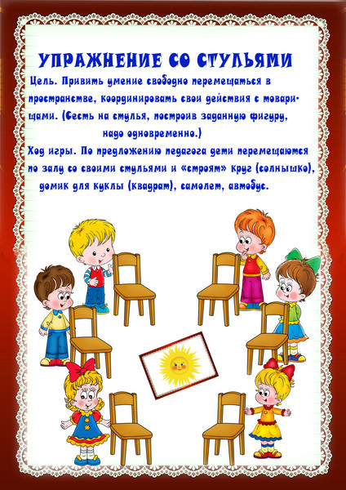](https://ok.ru/dk?cmd=PopLayerPhoto&st.layer.cmd=PopLayerPhotoOuter&st.layer.type=GROUP&st.layer.revNav=off&st.layer.limitedUi=false&st.layer.closeLayers=off&st.layer.sphotoIds=877365274069%3B877365273813%3B877365273557%3B877365273301%3B877365273045%3B877365272789%3B877365272533%3B877365272277%3B877365272021%3B877365271765%3B877365271509%3B877365271253%3B877365270997%3B877365270741%3B877365270485%3B877365270229%3B877365269973%3B877365269717%3B877365269461%3B877365269205&st.layer.showNav=on&st.layer.photoAlbumId=52406096429269&st.layer.epm=off&st.layer.photoId=877365272789&st.layer.opl=off&st.layer.navStartPhotoId=877365272789&st.layer.sbd=off&st.cmd=userMain&st.openPanel=feed&st._aid=GroupTopicLayer_openPhotoLayer)

[](https://ok.ru/dk?cmd=PopLayerPhoto&st.layer.cmd=PopLayerPhotoOuter&st.layer.type=GROUP&st.layer.revNav=off&st.layer.limitedUi=false&st.layer.closeLayers=off&st.layer.sphotoIds=877365274069%3B877365273813%3B877365273557%3B877365273301%3B877365273045%3B877365272789%3B877365272533%3B877365272277%3B877365272021%3B877365271765%3B877365271509%3B877365271253%3B877365270997%3B877365270741%3B877365270485%3B877365270229%3B877365269973%3B877365269717%3B877365269461%3B877365269205&st.layer.showNav=on&st.layer.photoAlbumId=52406096429269&st.layer.epm=off&st.layer.photoId=877365272533&st.layer.opl=off&st.layer.navStartPhotoId=877365272533&st.layer.sbd=off&st.cmd=userMain&st.openPanel=feed&st._aid=GroupTopicLayer_openPhotoLayer)

[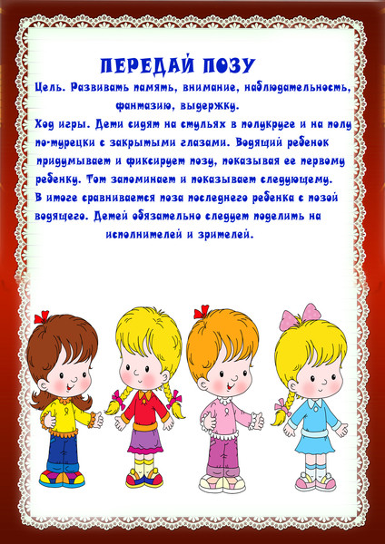](https://ok.ru/dk?cmd=PopLayerPhoto&st.layer.cmd=PopLayerPhotoOuter&st.layer.type=GROUP&st.layer.revNav=off&st.layer.limitedUi=false&st.layer.closeLayers=off&st.layer.sphotoIds=877365274069%3B877365273813%3B877365273557%3B877365273301%3B877365273045%3B877365272789%3B877365272533%3B877365272277%3B877365272021%3B877365271765%3B877365271509%3B877365271253%3B877365270997%3B877365270741%3B877365270485%3B877365270229%3B877365269973%3B877365269717%3B877365269461%3B877365269205&st.layer.showNav=on&st.layer.photoAlbumId=52406096429269&st.layer.epm=off&st.layer.photoId=877365272277&st.layer.opl=off&st.layer.navStartPhotoId=877365272277&st.layer.sbd=off&st.cmd=userMain&st.openPanel=feed&st._aid=GroupTopicLayer_openPhotoLayer)

[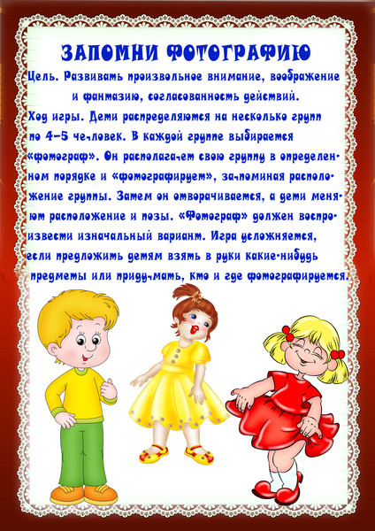](https://ok.ru/dk?cmd=PopLayerPhoto&st.layer.cmd=PopLayerPhotoOuter&st.layer.type=GROUP&st.layer.revNav=off&st.layer.limitedUi=false&st.layer.closeLayers=off&st.layer.sphotoIds=877365274069%3B877365273813%3B877365273557%3B877365273301%3B877365273045%3B877365272789%3B877365272533%3B877365272277%3B877365272021%3B877365271765%3B877365271509%3B877365271253%3B877365270997%3B877365270741%3B877365270485%3B877365270229%3B877365269973%3B877365269717%3B877365269461%3B877365269205&st.layer.showNav=on&st.layer.photoAlbumId=52406096429269&st.layer.epm=off&st.layer.photoId=877365272021&st.layer.opl=off&st.layer.navStartPhotoId=877365272021&st.layer.sbd=off&st.cmd=userMain&st.openPanel=feed&st._aid=GroupTopicLayer_openPhotoLayer)

[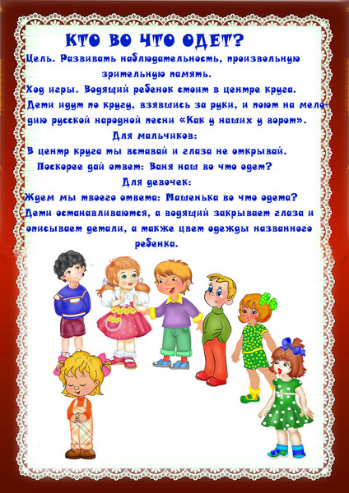](https://ok.ru/dk?cmd=PopLayerPhoto&st.layer.cmd=PopLayerPhotoOuter&st.layer.type=GROUP&st.layer.revNav=off&st.layer.limitedUi=false&st.layer.closeLayers=off&st.layer.sphotoIds=877365274069%3B877365273813%3B877365273557%3B877365273301%3B877365273045%3B877365272789%3B877365272533%3B877365272277%3B877365272021%3B877365271765%3B877365271509%3B877365271253%3B877365270997%3B877365270741%3B877365270485%3B877365270229%3B877365269973%3B877365269717%3B877365269461%3B877365269205&st.layer.showNav=on&st.layer.photoAlbumId=52406096429269&st.layer.epm=off&st.layer.photoId=877365271765&st.layer.opl=off&st.layer.navStartPhotoId=877365271765&st.layer.sbd=off&st.cmd=userMain&st.openPanel=feed&st._aid=GroupTopicLayer_openPhotoLayer)

[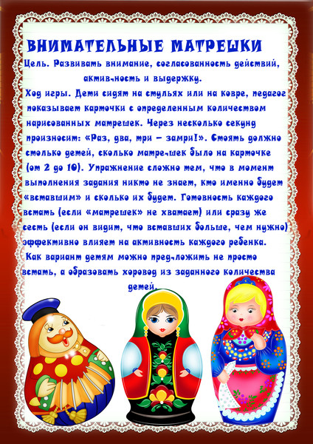](https://ok.ru/dk?cmd=PopLayerPhoto&st.layer.cmd=PopLayerPhotoOuter&st.layer.type=GROUP&st.layer.revNav=off&st.layer.limitedUi=false&st.layer.closeLayers=off&st.layer.sphotoIds=877365274069%3B877365273813%3B877365273557%3B877365273301%3B877365273045%3B877365272789%3B877365272533%3B877365272277%3B877365272021%3B877365271765%3B877365271509%3B877365271253%3B877365270997%3B877365270741%3B877365270485%3B877365270229%3B877365269973%3B877365269717%3B877365269461%3B877365269205&st.layer.showNav=on&st.layer.photoAlbumId=52406096429269&st.layer.epm=off&st.layer.photoId=877365271509&st.layer.opl=off&st.layer.navStartPhotoId=877365271509&st.layer.sbd=off&st.cmd=userMain&st.openPanel=feed&st._aid=GroupTopicLayer_openPhotoLayer)

[](https://ok.ru/dk?cmd=PopLayerPhoto&st.layer.cmd=PopLayerPhotoOuter&st.layer.type=GROUP&st.layer.revNav=off&st.layer.limitedUi=false&st.layer.closeLayers=off&st.layer.sphotoIds=877365274069%3B877365273813%3B877365273557%3B877365273301%3B877365273045%3B877365272789%3B877365272533%3B877365272277%3B877365272021%3B877365271765%3B877365271509%3B877365271253%3B877365270997%3B877365270741%3B877365270485%3B877365270229%3B877365269973%3B877365269717%3B877365269461%3B877365269205&st.layer.showNav=on&st.layer.photoAlbumId=52406096429269&st.layer.epm=off&st.layer.photoId=877365271253&st.layer.opl=off&st.layer.navStartPhotoId=877365271253&st.layer.sbd=off&st.cmd=userMain&st.openPanel=feed&st._aid=GroupTopicLayer_openPhotoLayer)

[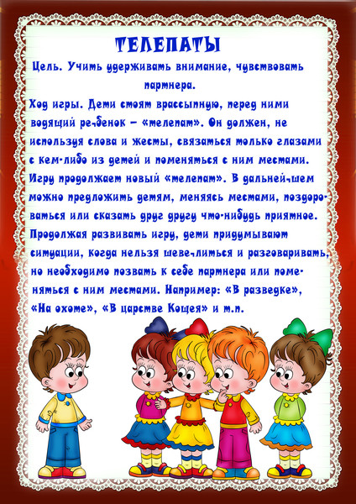](https://ok.ru/dk?cmd=PopLayerPhoto&st.layer.cmd=PopLayerPhotoOuter&st.layer.type=GROUP&st.layer.revNav=off&st.layer.limitedUi=false&st.layer.closeLayers=off&st.layer.sphotoIds=877365274069%3B877365273813%3B877365273557%3B877365273301%3B877365273045%3B877365272789%3B877365272533%3B877365272277%3B877365272021%3B877365271765%3B877365271509%3B877365271253%3B877365270997%3B877365270741%3B877365270485%3B877365270229%3B877365269973%3B877365269717%3B877365269461%3B877365269205&st.layer.showNav=on&st.layer.photoAlbumId=52406096429269&st.layer.epm=off&st.layer.photoId=877365270997&st.layer.opl=off&st.layer.navStartPhotoId=877365270997&st.layer.sbd=off&st.cmd=userMain&st.openPanel=feed&st._aid=GroupTopicLayer_openPhotoLayer)

[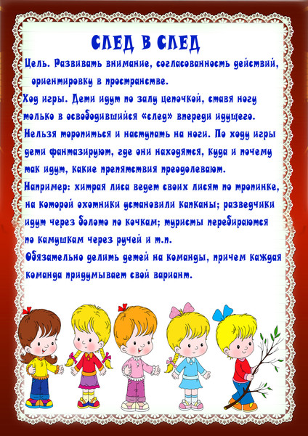](https://ok.ru/dk?cmd=PopLayerPhoto&st.layer.cmd=PopLayerPhotoOuter&st.layer.type=GROUP&st.layer.revNav=off&st.layer.limitedUi=false&st.layer.closeLayers=off&st.layer.sphotoIds=877365274069%3B877365273813%3B877365273557%3B877365273301%3B877365273045%3B877365272789%3B877365272533%3B877365272277%3B877365272021%3B877365271765%3B877365271509%3B877365271253%3B877365270997%3B877365270741%3B877365270485%3B877365270229%3B877365269973%3B877365269717%3B877365269461%3B877365269205&st.layer.showNav=on&st.layer.photoAlbumId=52406096429269&st.layer.epm=off&st.layer.photoId=877365270741&st.layer.opl=off&st.layer.navStartPhotoId=877365270741&st.layer.sbd=off&st.cmd=userMain&st.openPanel=feed&st._aid=GroupTopicLayer_openPhotoLayer)

[](https://ok.ru/dk?cmd=PopLayerPhoto&st.layer.cmd=PopLayerPhotoOuter&st.layer.type=GROUP&st.layer.revNav=off&st.layer.limitedUi=false&st.layer.closeLayers=off&st.layer.sphotoIds=877365274069%3B877365273813%3B877365273557%3B877365273301%3B877365273045%3B877365272789%3B877365272533%3B877365272277%3B877365272021%3B877365271765%3B877365271509%3B877365271253%3B877365270997%3B877365270741%3B877365270485%3B877365270229%3B877365269973%3B877365269717%3B877365269461%3B877365269205&st.layer.showNav=on&st.layer.photoAlbumId=52406096429269&st.layer.epm=off&st.layer.photoId=877365270485&st.layer.opl=off&st.layer.navStartPhotoId=877365270485&st.layer.sbd=off&st.cmd=userMain&st.openPanel=feed&st._aid=GroupTopicLayer_openPhotoLayer)

[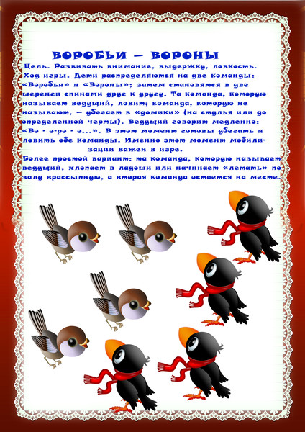](https://ok.ru/dk?cmd=PopLayerPhoto&st.layer.cmd=PopLayerPhotoOuter&st.layer.type=GROUP&st.layer.revNav=off&st.layer.limitedUi=false&st.layer.closeLayers=off&st.layer.sphotoIds=877365274069%3B877365273813%3B877365273557%3B877365273301%3B877365273045%3B877365272789%3B877365272533%3B877365272277%3B877365272021%3B877365271765%3B877365271509%3B877365271253%3B877365270997%3B877365270741%3B877365270485%3B877365270229%3B877365269973%3B877365269717%3B877365269461%3B877365269205&st.layer.showNav=on&st.layer.photoAlbumId=52406096429269&st.layer.epm=off&st.layer.photoId=877365270229&st.layer.opl=off&st.layer.navStartPhotoId=877365270229&st.layer.sbd=off&st.cmd=userMain&st.openPanel=feed&st._aid=GroupTopicLayer_openPhotoLayer)

[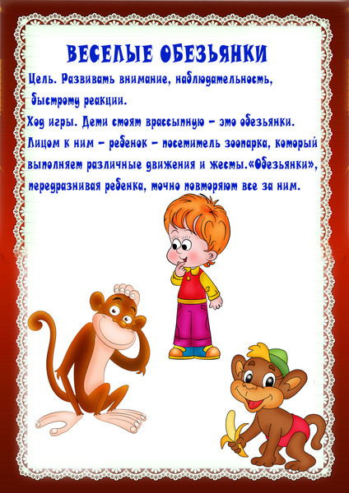](https://ok.ru/dk?cmd=PopLayerPhoto&st.layer.cmd=PopLayerPhotoOuter&st.layer.type=GROUP&st.layer.revNav=off&st.layer.limitedUi=false&st.layer.closeLayers=off&st.layer.sphotoIds=877365274069%3B877365273813%3B877365273557%3B877365273301%3B877365273045%3B877365272789%3B877365272533%3B877365272277%3B877365272021%3B877365271765%3B877365271509%3B877365271253%3B877365270997%3B877365270741%3B877365270485%3B877365270229%3B877365269973%3B877365269717%3B877365269461%3B877365269205&st.layer.showNav=on&st.layer.photoAlbumId=52406096429269&st.layer.epm=off&st.layer.photoId=877365269973&st.layer.opl=off&st.layer.navStartPhotoId=877365269973&st.layer.sbd=off&st.cmd=userMain&st.openPanel=feed&st._aid=GroupTopicLayer_openPhotoLayer)

[](https://ok.ru/dk?cmd=PopLayerPhoto&st.layer.cmd=PopLayerPhotoOuter&st.layer.type=GROUP&st.layer.revNav=off&st.layer.limitedUi=false&st.layer.closeLayers=off&st.layer.sphotoIds=877365274069%3B877365273813%3B877365273557%3B877365273301%3B877365273045%3B877365272789%3B877365272533%3B877365272277%3B877365272021%3B877365271765%3B877365271509%3B877365271253%3B877365270997%3B877365270741%3B877365270485%3B877365270229%3B877365269973%3B877365269717%3B877365269461%3B877365269205&st.layer.showNav=on&st.layer.photoAlbumId=52406096429269&st.layer.epm=off&st.layer.photoId=877365269717&st.layer.opl=off&st.layer.navStartPhotoId=877365269717&st.layer.sbd=off&st.cmd=userMain&st.openPanel=feed&st._aid=GroupTopicLayer_openPhotoLayer)

[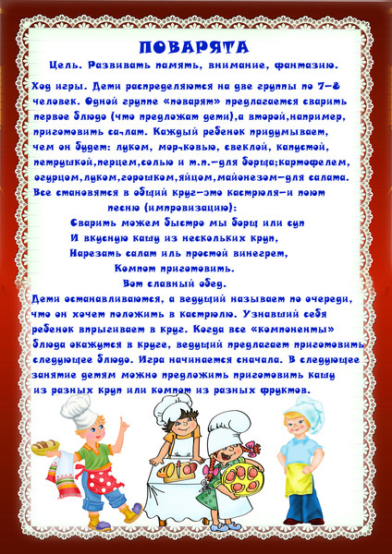](https://ok.ru/dk?cmd=PopLayerPhoto&st.layer.cmd=PopLayerPhotoOuter&st.layer.type=GROUP&st.layer.revNav=off&st.layer.limitedUi=false&st.layer.closeLayers=off&st.layer.sphotoIds=877365274069%3B877365273813%3B877365273557%3B877365273301%3B877365273045%3B877365272789%3B877365272533%3B877365272277%3B877365272021%3B877365271765%3B877365271509%3B877365271253%3B877365270997%3B877365270741%3B877365270485%3B877365270229%3B877365269973%3B877365269717%3B877365269461%3B877365269205&st.layer.showNav=on&st.layer.photoAlbumId=52406096429269&st.layer.epm=off&st.layer.photoId=877365269461&st.layer.opl=off&st.layer.navStartPhotoId=877365269461&st.layer.sbd=off&st.cmd=userMain&st.openPanel=feed&st._aid=GroupTopicLayer_openPhotoLayer)

[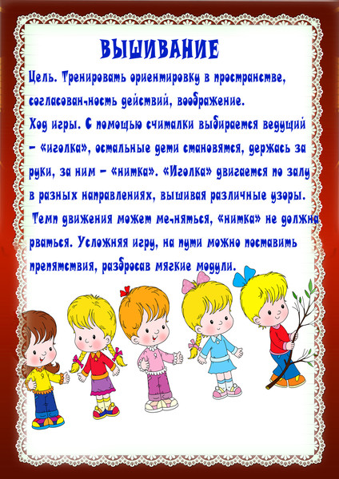](https://ok.ru/dk?cmd=PopLayerPhoto&st.layer.cmd=PopLayerPhotoOuter&st.layer.type=GROUP&st.layer.revNav=off&st.layer.limitedUi=false&st.layer.closeLayers=off&st.layer.sphotoIds=877365274069%3B877365273813%3B877365273557%3B877365273301%3B877365273045%3B877365272789%3B877365272533%3B877365272277%3B877365272021%3B877365271765%3B877365271509%3B877365271253%3B877365270997%3B877365270741%3B877365270485%3B877365270229%3B877365269973%3B877365269717%3B877365269461%3B877365269205&st.layer.showNav=on&st.layer.photoAlbumId=52406096429269&st.layer.epm=off&st.layer.photoId=877365269205&st.layer.opl=off&st.layer.navStartPhotoId=877365269205&st.layer.sbd=off&st.cmd=userMain&st.openPanel=feed&st._aid=GroupTopicLayer_openPhotoLayer)