[](https://ok.ru/dk?cmd=PopLayerPhoto&st.layer.cmd=PopLayerPhotoOuter&st.layer.type=GROUP&st.layer.revNav=off&st.layer.limitedUi=false&st.layer.closeLayers=off&st.layer.sphotoIds=877453147631%3B877453147887%3B877453148143%3B877453148399%3B877453148655%3B877453148911%3B877453149167&st.layer.showNav=on&st.layer.photoAlbumId=53409783939311&st.layer.epm=off&st.layer.photoId=877453147631&st.layer.opl=off&st.layer.navStartPhotoId=877453147631&st.layer.sbd=off&st.cmd=userMain&st.openPanel=feed&st._aid=GroupTopicLayer_openPhotoLayer)

[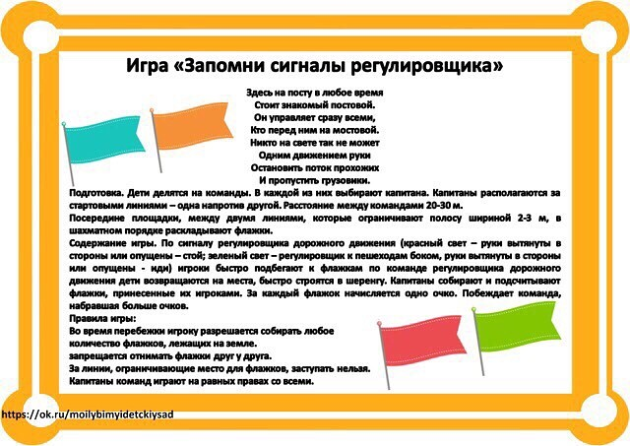](https://ok.ru/dk?cmd=PopLayerPhoto&st.layer.cmd=PopLayerPhotoOuter&st.layer.type=GROUP&st.layer.revNav=off&st.layer.limitedUi=false&st.layer.closeLayers=off&st.layer.sphotoIds=877453147631%3B877453147887%3B877453148143%3B877453148399%3B877453148655%3B877453148911%3B877453149167&st.layer.showNav=on&st.layer.photoAlbumId=53409783939311&st.layer.epm=off&st.layer.photoId=877453147887&st.layer.opl=off&st.layer.navStartPhotoId=877453147887&st.layer.sbd=off&st.cmd=userMain&st.openPanel=feed&st._aid=GroupTopicLayer_openPhotoLayer)

[](https://ok.ru/dk?cmd=PopLayerPhoto&st.layer.cmd=PopLayerPhotoOuter&st.layer.type=GROUP&st.layer.revNav=off&st.layer.limitedUi=false&st.layer.closeLayers=off&st.layer.sphotoIds=877453147631%3B877453147887%3B877453148143%3B877453148399%3B877453148655%3B877453148911%3B877453149167&st.layer.showNav=on&st.layer.photoAlbumId=53409783939311&st.layer.epm=off&st.layer.photoId=877453148143&st.layer.opl=off&st.layer.navStartPhotoId=877453148143&st.layer.sbd=off&st.cmd=userMain&st.openPanel=feed&st._aid=GroupTopicLayer_openPhotoLayer)

[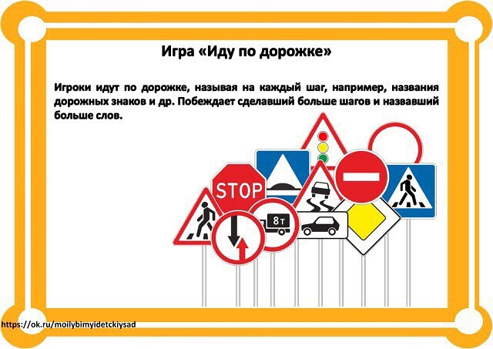](https://ok.ru/dk?cmd=PopLayerPhoto&st.layer.cmd=PopLayerPhotoOuter&st.layer.type=GROUP&st.layer.revNav=off&st.layer.limitedUi=false&st.layer.closeLayers=off&st.layer.sphotoIds=877453147631%3B877453147887%3B877453148143%3B877453148399%3B877453148655%3B877453148911%3B877453149167&st.layer.showNav=on&st.layer.photoAlbumId=53409783939311&st.layer.epm=off&st.layer.photoId=877453148399&st.layer.opl=off&st.layer.navStartPhotoId=877453148399&st.layer.sbd=off&st.cmd=userMain&st.openPanel=feed&st._aid=GroupTopicLayer_openPhotoLayer)

[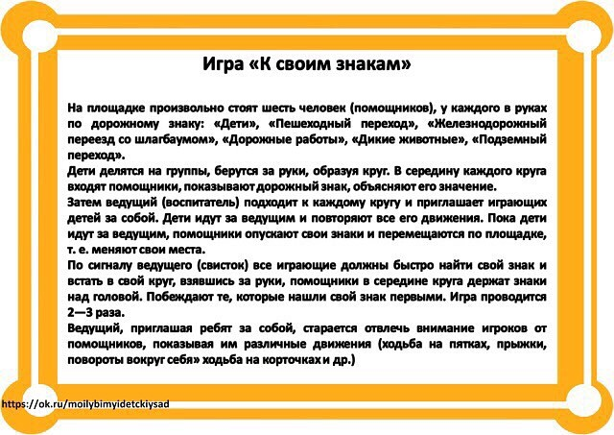](https://ok.ru/dk?cmd=PopLayerPhoto&st.layer.cmd=PopLayerPhotoOuter&st.layer.type=GROUP&st.layer.revNav=off&st.layer.limitedUi=false&st.layer.closeLayers=off&st.layer.sphotoIds=877453147631%3B877453147887%3B877453148143%3B877453148399%3B877453148655%3B877453148911%3B877453149167&st.layer.showNav=on&st.layer.photoAlbumId=53409783939311&st.layer.epm=off&st.layer.photoId=877453148655&st.layer.opl=off&st.layer.navStartPhotoId=877453148655&st.layer.sbd=off&st.cmd=userMain&st.openPanel=feed&st._aid=GroupTopicLayer_openPhotoLayer)

[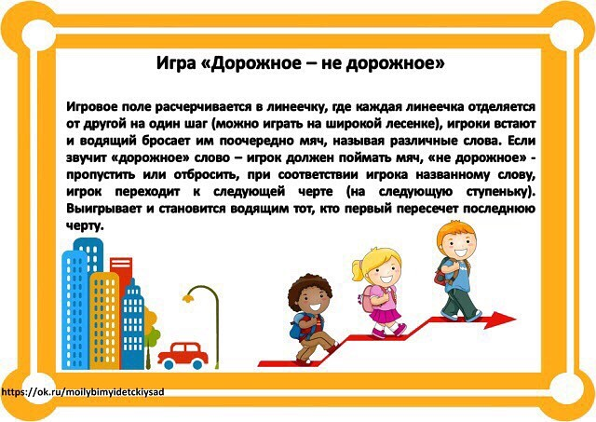](https://ok.ru/dk?cmd=PopLayerPhoto&st.layer.cmd=PopLayerPhotoOuter&st.layer.type=GROUP&st.layer.revNav=off&st.layer.limitedUi=false&st.layer.closeLayers=off&st.layer.sphotoIds=877453147631%3B877453147887%3B877453148143%3B877453148399%3B877453148655%3B877453148911%3B877453149167&st.layer.showNav=on&st.layer.photoAlbumId=53409783939311&st.layer.epm=off&st.layer.photoId=877453148911&st.layer.opl=off&st.layer.navStartPhotoId=877453148911&st.layer.sbd=off&st.cmd=userMain&st.openPanel=feed&st._aid=GroupTopicLayer_openPhotoLayer)

[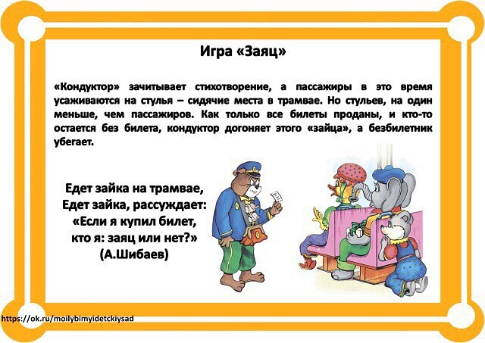](https://ok.ru/dk?cmd=PopLayerPhoto&st.layer.cmd=PopLayerPhotoOuter&st.layer.type=GROUP&st.layer.revNav=off&st.layer.limitedUi=false&st.layer.closeLayers=off&st.layer.sphotoIds=877453147631%3B877453147887%3B877453148143%3B877453148399%3B877453148655%3B877453148911%3B877453149167&st.layer.showNav=on&st.layer.photoAlbumId=53409783939311&st.layer.epm=off&st.layer.photoId=877453149167&st.layer.opl=off&st.layer.navStartPhotoId=877453149167&st.layer.sbd=off&st.cmd=userMain&st.openPanel=feed&st._aid=GroupTopicLayer_openPhotoLayer)