К сожалению, современные дети все меньше читают. Поэтому эту любовь к книгам просто необходимо прививать с раннего возраста. И делать это должны не только учителя, но и родители. Как превратить чтение в удовольствие.

[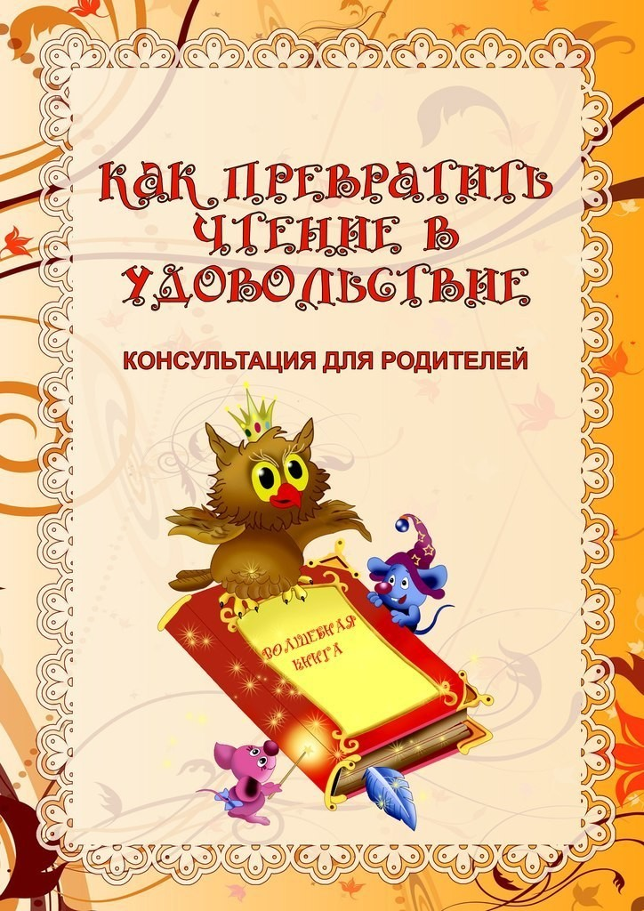](https://ok.ru/dk?cmd=PopLayerPhoto&st.layer.cmd=PopLayerPhotoOuter&st.layer.type=GROUP&st.layer.revNav=off&st.layer.limitedUi=false&st.layer.closeLayers=off&st.layer.sphotoIds=873321745828%3B873321746084%3B873321746340%3B873321746596%3B873321746852%3B873321747108&st.layer.showNav=on&st.layer.photoAlbumId=52920076599460&st.layer.epm=off&st.layer.photoId=873321745828&st.layer.opl=off&st.layer.navStartPhotoId=873321745828&st.layer.sbd=off&st.cmd=userMain&st.openPanel=feed&st._aid=GroupTopicLayer_openPhotoLayer)

[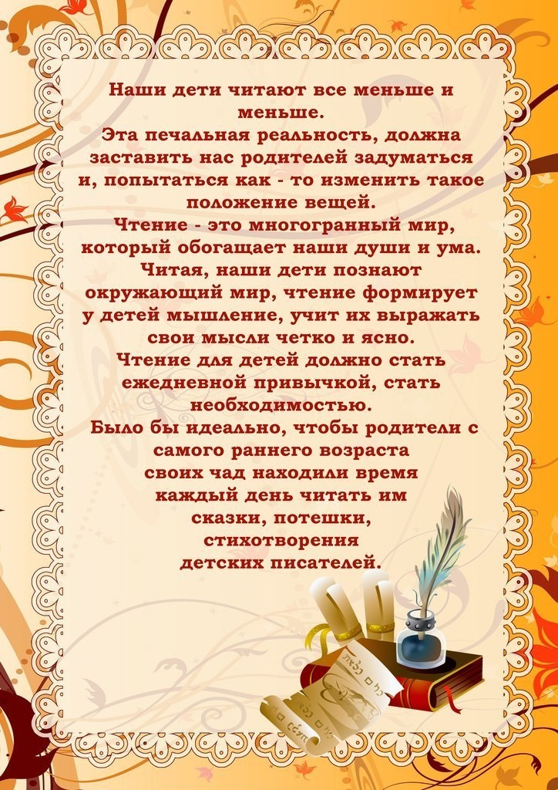](https://ok.ru/dk?cmd=PopLayerPhoto&st.layer.cmd=PopLayerPhotoOuter&st.layer.type=GROUP&st.layer.revNav=off&st.layer.limitedUi=false&st.layer.closeLayers=off&st.layer.sphotoIds=873321745828%3B873321746084%3B873321746340%3B873321746596%3B873321746852%3B873321747108&st.layer.showNav=on&st.layer.photoAlbumId=52920076599460&st.layer.epm=off&st.layer.photoId=873321746084&st.layer.opl=off&st.layer.navStartPhotoId=873321746084&st.layer.sbd=off&st.cmd=userMain&st.openPanel=feed&st._aid=GroupTopicLayer_openPhotoLayer)

[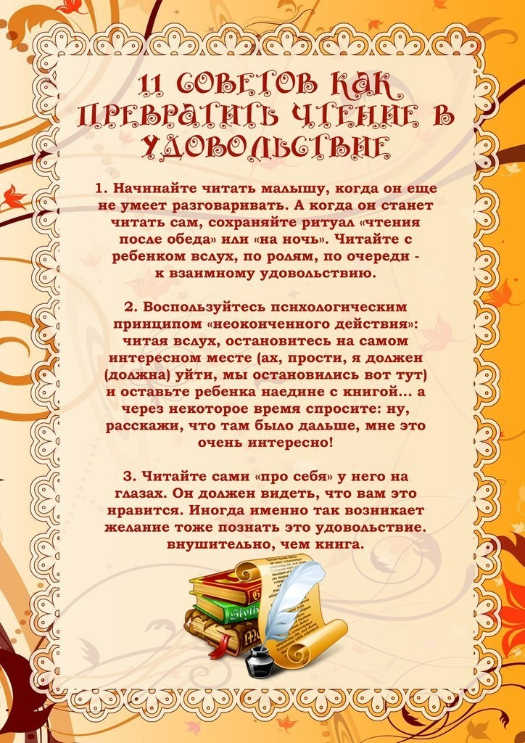](https://ok.ru/dk?cmd=PopLayerPhoto&st.layer.cmd=PopLayerPhotoOuter&st.layer.type=GROUP&st.layer.revNav=off&st.layer.limitedUi=false&st.layer.closeLayers=off&st.layer.sphotoIds=873321745828%3B873321746084%3B873321746340%3B873321746596%3B873321746852%3B873321747108&st.layer.showNav=on&st.layer.photoAlbumId=52920076599460&st.layer.epm=off&st.layer.photoId=873321746340&st.layer.opl=off&st.layer.navStartPhotoId=873321746340&st.layer.sbd=off&st.cmd=userMain&st.openPanel=feed&st._aid=GroupTopicLayer_openPhotoLayer)

[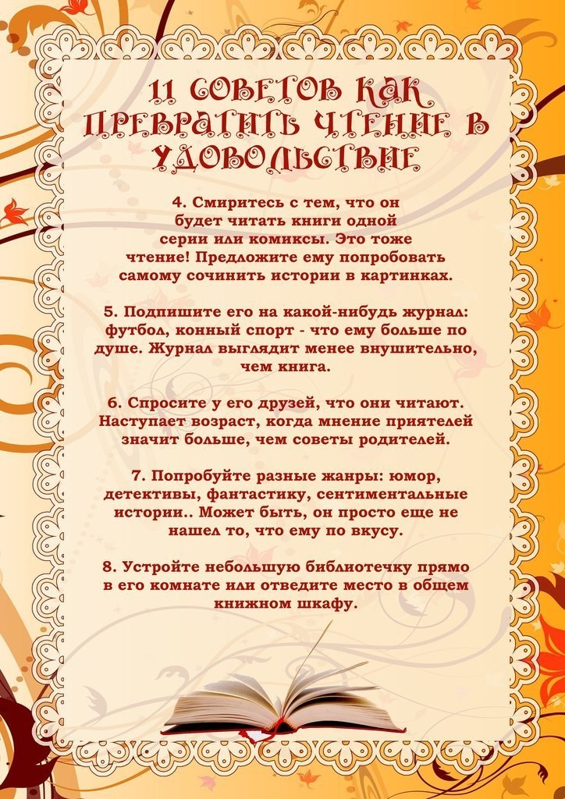](https://ok.ru/dk?cmd=PopLayerPhoto&st.layer.cmd=PopLayerPhotoOuter&st.layer.type=GROUP&st.layer.revNav=off&st.layer.limitedUi=false&st.layer.closeLayers=off&st.layer.sphotoIds=873321745828%3B873321746084%3B873321746340%3B873321746596%3B873321746852%3B873321747108&st.layer.showNav=on&st.layer.photoAlbumId=52920076599460&st.layer.epm=off&st.layer.photoId=873321746596&st.layer.opl=off&st.layer.navStartPhotoId=873321746596&st.layer.sbd=off&st.cmd=userMain&st.openPanel=feed&st._aid=GroupTopicLayer_openPhotoLayer)

[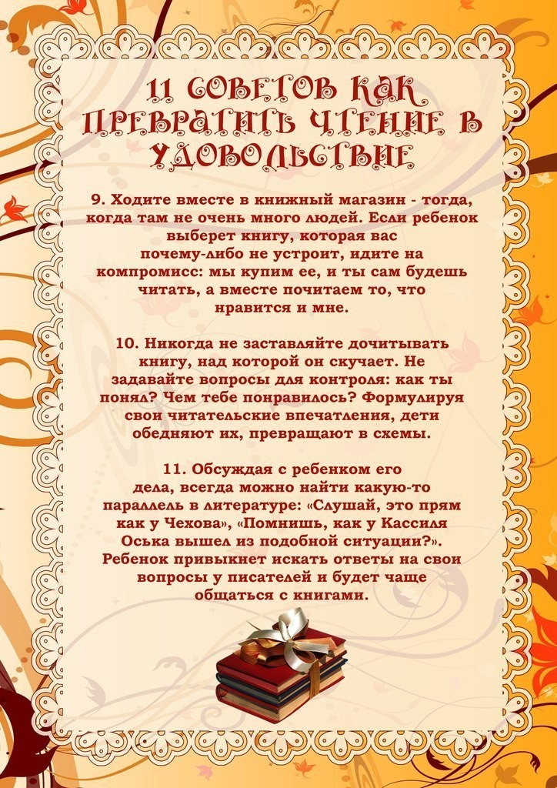](https://ok.ru/dk?cmd=PopLayerPhoto&st.layer.cmd=PopLayerPhotoOuter&st.layer.type=GROUP&st.layer.revNav=off&st.layer.limitedUi=false&st.layer.closeLayers=off&st.layer.sphotoIds=873321745828%3B873321746084%3B873321746340%3B873321746596%3B873321746852%3B873321747108&st.layer.showNav=on&st.layer.photoAlbumId=52920076599460&st.layer.epm=off&st.layer.photoId=873321746852&st.layer.opl=off&st.layer.navStartPhotoId=873321746852&st.layer.sbd=off&st.cmd=userMain&st.openPanel=feed&st._aid=GroupTopicLayer_openPhotoLayer)

[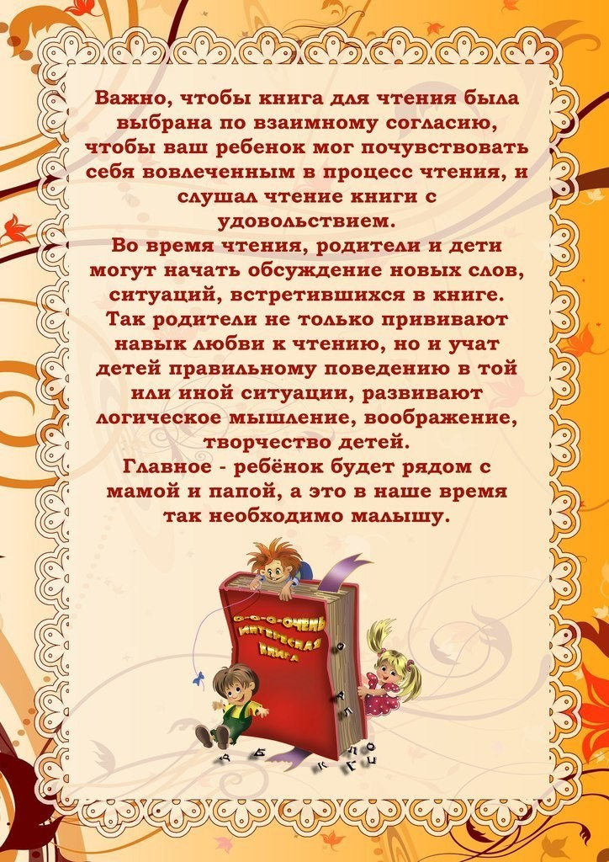](https://ok.ru/dk?cmd=PopLayerPhoto&st.layer.cmd=PopLayerPhotoOuter&st.layer.type=GROUP&st.layer.revNav=off&st.layer.limitedUi=false&st.layer.closeLayers=off&st.layer.sphotoIds=873321745828%3B873321746084%3B873321746340%3B873321746596%3B873321746852%3B873321747108&st.layer.showNav=on&st.layer.photoAlbumId=52920076599460&st.layer.epm=off&st.layer.photoId=873321747108&st.layer.opl=off&st.layer.navStartPhotoId=873321747108&st.layer.sbd=off&st.cmd=userMain&st.openPanel=feed&st._aid=GroupTopicLayer_openPhotoLayer)