ПДД. ДОРОЖНЫЕ ЗНАКИ. КАРТОТЕКА СТИХОВ - ЗАГАДОК

[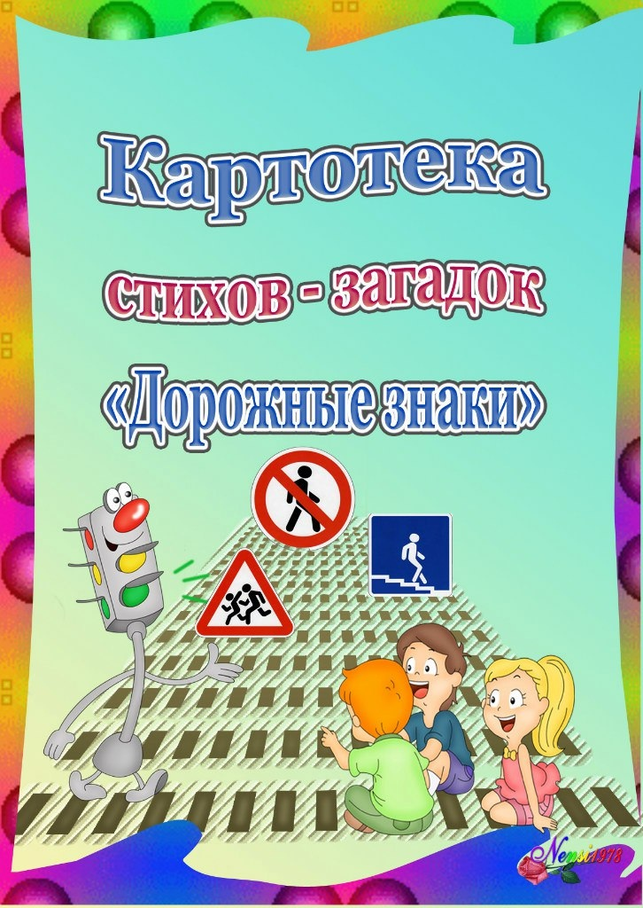](https://ok.ru/dk?cmd=PopLayerPhoto&st.layer.cmd=PopLayerPhotoOuter&st.layer.type=GROUP&st.layer.revNav=off&st.layer.limitedUi=false&st.layer.closeLayers=off&st.layer.sphotoIds=872206132636;872206134940;872206136988;872206138524;872206140060;872206142620;872206144668;872206146972;872206148764;872206152604&st.layer.showNav=on&st.layer.photoAlbumId=53850107609244&st.layer.epm=off&st.layer.photoId=872206132636&st.layer.opl=off&st.layer.navStartPhotoId=872206132636&st.layer.sbd=off&st.cmd=altGroupMain&st.groupId=53850080215196&st.referenceName=podgotovishkaru&st._aid=GroupTopicLayer_openPhotoLayer)

[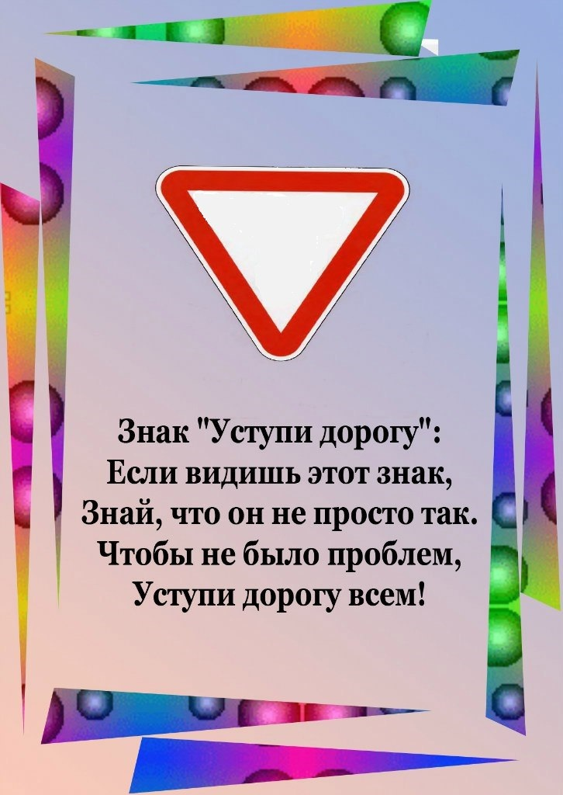](https://ok.ru/dk?cmd=PopLayerPhoto&st.layer.cmd=PopLayerPhotoOuter&st.layer.type=GROUP&st.layer.revNav=off&st.layer.limitedUi=false&st.layer.closeLayers=off&st.layer.sphotoIds=872206132636;872206134940;872206136988;872206138524;872206140060;872206142620;872206144668;872206146972;872206148764;872206152604&st.layer.showNav=on&st.layer.photoAlbumId=53850107609244&st.layer.epm=off&st.layer.photoId=872206134940&st.layer.opl=off&st.layer.navStartPhotoId=872206134940&st.layer.sbd=off&st.cmd=altGroupMain&st.groupId=53850080215196&st.referenceName=podgotovishkaru&st._aid=GroupTopicLayer_openPhotoLayer)

[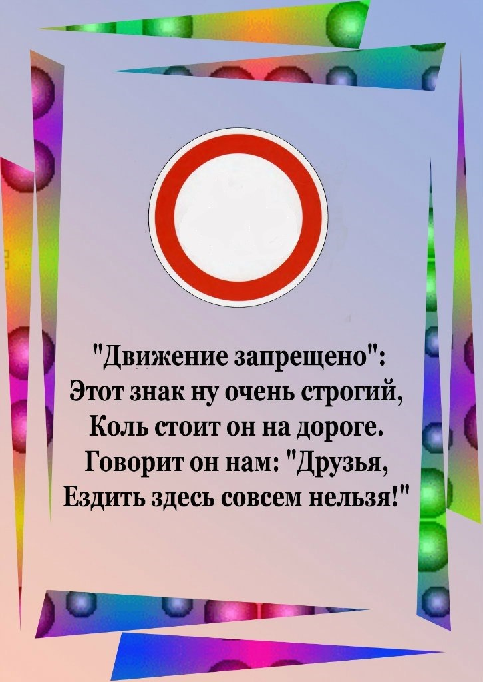](https://ok.ru/dk?cmd=PopLayerPhoto&st.layer.cmd=PopLayerPhotoOuter&st.layer.type=GROUP&st.layer.revNav=off&st.layer.limitedUi=false&st.layer.closeLayers=off&st.layer.sphotoIds=872206132636;872206134940;872206136988;872206138524;872206140060;872206142620;872206144668;872206146972;872206148764;872206152604&st.layer.showNav=on&st.layer.photoAlbumId=53850107609244&st.layer.epm=off&st.layer.photoId=872206136988&st.layer.opl=off&st.layer.navStartPhotoId=872206136988&st.layer.sbd=off&st.cmd=altGroupMain&st.groupId=53850080215196&st.referenceName=podgotovishkaru&st._aid=GroupTopicLayer_openPhotoLayer)

[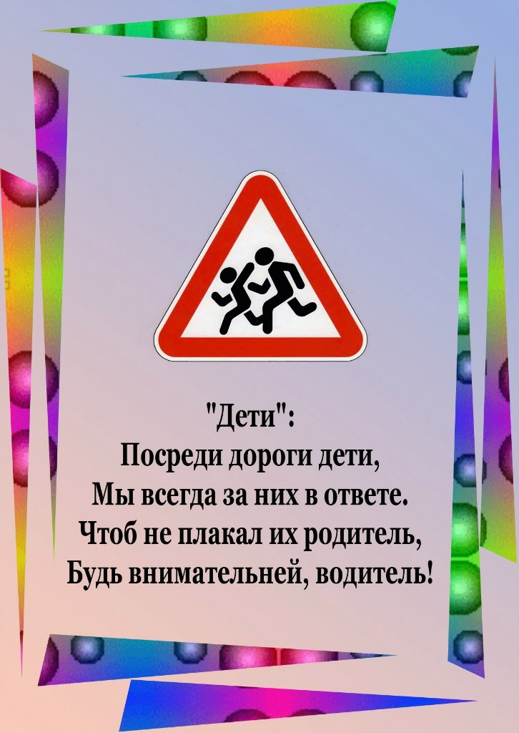](https://ok.ru/dk?cmd=PopLayerPhoto&st.layer.cmd=PopLayerPhotoOuter&st.layer.type=GROUP&st.layer.revNav=off&st.layer.limitedUi=false&st.layer.closeLayers=off&st.layer.sphotoIds=872206132636;872206134940;872206136988;872206138524;872206140060;872206142620;872206144668;872206146972;872206148764;872206152604&st.layer.showNav=on&st.layer.photoAlbumId=53850107609244&st.layer.epm=off&st.layer.photoId=872206138524&st.layer.opl=off&st.layer.navStartPhotoId=872206138524&st.layer.sbd=off&st.cmd=altGroupMain&st.groupId=53850080215196&st.referenceName=podgotovishkaru&st._aid=GroupTopicLayer_openPhotoLayer)

[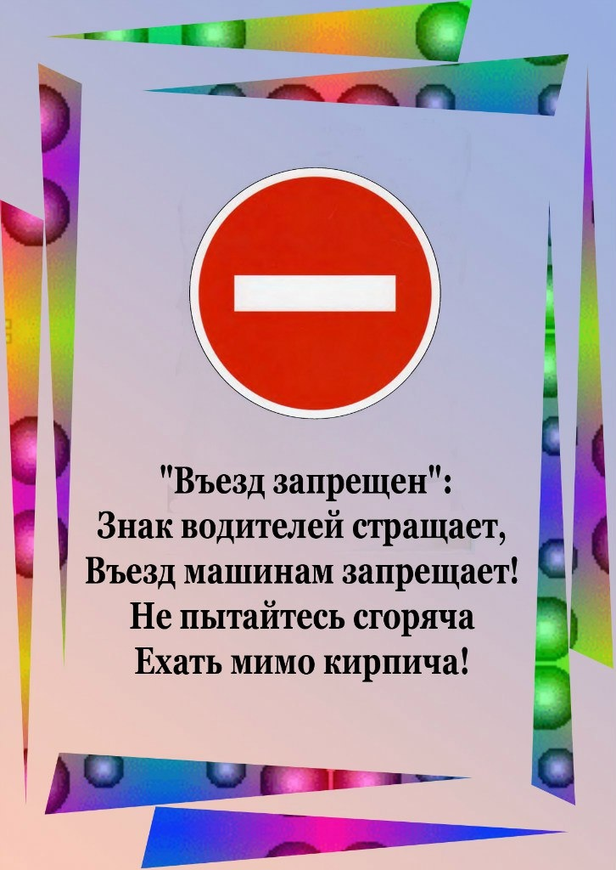](https://ok.ru/dk?cmd=PopLayerPhoto&st.layer.cmd=PopLayerPhotoOuter&st.layer.type=GROUP&st.layer.revNav=off&st.layer.limitedUi=false&st.layer.closeLayers=off&st.layer.sphotoIds=872206132636;872206134940;872206136988;872206138524;872206140060;872206142620;872206144668;872206146972;872206148764;872206152604&st.layer.showNav=on&st.layer.photoAlbumId=53850107609244&st.layer.epm=off&st.layer.photoId=872206140060&st.layer.opl=off&st.layer.navStartPhotoId=872206140060&st.layer.sbd=off&st.cmd=altGroupMain&st.groupId=53850080215196&st.referenceName=podgotovishkaru&st._aid=GroupTopicLayer_openPhotoLayer)

[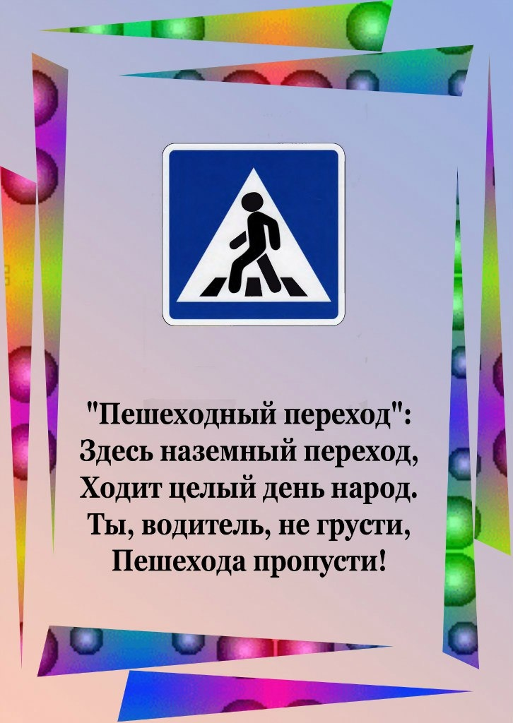](https://ok.ru/dk?cmd=PopLayerPhoto&st.layer.cmd=PopLayerPhotoOuter&st.layer.type=GROUP&st.layer.revNav=off&st.layer.limitedUi=false&st.layer.closeLayers=off&st.layer.sphotoIds=872206132636;872206134940;872206136988;872206138524;872206140060;872206142620;872206144668;872206146972;872206148764;872206152604&st.layer.showNav=on&st.layer.photoAlbumId=53850107609244&st.layer.epm=off&st.layer.photoId=872206142620&st.layer.opl=off&st.layer.navStartPhotoId=872206142620&st.layer.sbd=off&st.cmd=altGroupMain&st.groupId=53850080215196&st.referenceName=podgotovishkaru&st._aid=GroupTopicLayer_openPhotoLayer)

[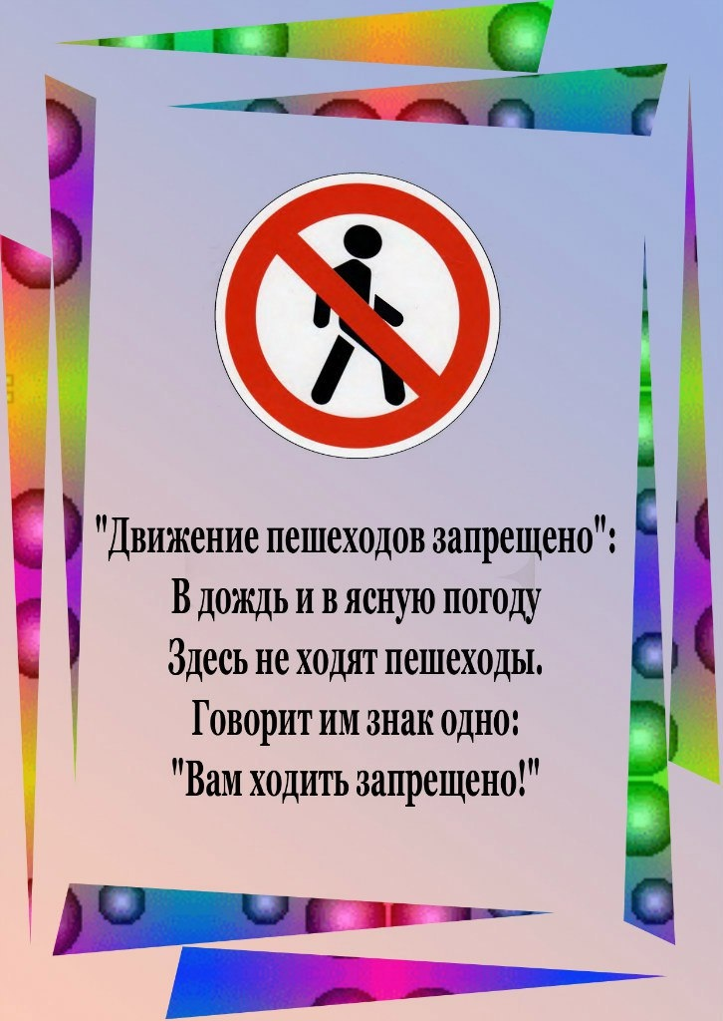](https://ok.ru/dk?cmd=PopLayerPhoto&st.layer.cmd=PopLayerPhotoOuter&st.layer.type=GROUP&st.layer.revNav=off&st.layer.limitedUi=false&st.layer.closeLayers=off&st.layer.sphotoIds=872206132636;872206134940;872206136988;872206138524;872206140060;872206142620;872206144668;872206146972;872206148764;872206152604&st.layer.showNav=on&st.layer.photoAlbumId=53850107609244&st.layer.epm=off&st.layer.photoId=872206144668&st.layer.opl=off&st.layer.navStartPhotoId=872206144668&st.layer.sbd=off&st.cmd=altGroupMain&st.groupId=53850080215196&st.referenceName=podgotovishkaru&st._aid=GroupTopicLayer_openPhotoLayer)

[](https://ok.ru/dk?cmd=PopLayerPhoto&st.layer.cmd=PopLayerPhotoOuter&st.layer.type=GROUP&st.layer.revNav=off&st.layer.limitedUi=false&st.layer.closeLayers=off&st.layer.sphotoIds=872206132636;872206134940;872206136988;872206138524;872206140060;872206142620;872206144668;872206146972;872206148764;872206152604&st.layer.showNav=on&st.layer.photoAlbumId=53850107609244&st.layer.epm=off&st.layer.photoId=872206146972&st.layer.opl=off&st.layer.navStartPhotoId=872206146972&st.layer.sbd=off&st.cmd=altGroupMain&st.groupId=53850080215196&st.referenceName=podgotovishkaru&st._aid=GroupTopicLayer_openPhotoLayer)

[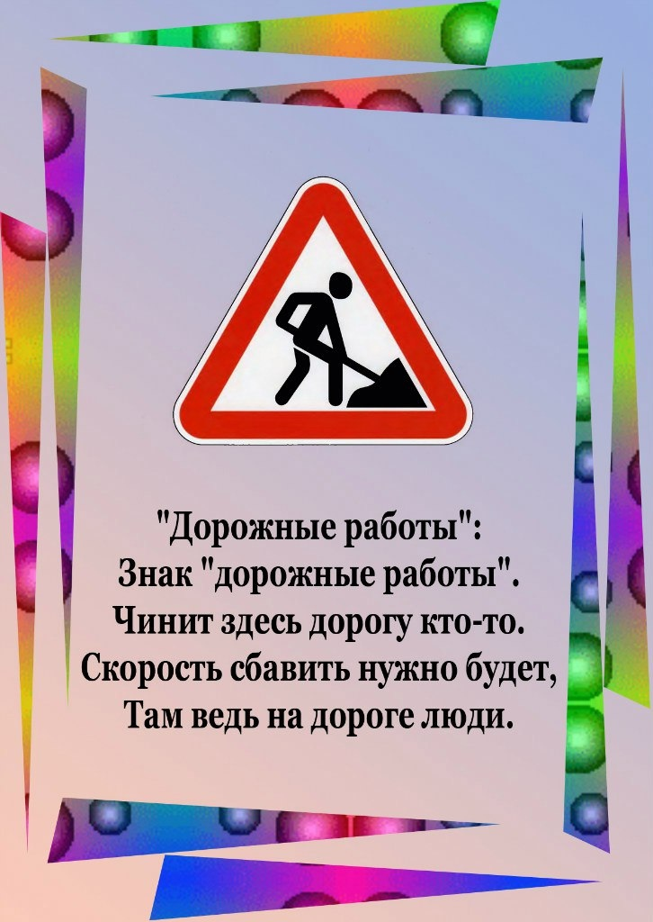](https://ok.ru/dk?cmd=PopLayerPhoto&st.layer.cmd=PopLayerPhotoOuter&st.layer.type=GROUP&st.layer.revNav=off&st.layer.limitedUi=false&st.layer.closeLayers=off&st.layer.sphotoIds=872206132636;872206134940;872206136988;872206138524;872206140060;872206142620;872206144668;872206146972;872206148764;872206152604&st.layer.showNav=on&st.layer.photoAlbumId=53850107609244&st.layer.epm=off&st.layer.photoId=872206148764&st.layer.opl=off&st.layer.navStartPhotoId=872206148764&st.layer.sbd=off&st.cmd=altGroupMain&st.groupId=53850080215196&st.referenceName=podgotovishkaru&st._aid=GroupTopicLayer_openPhotoLayer)

[](https://ok.ru/dk?cmd=PopLayerPhoto&st.layer.cmd=PopLayerPhotoOuter&st.layer.type=GROUP&st.layer.revNav=off&st.layer.limitedUi=false&st.layer.closeLayers=off&st.layer.sphotoIds=872206132636;872206134940;872206136988;872206138524;872206140060;872206142620;872206144668;872206146972;872206148764;872206152604&st.layer.showNav=on&st.layer.photoAlbumId=53850107609244&st.layer.epm=off&st.layer.photoId=872206152604&st.layer.opl=off&st.layer.navStartPhotoId=872206152604&st.layer.sbd=off&st.cmd=altGroupMain&st.groupId=53850080215196&st.referenceName=podgotovishkaru&st._aid=GroupTopicLayer_openPhotoLayer)