[](https://ok.ru/dk?cmd=PopLayerPhoto&st.layer.cmd=PopLayerPhotoOuter&st.layer.type=GROUP&st.layer.revNav=off&st.layer.limitedUi=false&st.layer.closeLayers=off&st.layer.sphotoIds=874638309135%3B874638309391%3B874638309647%3B874638309903%3B874638310159%3B874638310415&st.layer.showNav=on&st.layer.photoAlbumId=54997229240335&st.layer.epm=off&st.layer.photoId=874638309135&st.layer.opl=off&st.layer.navStartPhotoId=874638309135&st.layer.sbd=off&st.cmd=userMain&st.openPanel=feed&st._aid=GroupTopicLayer_openPhotoLayer)

[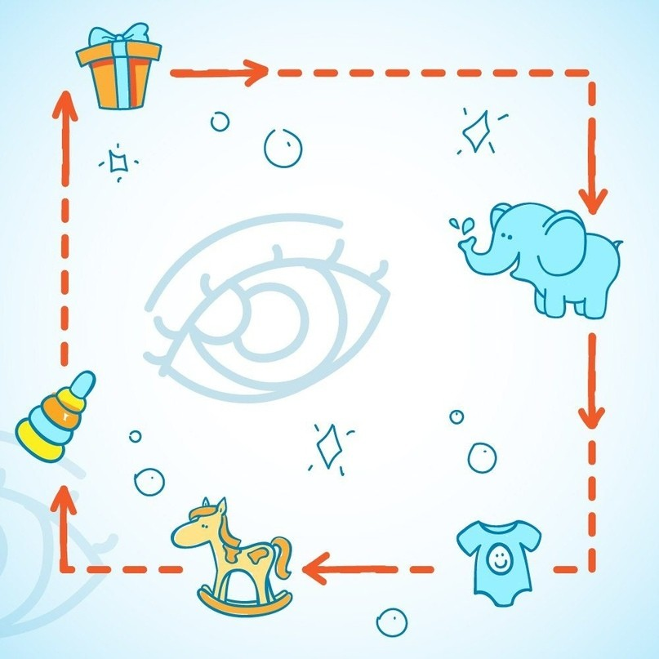](https://ok.ru/dk?cmd=PopLayerPhoto&st.layer.cmd=PopLayerPhotoOuter&st.layer.type=GROUP&st.layer.revNav=off&st.layer.limitedUi=false&st.layer.closeLayers=off&st.layer.sphotoIds=874638309135%3B874638309391%3B874638309647%3B874638309903%3B874638310159%3B874638310415&st.layer.showNav=on&st.layer.photoAlbumId=54997229240335&st.layer.epm=off&st.layer.photoId=874638309391&st.layer.opl=off&st.layer.navStartPhotoId=874638309391&st.layer.sbd=off&st.cmd=userMain&st.openPanel=feed&st._aid=GroupTopicLayer_openPhotoLayer)

[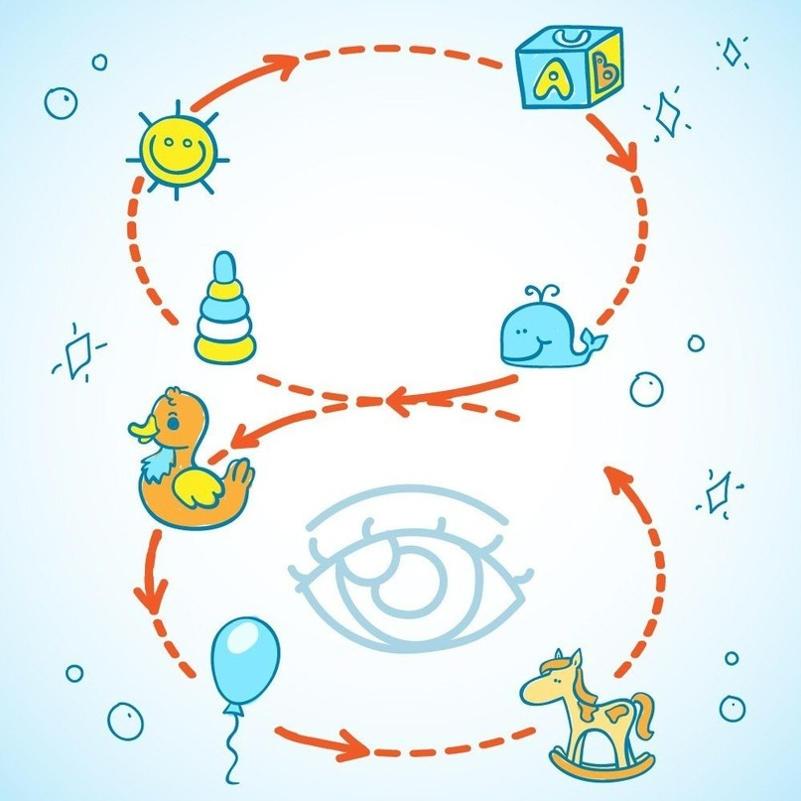](https://ok.ru/dk?cmd=PopLayerPhoto&st.layer.cmd=PopLayerPhotoOuter&st.layer.type=GROUP&st.layer.revNav=off&st.layer.limitedUi=false&st.layer.closeLayers=off&st.layer.sphotoIds=874638309135%3B874638309391%3B874638309647%3B874638309903%3B874638310159%3B874638310415&st.layer.showNav=on&st.layer.photoAlbumId=54997229240335&st.layer.epm=off&st.layer.photoId=874638309647&st.layer.opl=off&st.layer.navStartPhotoId=874638309647&st.layer.sbd=off&st.cmd=userMain&st.openPanel=feed&st._aid=GroupTopicLayer_openPhotoLayer)

[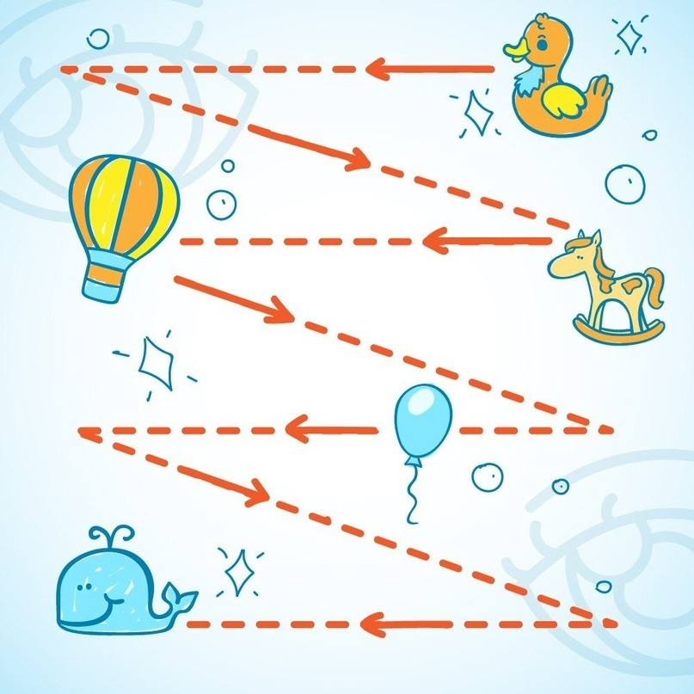](https://ok.ru/dk?cmd=PopLayerPhoto&st.layer.cmd=PopLayerPhotoOuter&st.layer.type=GROUP&st.layer.revNav=off&st.layer.limitedUi=false&st.layer.closeLayers=off&st.layer.sphotoIds=874638309135%3B874638309391%3B874638309647%3B874638309903%3B874638310159%3B874638310415&st.layer.showNav=on&st.layer.photoAlbumId=54997229240335&st.layer.epm=off&st.layer.photoId=874638309903&st.layer.opl=off&st.layer.navStartPhotoId=874638309903&st.layer.sbd=off&st.cmd=userMain&st.openPanel=feed&st._aid=GroupTopicLayer_openPhotoLayer)

[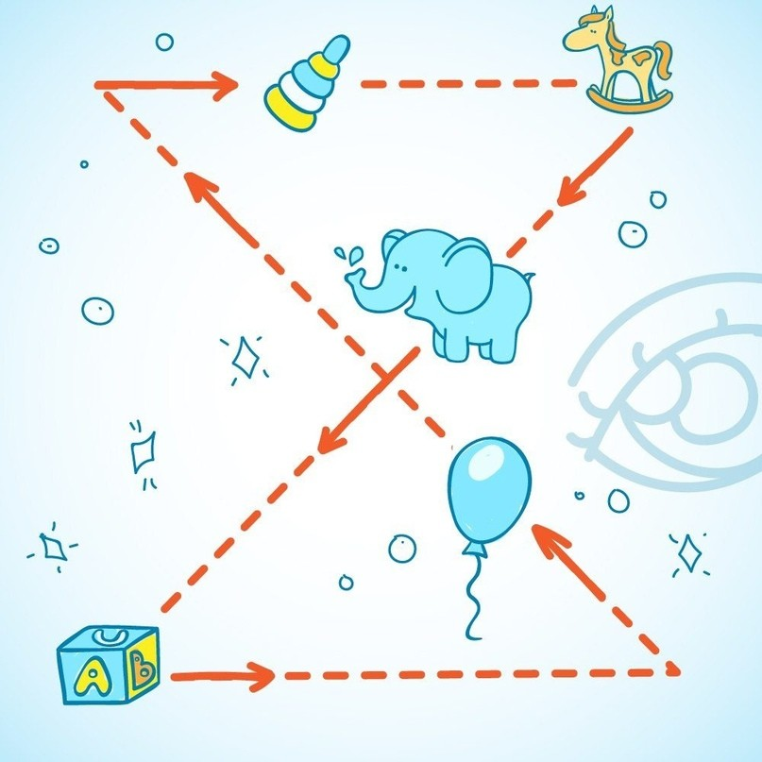](https://ok.ru/dk?cmd=PopLayerPhoto&st.layer.cmd=PopLayerPhotoOuter&st.layer.type=GROUP&st.layer.revNav=off&st.layer.limitedUi=false&st.layer.closeLayers=off&st.layer.sphotoIds=874638309135%3B874638309391%3B874638309647%3B874638309903%3B874638310159%3B874638310415&st.layer.showNav=on&st.layer.photoAlbumId=54997229240335&st.layer.epm=off&st.layer.photoId=874638310159&st.layer.opl=off&st.layer.navStartPhotoId=874638310159&st.layer.sbd=off&st.cmd=userMain&st.openPanel=feed&st._aid=GroupTopicLayer_openPhotoLayer)

[](https://ok.ru/dk?cmd=PopLayerPhoto&st.layer.cmd=PopLayerPhotoOuter&st.layer.type=GROUP&st.layer.revNav=off&st.layer.limitedUi=false&st.layer.closeLayers=off&st.layer.sphotoIds=874638309135%3B874638309391%3B874638309647%3B874638309903%3B874638310159%3B874638310415&st.layer.showNav=on&st.layer.photoAlbumId=54997229240335&st.layer.epm=off&st.layer.photoId=874638310415&st.layer.opl=off&st.layer.navStartPhotoId=874638310415&st.layer.sbd=off&st.cmd=userMain&st.openPanel=feed&st._aid=GroupTopicLayer_openPhotoLayer)